Contact person:
Barbara Weber
Barbara.Weber@profibus.com
+49 721 986197-49

P R E S S R E L E A S E

Impressive figures for PROFINET and IO-Link

PROFINET is approaching the milestone of 50 million installed devices

Karlsruhe, Germany – April 25, 2022: Despite more than two years of delivery issues and other uncertainties as a result of the pandemic, manufacturers of products using technology from PROFIBUS & PROFINET International (PI) have reported very positive figures for 2021. This is especially true for PROFINET and IO-Link. In no small part is this thanks to years of consistent further development of the technologies coordinated with users. The latest example of this is the publication of specification documents on Ethernet-APL. “Ethernet-APL hasn’t contributed to the current figures just yet, but it’ll ensure the widespread use of PROFINET throughout process automation in the near future. The reason for this optimism is the very highly rated demo systems of users in the chemical industry,” said Dr. Jörg Hähniche, head of the APL project.

8.5 million PROFINET devices were installed in the market in 2021 – the largest annual figure yet. This corresponds to an increase of more than 22% and a total of 48.2 million devices. Though the 1.5 million PROFIBUS devices installed in 2021 is somewhat less than the previous year, the total number of PROFIBUS and PROFINET devices installed came in at a record 10 million for the year.

The biggest year-over-year increase in 2021 was 30%, seen by IO-Link. This is nearly the same growth rate as the year prior and proof that further development of IO-Link in the right direction has been striven for by active experts, who have also been consistently making progress with IO-Link over SPE. The annual figure of IO-Link devices installed amounted to 6.3 million nodes, and the total number is now over 27 million.

The figures for PROFIsafe (2.6 million) and PROFIBUS in process automation (0.8 million) remained steady in 2021 compared to the previous year. The total number for PROFIsafe is now close to 19 million, and a total of nearly 15 million devices have been installed altogether for PROFIBUS in process automation.

“The continuing positive trend for products with PI technology on the market is based on the user’s trust in having bet on the right horse. And this is no coincidence. In our active working groups, a large community is continuously developing sustainable communication and information standards, which offer our users technologies for implementing digital production in line with Industry 4.0,” said PI Chairman Karsten Schneider. “Motivated by market success, our working groups are deeply committed to a number of projects. We hope to be able to present our technological developments in person at this year’s Hanover Fair after being away for more than two years,” added Schneider.

***

Graphic: In 2021, 8.5 million new PROFINET devices were installed in the market. This brings the total number of PROFINET devices installed in systems up to 48.2 million.
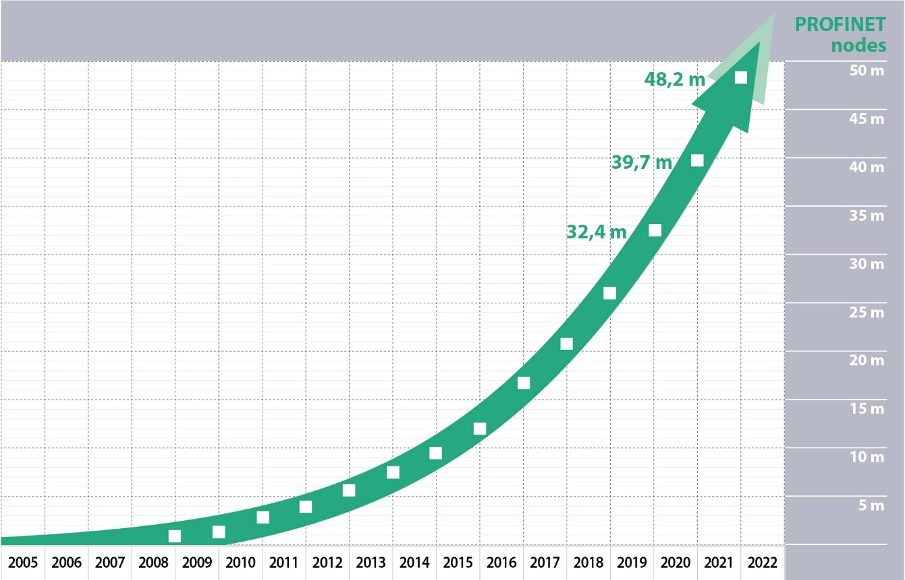
Graphic: With 6.3 million new nodes installed in 2021, IO-Link saw a growth rate of 30% – just like the previous year – and the total installed base of IO-Link devices rose to more than 27 million.

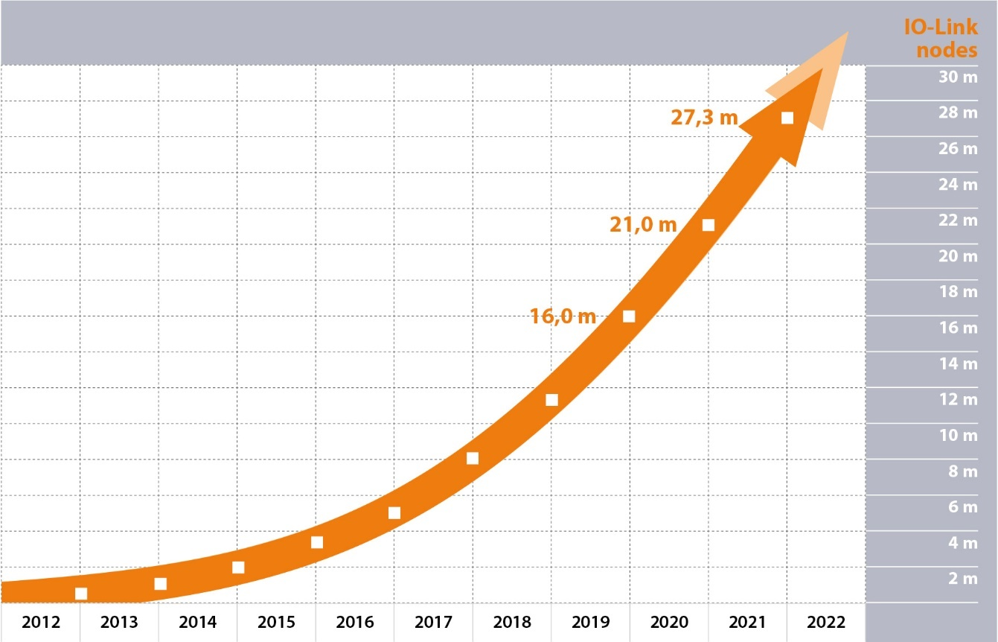

Press contact:
PI (PROFIBUS & PROFINET International)
PROFIBUS Nutzerorganisation e. V.
Barbara Weber

Haid-und-Neu-Str. 7

D-76131 Karlsruhe, Germany
Phone: +49 721 986 197 49

Fax: +49 721 986 197 11
Barbara.Weber@profibus.com
http://www.PROFIBUS.com
The text of this press release is available for download at www.profibus.com.

