Contact person:
Barbara Weber
Barbara.Weber@profibus.com
+49 721 9658-549

P R E S S R E L E A S E

The PROFINET Community Comes Together for Testing

Karlsruhe – July 21, 2017: On July 12 and 13, 2017, the PROFINET community met at Festo AG & Co. KG in Esslingen for a PROFINET Plugfest, an event providing participants with the perfect setting for practice-based testing and knowledge sharing. Some 70 developers and suppliers of basic technologies, devices, and systems representing a wide range of sectors used this opportunity to simply and directly test their latest developments in a diverse environment, including under stress conditions. Experienced specialists from the field of end-user support directed application scenarios – related to PROFIenergy, for instance – allowing for the testing of not only basic communication but also of the application view that is so vital to market success. The tests also focused on PROFIsafe, PROFIdrive, net load, and asset management.

Matthias Prinzen, of Festo, explains his involvement in the Plugfest: “Festo sees PROFINET as one of the world’s leading communication systems in the field level. Our pneumatic and electric actuators use PROFINET as a communication interface. Plugfests serve as a platform for verifying new implementations and for testing the new features of the PROFIenergy profile. Energy management is becoming increasingly important to customers – for example, with our energy efficiency module with PROFINET and PROFIenergy.”

Testing was carried out in a proven fashion in various systems ranging from small groups up to larger shared networks. Participants particularly appreciated the open exchange of experience among specification experts, device developers, and certification bodies. Joachim Probst, of Endress & Hauser Flowtec AG, confirms this point: “We have the great advantage here of connecting our devices to different control systems. This enables us to ensure that all implemented features are supported by all PROFINET controllers on the market – before making them available to customers.”

Plugfests have become an established event in the meantime, even in other countries (such as the United States and China), and will be held in Germany again next year.

***

Foto: The PROFINET community comes together for testing at Festo AG & Co. KG in Esslingen.
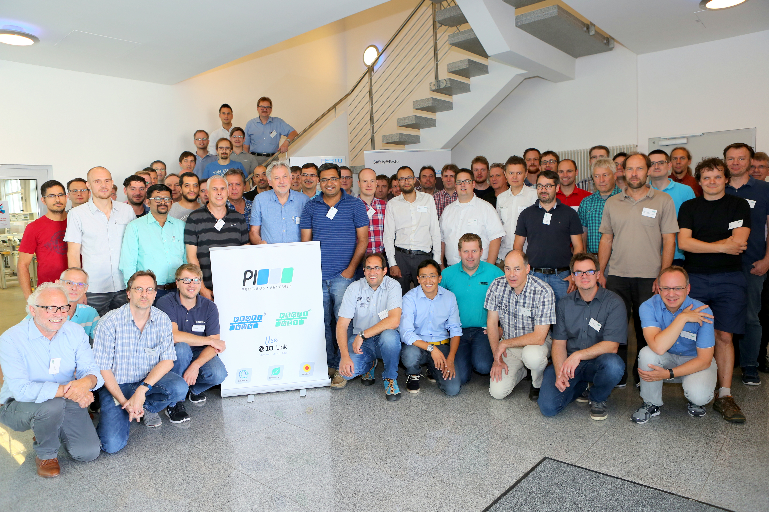
Press contact:
PI (PROFIBUS & PROFINET International)
PROFIBUS Nutzerorganisation e. V.
Barbara Weber

Haid-und-Neu-Strasse 7

D-76131 Karlsruhe, Germany
Tel.: +49 (721) 96 58 - 5 49

Fax: +49 (721) 96 58 - 5 89
Barbara.Weber@profibus.com
http://www.PROFIBUS.com
The text of this press release is available for download at www.profibus.com,

