P R E S S E M I T T E I L U N G

IO-Link Interop Workshop 2021

Karlsruhe, 12th August 2021: From the very first hour of the innovative point-to-point technology, the IO-Link community regularly organizes Interop workshops, where participants can test their new products and developments in interaction with other devices for proper function and interoperability. Due to Sars-Cov 2, unfortunately this event had to be cancelled last year.

Now, all IO-Link device and technology manufacturers will again have the opportunity to thoroughly test their new developments in a two-day Plugfest on November 3 and 4, 2021 in Bad Soden (Germany). A lot has happened with IO-Link in the last two years, so you can be excited and expect to see many new types of devices and functions.

In addition to the workshop, three expert groups will be formed on special topics, such as "Test Systems", "Profiles and System Integration" or "Data Storage". Experts from the Steering Committee and the working groups will also be available during the two days for detailed information and technical exchange.

The participation fee for the Interop workshop is 150,00 € (plus VAT). Further information and the online registration form can be found at www.io-link.com.

***

Graphic: A master / device test at an Interop workshop can also look like this - it remains exciting to see which new developments the device manufacturers will bring along this year.

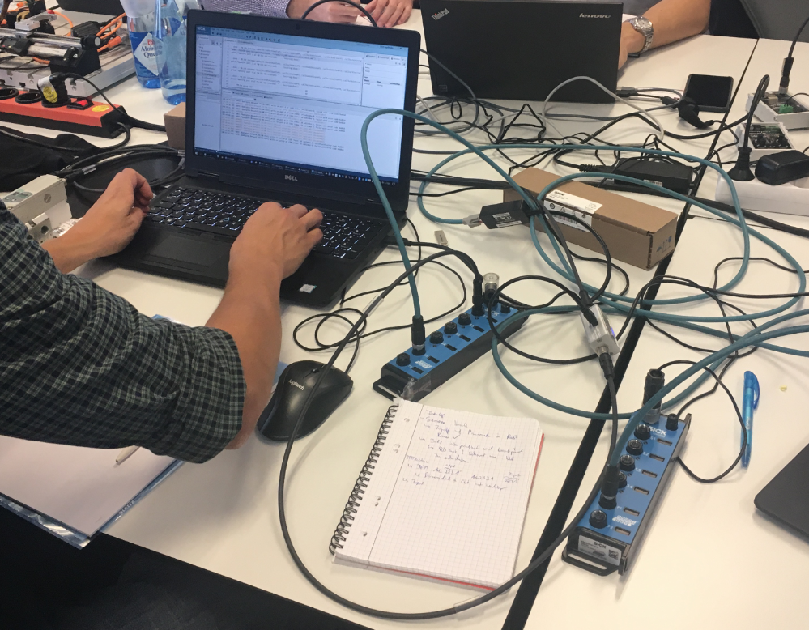

Pressekontakt:
PI (PROFIBUS & PROFINET International)
PROFIBUS Nutzerorganisation e. V.
Barbara Weber

Haid-und-Neu-Str. 7

D-76131 Karlsruhe
Tel.: 07 21 /96 58 - 5 49

Fax: 07 21 / 96 58 - 5 89
Barbara.Weber@profibus.com
http://www.PROFIBUS.com
Der Text dieser Pressemitteilung liegt unter www.profibus.com zum Download für Sie bereit.

