P R E S S R E L E A S E

PROFINET over APL is ready for use

Karlsruhe, Germany – December 12, 2023: The experts at PROFIBUS & PROFINET International (PI) have successfully completed all activities for the use of PROFINET in hazardous applications in process automation. The final step here was provision of a complete certification test for PROFINET over APL devices.

This was based on the specification documentation for the intrinsically safe physical layer for 2-wire Ethernet—that is, Ethernet APL—created as part of the cooperative effort with the FieldComm Group, ODVA and OPC Foundation organizations. At the same time, corresponding additions were made to the PROFINET specification by the PI working groups. Another component consisted of updating the GSDML specification. Previously, work which optimized the Profile for PA Devices for use in PROFINET devices in process automation had been carried out. To support simple, manufacturer-independent device replacement, corresponding profile GSDs were provided.

To ensure a high degree of interoperability between products from different suppliers from the very beginning, the Test System Development Group (TSDG) coordinated work for the provision of certification tests in a proven and recognized way. Among other things, the scope includes additional APL-specific test cases for checking PROFINET communication, the establishment of an APL-specific test setup for interoperability scenarios and the provision of a test for functions for the Profile for PA Devices. The certification tests and tools for the physical layer were provided as part of the cooperation with the organizations named above. Therefore, they are the same for all higher-level communication systems and only need to be conducted once, by agreement, for mutual recognition for the same hardware version of a product.

The certification test is therefore available to all manufacturers of PROFINET over APL devices at accredited PI test labs. The initial certificates were created in good time before SPS 2023, making PROFINET the leading Ethernet APL-based technology.

Now that certification is available, the experts at PI have successfully completed all the necessary steps—preparing PROFINET over APL for use in process automation. Meanwhile, end users have positively rated the suitability of PROFINET over APL in a host of lab installations. PI is already working on the next issue in coordination with end users from the process industry: functional safety with PROFIsafe.

***

Graphic: The first Ethernet APL certificate for the iTEMP temperature transmitter from Endress + Hauser was presented to Harald Müller at the SPS show in Nuremberg, Germany, in November. (left to right: Peter Wenzel (PI), Harald Müller (E+H) and Xaver Schmidt (PI))
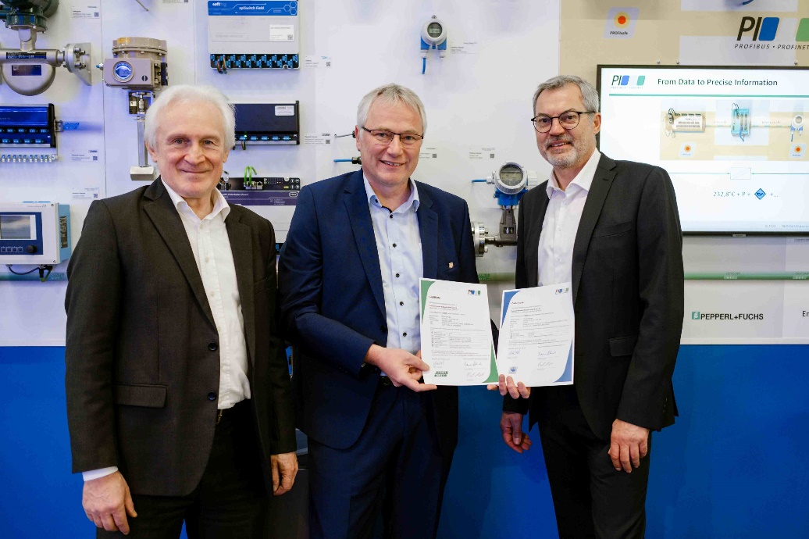

Press contact:
PI (PROFIBUS & PROFINET International)
PROFIBUS Nutzerorganisation e. V.
Barbara Weber

Ohiostr. 8

D-76149 Karlsruhe, Germany
Phone: +49 7 21 986197 49

Fax: +49 7 21 986197 11
Barbara.Weber@profibus.com
http://www.PROFIBUS.com

