Contact person:
Barbara Weber
Barbara.Weber@profibus.com
+49 721 9658-549

P R E S S R E L E A S E

Integration of IO-Link into OPC UA

Karlsruhe, August 30th, 2017: The IO-Link community has founded a technical working group for specifying the integration of IO-Link into OPC UA based on existing use cases. The Industry 4.0 platform sees OPC UA (from OPC Foundation) as a suitable architecture model for implementing consistent integration of IT on the field level. This is why a corresponding standard for a data and function model is now being developed within the framework of the IO-Link community so as to accurately represent future IO-Link Devices and IO-Link Masters in OPC UA. This approach follows the general recommendation for developing OPC UA Companion Standards.

Over the past few years, IO-Link as a point-to-point protocol for sensors and actuators has been able to solidly establish itself and increase its presence. It is manufacturer independent (and thus field bus independent), has come to support more than 4,500 devices and enjoys steadily increasing acceptance.

Through the use of corresponding logic, so-called "IO-Link Masters", IO-Link sensors and actuators can be connected to the various different field bus systems without further adjustment. Such masters can even be economically integrated into simple devices today. IO-Link thus offers the opportunity to access a very broad range of sensors and actuators in a standardized way and fieldbus independent.

As Industrie 4.0 efforts progress, it is also necessary to semantically incorporate IO-Link Devices into systems on a higher level than the field bus in order to evaluate sensor data. This functionality is often designated as a "sensor to the cloud" to express that sensor data is analyzed by IT systems outside the automation process. In this way, sensor data can also be seamlessly linked to MES and ERP systems.

The goal of this new IO-Link/OPC UA working group (C4/PG51), lead by Michael Tiegelkamp (TE Connectivity), is to complete a final proposal for the Companion Specification (draft for voting) before the end of 2018.

***
Graphic: A final proposal for the companion specification is to be available before the end of 2018.
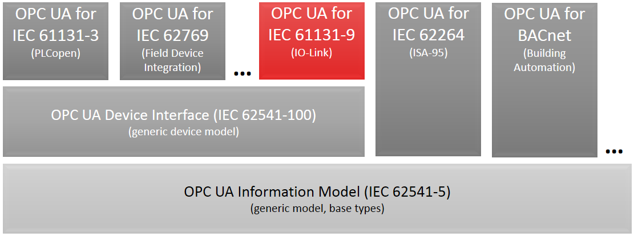
Press contact:
PROFIBUS Nutzerorganisation e. V.
PI (PROFIBUS & PROFINET International)
c/o IO-Link Community
Barbara Weber

Haid-und-Neu-Strasse 7

D-76131 Karlsruhe, Germany
Phone: +49 (721) 96 58 - 5 49

Fax: +49 (721) 96 58 - 5 89
Barbara.Weber@profibus.com
http://www.PROFIBUS.com
The text of this press release is available for download at www.profibus.com.

