Contact person:
Barbara Weber
Barbara.Weber@profibus.com
+49 (721) 9658-549

P R E S S R E L E A S E

First results on the way to Industrie 4.0 with PROFINET

Nuremberg, November 23, 2016: PI (PROFIBUS & PROFINET International) is making good progress with the subject Industrie 4.0. Main work is done in the teams of the PI working group „I4.0@PI“ set up for individual topics. The requirements are closely harmonized with the users and the senior experts in the various companies.

For a practice-oriented further development of the successful communications standards, a deep understanding of the continuous enhancement of the user’s requirements and the innovative Industrie 4.0 scenarios is needed. For this reason, use cases have been developed, assessed and harmonized first in the working group. In the next step, an examination was carried out of new communication technologies and standards in the environment of Industrie 4.0.

The combination of requirements and technical possibilities has resulted in the main areas of focus of TSN, IPv6, Semantics, Security and OPC UA. Currently these are discussed in the teams set up. The solutions established are issued in white papers and concepts.

The integration of TSN aims in a definition of an ideal image of PROFINET on TSN. The advantage of PROFINET will be its participation in the technical progress of standard Ethernet technology. With respect to IPv6, the characteristic features of auto-addressing and name concept play an important role. At present this is being developed in a corresponding concept. The Semantics Team has set itself the objective of integrating the existing PROFINET features in the standard, whereby the most important definitions can be selected of the underlying standards eCl@ss and Automation ML. In case of Security the security features are defined by means of requirements and use cases. The possibilities of using OPC UA are determined in cooperation with the OPC Foundation. As for PROFINET the TCP/IP communication is always integrated in parallel, thus PROFINET offers a lot of flexibility.

Even with a high involvement of the members, time is needed for working out detailed preparations of sensible and practice-oriented standards - first white papers are expected for Hannover Fair 2017. On account of the examinations, it can be determined already today that the available PI technologies are and remain a sound basis, but also enable a future-proof step.

***

Graphic: PROFINET – The standard for industrie 4.0
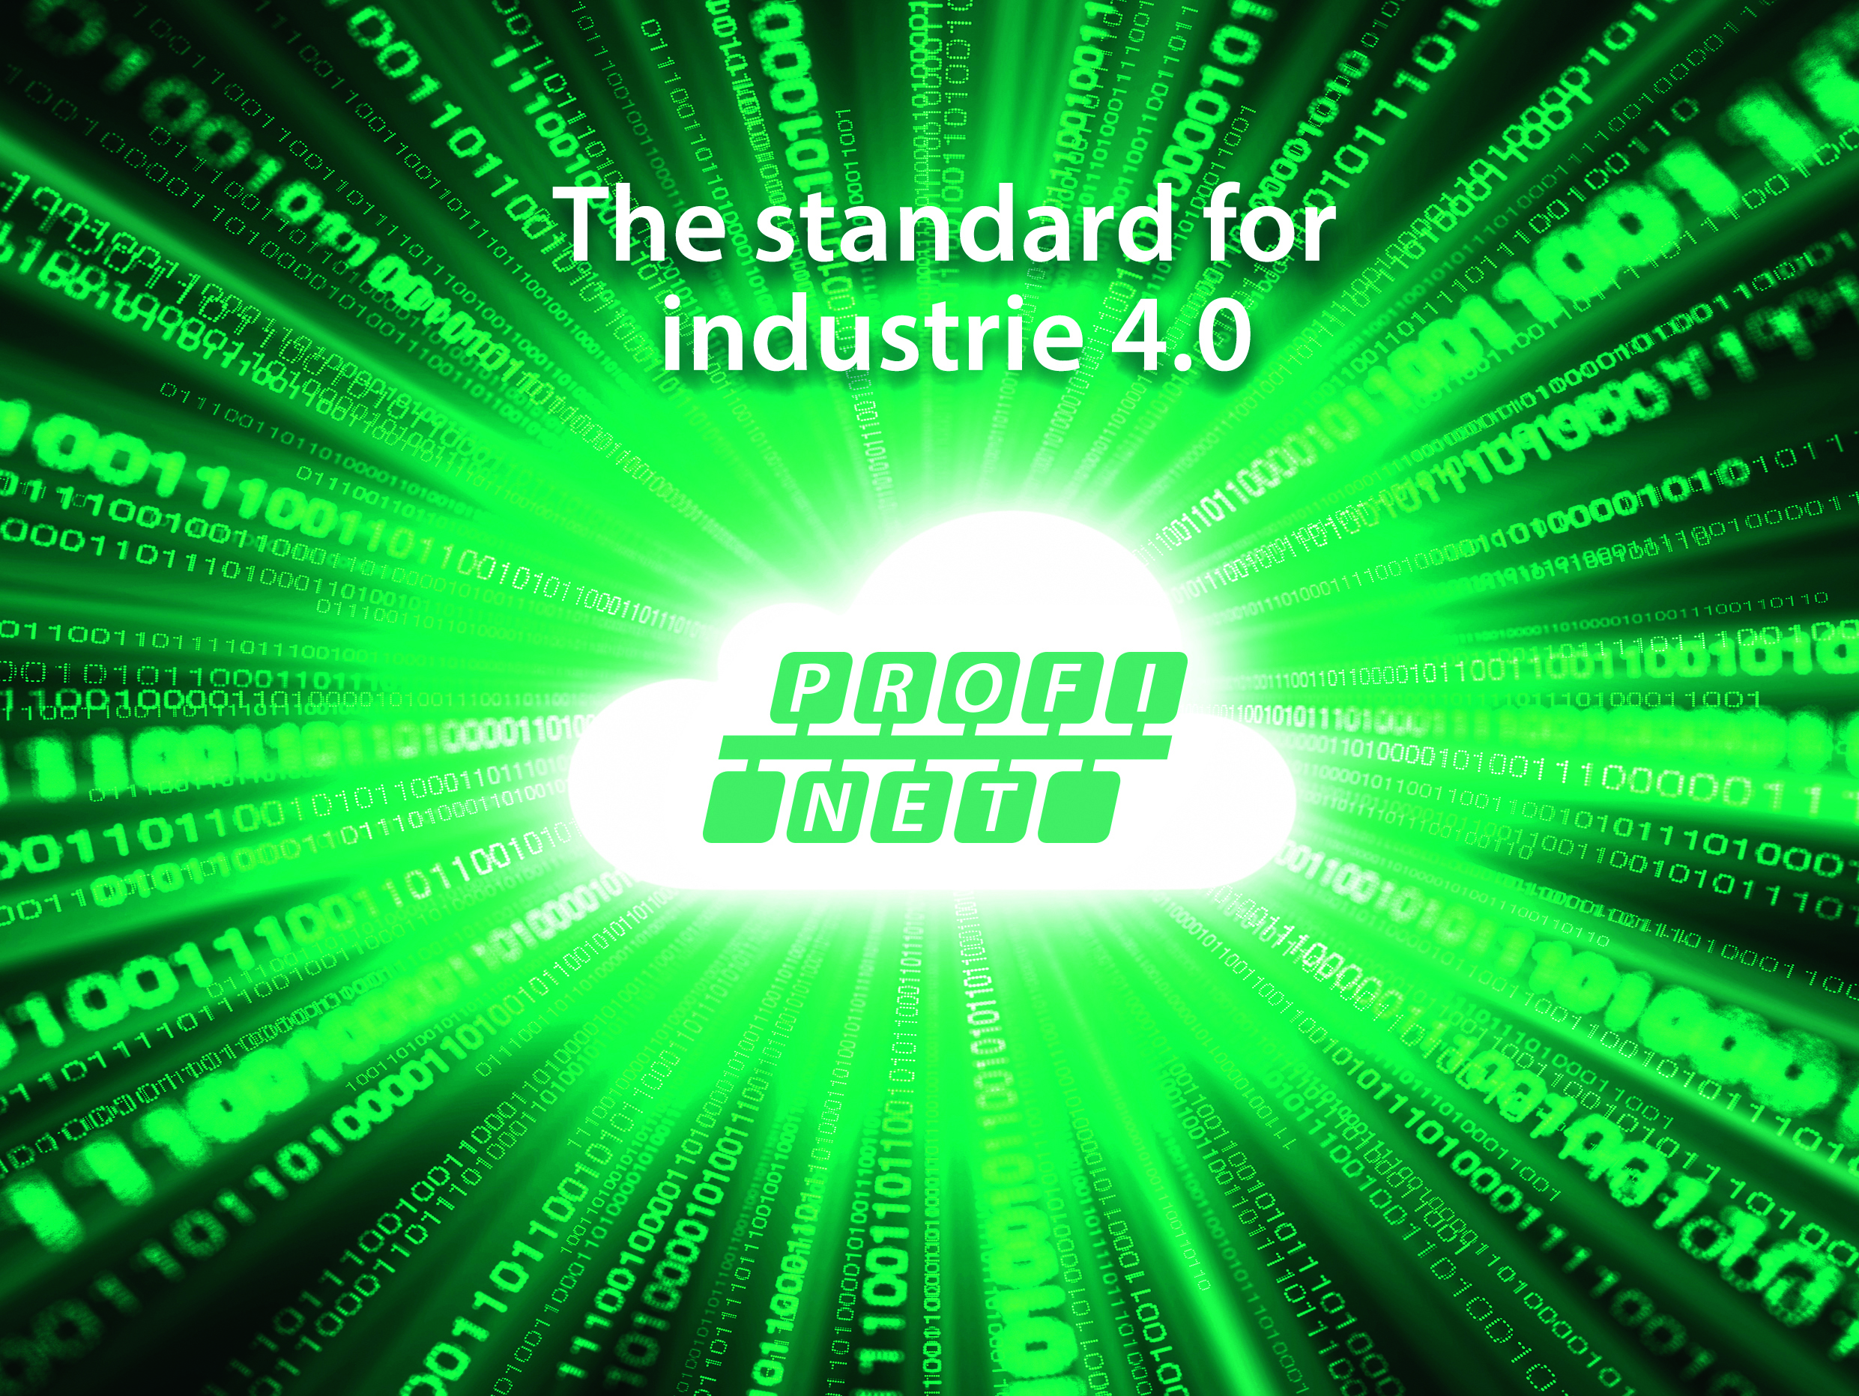

Press contact:
PI (PROFIBUS & PROFINET International)
PROFIBUS Nutzerorganisation e. V.
Barbara Weber

Haid-und-Neu-Strasse 7

D-76131 Karlsruhe, Germany
Phone: +49 (721) 96 58 - 5 49

Fax: +49 (721) 96 58 - 5 89
Barbara.Weber@profibus.com
http://www.PROFIBUS.com
The text of this press release is available for download at www.profibus.com,

