Contact person:
Barbara Weber
Barbara.Weber@profibus.com
+49 (0) 721 9658-549

P R E S S R E L E A S E

PI Konferenz sees record attendance

Karlsruhe, Germany – March 26, 2019: The 2019 PI Konferenz, which was held in Frankfurt/Germany at the House of Logistics and Mobility (HOLM) on March 19 and 20, set a new record for attendance. More than 340 interested persons took up the invitation to learn about the PI technologies of today and tomorrow.
According to Chairman Karsten Schneider, the main question of the PI community is how to develop a vision for the future which builds upon the infrastructure we have today, i.e. the more than 86 million PROFIBUS and PROFINET nodes installed in the field. “The task now is to transfer this tried-and-tested technology to the world of Industry 4.0.”
Consequently, every important topic was covered at the conference, from the combination of PROFINET and OPC UA to the supplementing of PROFINET to include TSN technologies to work being carried out on the APL (advance physical layer) and vertical & horizontal integration. This shows that PI has already begun to work on the comprehensive spectrum of topics for ultimately making the Industrial Internet of Things a reality.
It became clear here, for example, that semantics and information models will play a decisive role in the future. “Industry 4.0 concepts won’t even be possible at all until the data is understood by everyone,” said Schneider in reference to the current challenge. PI is not only working closely together with eCl@ss, but is developing application-specific information models in cooperation with the OPC Foundation as well. Against this backdrop, corresponding companion specifications which put standards in the hands of users on the path to the world of Industry 4.0 are currently being devised. These specifications were also presented at the PI conference, including a new white paper on the topic of security. This was rounded out with the start of activities relating to 5G. At 55 presentations and discussions with experts, both users and manufacturers were able to get concrete information on necessary and sensible steps in development.
Despite all the work still required to complete the big picture of PROFINET@I40, the basic foundations were already laid decades ago. This includes binding compliance with standards, a clear-cut decision for a modular architecture and openness to TCP/IP. This is what makes it possible to implement innovative Industry 4.0 concepts on top of existing installations and to put practical solutions into the hands of users today.
Presentations on 5G, LNI 4.0, standardized information models and data security also illustrated the fact that openness to a longer-term future is also well worth it. Statements by best-selling author Frank Schätzing, which provided an outlook on how artificial intelligence may develop, also resulted in some exciting ideas – certainly a source of inspiration for the next PI conference in two years.

***
Photos: Impressions of the 2019 PI Konferenz
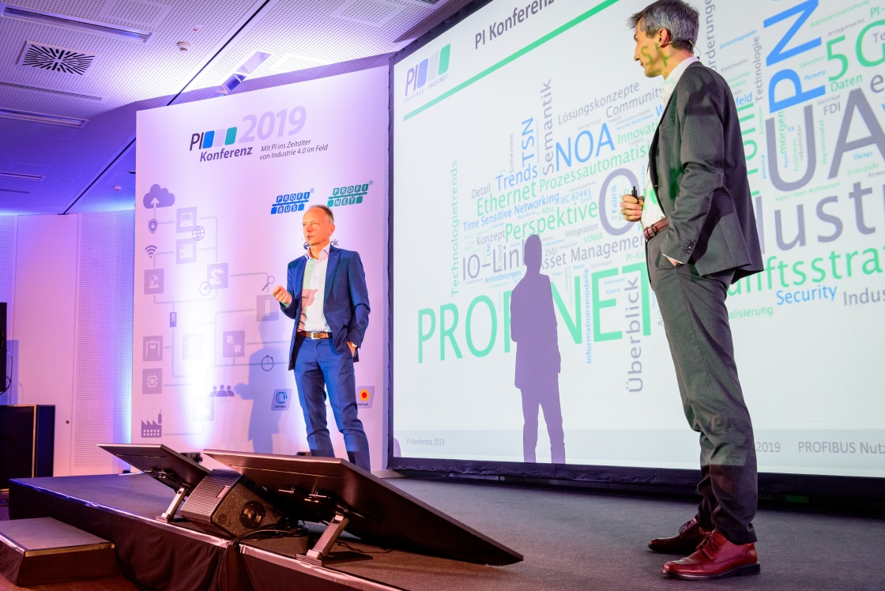
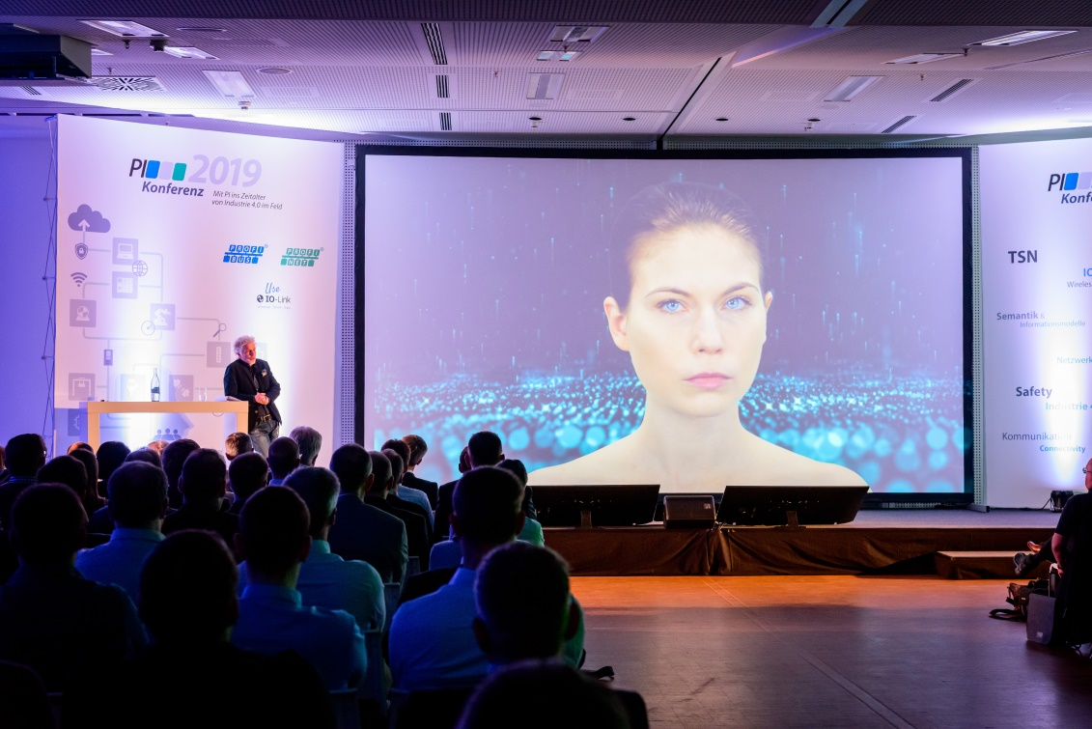
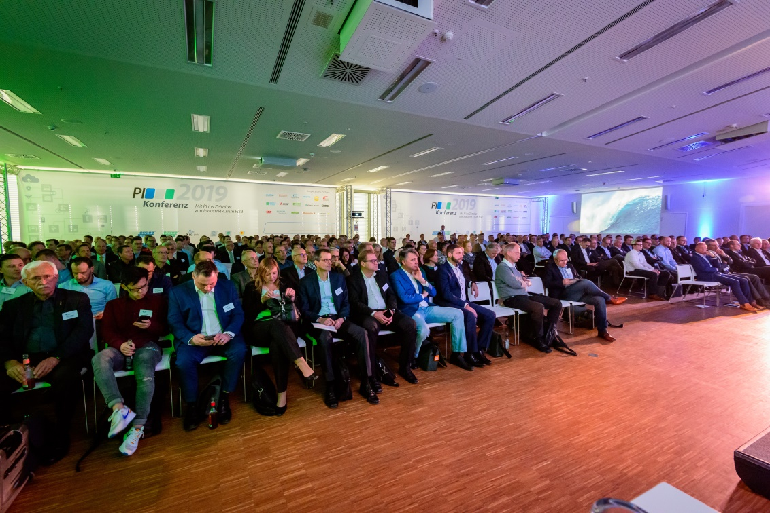
Press contact:
PI (PROFIBUS & PROFINET International)
PROFIBUS Nutzerorganisation e. V.
Barbara Weber

Haid-und-Neu-Strasse 7

D-76131 Karlsruhe, Germany
Phone: +49 (0) 721/96 58 - 5 49

Fax: +49 (0) 721/96 58 - 5 89
Barbara.Weber@profibus.com
http://www.PROFIBUS.com
The text of this press release is available for download at www.profibus.com.

