P R E S S R E L E A S E

PI presents everything about digitalization at SPS 2022

Karlsruhe, Germany – October 17, 2022: The experts of the PI Community are looking forward to meeting their customers and interested parties in person at SPS from 8 to 10 November 2022 at booth 210 in Hall 5. Covering an area of more than 260 m², we will once again showcase numerous innovations at our joint booth of PROFIBUS & PROFINET International (PI) with numerous co-exhibitors. Digitalization is driving technology development at PI. The requirements from the various user industries are setting the direction for the further development of new and existing technologies in the fields of industrial communication and data continuity.

TSN and OPC UA for PROFINET play a key role here. In this context, integrated modern security concepts are becoming a must for all automation systems. Trade fair visitors will experience live demos and presentations on the topics of TSN, security and PROFINET over OPC UA. Among them is a special highlight this year. The new TSN demo offers visitors not only the new technical implementation but also a greater variety of products.

With Ethernet-APL, Ethernet-based communication systems can be used in process automation without any restrictions. With the completion of the specifications and guidelines, everything is set for PROFINET over APL to be used in the relevant industries. The Process Automation live demo provides an overview of the PROFINET process automation products available on the market. A new addition is a series of PROFINET products with an Ethernet-APL physical layer. Visitors will have the opportunity to interactively operate a plant structure based on PROFINET and PROFIBUS PA. In addition, the wide variety of PI technologies will be demonstrated on the Factory Automation Wall using numerous different products as examples. The advantages of the PROFIdrive application profile in the respective application classes will also be presented with an interoperability demo, and IO-Link will again be on show with a large number of different products from numerous manufacturers.

The topic of functional safety will be presented with a PROFIsafe live demo and an OPC UA Safety live demo. At the IO-Link Safety Wall, IO-Link presents FS master and FS device products as well as development aids and pre-certified stacks. A new feature is an IO-Link Safety live demo, which provides a hands-on demonstration of the functionality.

For the first time at this year's SPS, PI will be presenting omlox, the locating technology newly added to the industrial communication portfolio. Together, the community members will present the first open locating technology based on ultrawideband as well as a series of use cases. In addition, visitors will get first-hand information on the MTP technology, which was recently added to PI's technology portfolio. MTP can be used to build complex production systems in a modular way and is highly flexible with regards to their reconfiguration.

For more information on the joint PI booth, exhibitors and obtaining visitor tickets, go to https://www.profibus.com/sps.

***

Graphic: Visitors can look forward to many new demos at the joint PI booth at SPS.
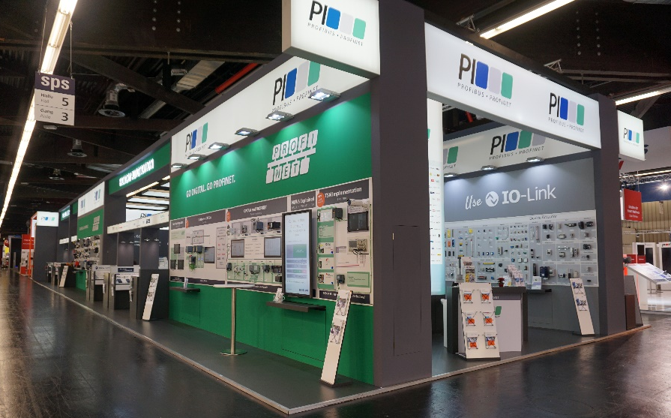
Press contact:
PI (PROFIBUS & PROFINET International)
PROFIBUS Nutzerorganisation e. V.
Barbara Weber

Haid-und-Neu-Str. 7

D-76131 Karlsruhe, Germany
Phone: +49 07 21 986 197-49
Fax: +49 7 21 986 197-49
Barbara.Weber@profibus.com
http://www.PROFIBUS.com
The text of this press release is available for download at www.profibus.com.

