Contact person:
Barbara Weber
Barbara.Weber@io-link..com
+49 (721) 9658-549

P R E S S R E L E A S E

IO-Link Wireless specification completed

Karlsruhe, Germany – April 11, 2018: IO-Link is the first technology for communicating with sensors and actuators below the fieldus level to be adopted as an international standard (IEC 61131-9). This technology has now been expanded to include wireless communication.

The IO-Link community has completed work on the specifications for IO-Link Wireless and will publish an approved version at the 2018 Hanover Trade Show. IO-Link Wireless technology will be presented to the broader public in the form of a demonstration at the joint PI booth in Hanover, Germany (Hall 9, D687) for the first time.

IO-Link Wireless defines wireless communication between sensors/actuators and controllers (PLC) in the industrial automation environment. Performance, functionality and capacity are comparable to cable-bound solutions.

IO-Link Wireless offers real-time latency of 5 ms for communication with up to 40 devices (sensors and actuators). Reliability lies above a packet-error rate (PER) of 10⁻⁹, while the rates of other comparable wireless standards, such as WLAN, Bluetooth and Zigbee, are around 10⁻³. IO-Link Wireless supports roaming functions and the option of using battery-operated or energy-harvesting sensors with minimal energy consumption in a real-time network. A key feature of IO-Link Wireless is its compatibility with industry- and process-automation protocols. Planning, commissioning, operation and maintenance can all be carried out using standard IO-Link tools. This guarantees backward compatibility with cable-bound IO-Link systems.

In parallel with the specification work, the necessary test specifications and test scenarios needed when the first suppliers develop their components for the new system are already being defined in the IO-Link wireless working group. The IO-Link community will also be holding an IO-Link Wireless developer workshop at Helmut-Schmidt-Universität (HSU) in Hamburg, Germany in June of 2018. This workshop will enable interested device manufacturers to develop IO-Link Wireless components in a fast and straightforward way.

***
Graphic:

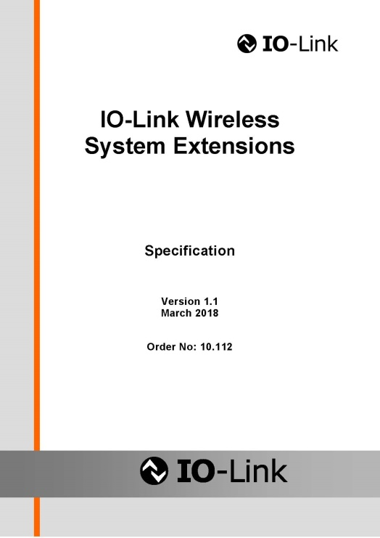

Press contact:
PI (PROFIBUS & PROFINET International)
PROFIBUS Nutzerorganisation e. V.
Barbara Weber

Haid-und-Neu-Strasse 7

D-76131 Karlsruhe, Germany
Phone: +49 721 96 58 - 5 49

Fax: +49 721 96 58 - 5 89
Barbara.Weber@profibus.com
http://www.PROFIBUS.com
The text of this press release is available for download at www.profibus.com,

