Contact person:
Barbara Weber
Barbara.Weber@profibus.com
+49 (0) 721 9658-549

P R E S S R E L E A S E

Into the world of wireless with IO-Link

IO-Link Wireless completes the big picture for IO-Link

Karlsruhe, Germany – July 3, 2018: At the end of June this year, an IO-Link Wireless workshop at Helmut-Schmidt University in Hamburg, Germany concluded with great success. More than 60 participants learned about IO-Link Wireless over the course of two days. The goal was to give participants a greater understanding of the technology and put them in a position to develop IO-Link Wireless devices themselves through the use of practical demonstrations and interactive workshops. The group of participants was made up of both developers from many well-known device manufacturers and the technology representatives of a variety of end users.
Since the IO-Link Wireless system extensions specification passed all internal reviews of the IO-Link Community and was approved in March of 2018, all indications point toward a green light. The specification is now available to all device manufacturers worldwide so that IO-Link Wireless can be implemented in practice.
At the workshop, a wide variety of different technology providers gave an introduction to IO-Link Wireless and demonstrated the technologies which are already available. This included evaluation boards and diagnostic software, as well as consulting and testing expertise, for example. “From past experience, we know how important aspects of the certification program are, that is, the development of a test specification, offers to support developers etc. This is the only way a new technology can become sustainably established,” said Stephan Langer, who heads up the IO-Link Wireless marketing working group. “This has also been confirmed in many discussions outside the presentations.”
IO-Link Wireless is an important pillar of the big picture, i.e. for guaranteeing data consistency from the sensor to the cloud. This plays a large role primarily for production systems of the Industry 4.0 generation and the frequently discussed new business processes, where sensor data is a valuable raw material.

***
Foto: Delving deeply into the topic at workshops and laboratory demonstrations proved the robustness and reliability of IO-Link Wireless in practice to participants.
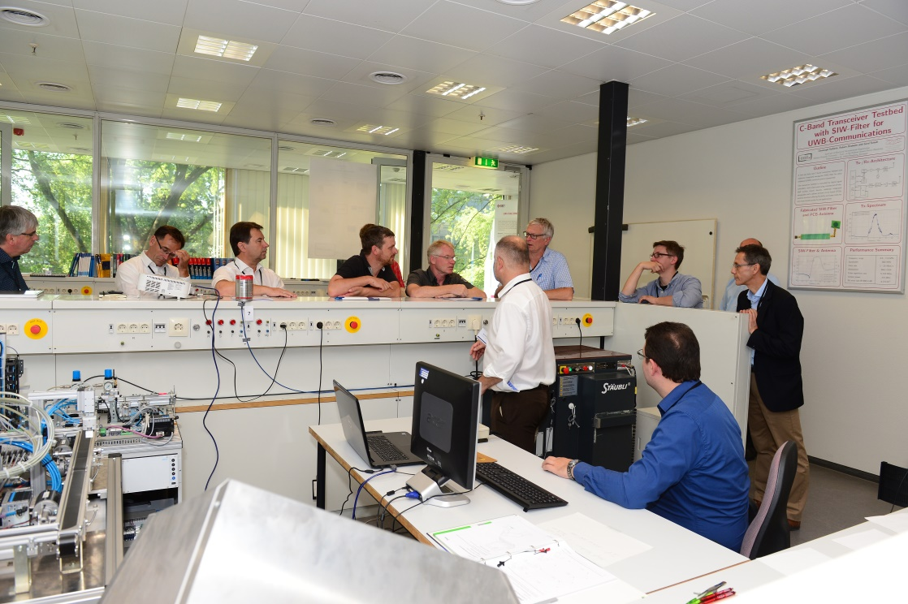
Press contact:
PI (PROFIBUS & PROFINET International)
PROFIBUS Nutzerorganisation e. V.
Barbara Weber

Haid-und-Neu-Strasse 7

D-76131 Karlsruhe, Germany
Phone: +49 (0) 7 21/96 58 - 5 49

Fax: +49 (0) 7 21/96 58 - 5 89
Barbara.Weber@profibus.com
http://www.PROFIBUS.com
The text of this press release is available for download at www.profibus.com.

