P R E S S R E L E A S E

omlox to premier at Logimat
Karlsruhe, Germany – March 24, 2022: After a nearly two-year break from trade fairs, PI (PROFIBUS & PROFINET International) is especially looking forward to its trade shows appearances in 2022. It will be represented with a stand (hall 6/G34) at Logimat in Stuttgart, Germany from May 31 through June 2, 2022 for the first time, where it will be presenting the new omlox tracking standard.

Logimat is one of the largest European trade fairs in the field of distribution, material flow and information flow. It provides an overview of everything that moves the intralogistics industry – from acquisition to production to delivery. omlox, the world’s first open tracking standard, is not to be missed here.

The omlox technology is an open and interoperable standard which is revolutionizing real-time localization and therefore represents a milestone for companies on the path to Industry 4.0. The focus here lies on open interfaces for an interoperable localization system. With omlox, products from different manufacturers can be networked in a core zone for the first time. The omlox hub then links a wide variety of different tracking technologies with one another. This enables manufacturer-independent tracking of all moving objects – like load carriers, spare parts and tools – in closed rooms.

PI will be providing comprehensive insight into the omlox tracking technology with the first live demo at the omlox stand at Logimat. Member companies will also be exhibiting the first omlox products.

For more information on the new tracking standard, visit https://www.omlox.com.
***

Graphic: PI to present the new omlox tracking standard at Logimat 2022.

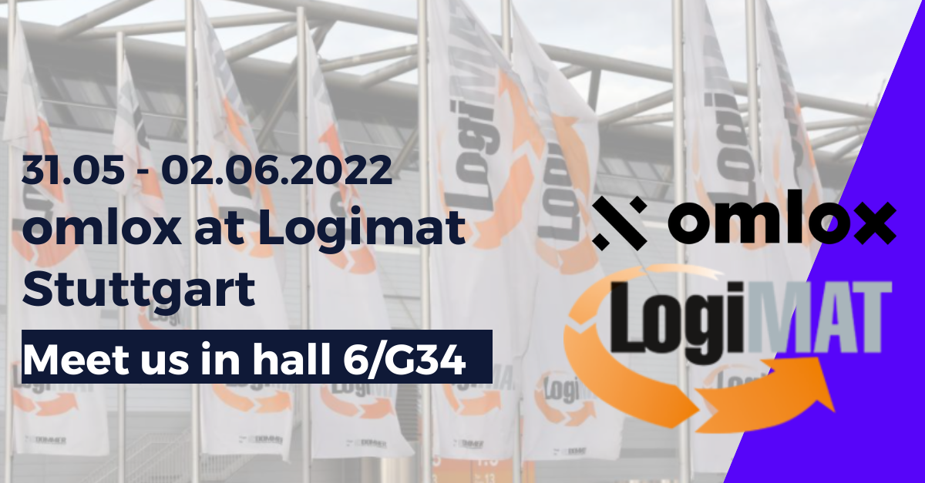

Press contact:
PI (PROFIBUS & PROFINET International)
PROFIBUS Nutzerorganisation e. V.
Barbara Weber

Haid-und-Neu-Str. 7

D-76131 Karlsruhe
Tel.: 07 21 /986 197 - 49
Barbara.Weber@profibus.com
http://www.PROFIBUS.com
The text of this press release is available for download at www.profibus.com.

