P R E S S R E L E A S E

Record PROFINET and IO-Link numbers

Karlsruhe, Germany – April 17, 2023: The annual notarial recording of installed products with interfaces using technology from PROFIBUS & PROFINET International (PI) yielded very positive numbers for 2022. This is especially true for PROFINET and IO-Link, but PROFIsafe achieved a considerable increase over the previous year as well.

In the case of PROFINET, the count yielded a never-before-seen number of 10.5 million nodes. In 2022, 2 million more PROFINET devices were put on the market than in 2021. This corresponds to an increase of 23.5% over the previous year. Altogether, a total of 58.7 million PROFINET products have been installed in systems over the years.

In the case of IO-Link, 8.4 million IO-Link nodes were integrated into systems over the past year. This means that 2.1 million more nodes were installed than in the previous year (2021), which corresponds to an increase of 33% over that year's number. In all, a total of 35.7 million IO-Link nodes was reached by the end of 2022.

"These numbers and the trends of previous years impressively prove that our technology hasn't just arrived on the market, but will remain a market leader for the long term," said Karsten Schneider, PI Chairman, with delight. "We made the right decisions, our experts in the working groups did an outstanding job and member companies implemented a large number of marketable products. For this, I would like to thank the entire community," said Schneider.

Another highly successful technology is PROFIsafe. The highest value ever in one year of 2.8 million nodes was reached in 2022. This brings the total number to 21.7 million. With a count of 1.5 million new devices for the year, PROFIBUS reached the same number as the previous year. The situation was similar with PROFIBUS numbers in process automation. With a count of 0.8 million in 2022, the value remained stable compared to the previous year. Accordingly, a total of 67.4 million PROFIBUS devices were put on the market, with 15.4 million of them having been installed in processing plants.

To maintain this trend over the next few years, the entire PI community is working on further establishing PI technology as an enabler for digitalization in industrial automation applications. The marketing working groups are continually coordinating the requirements for the various different areas of application with end users, and the technology working groups are working intensively to implement them in corresponding innovations. These innovations not only involve the expansion of existing technology, such as the integration of Ethernet-APL into PROFINET, but the inclusion of new technologies which advance digitalization as well. Examples here include the omlox localization standard for applications in buildings and Modular Type Package (MTP).

***

Graphic: The annual node count yielded a record number for PROFINET. In 2022, 10.5 million new devices were put on the market.
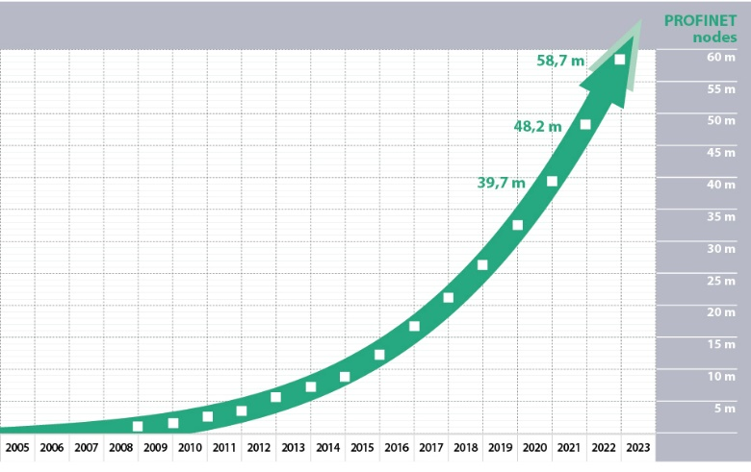

Graphic: IO-Link technology has been growing rapidly for many years. 2022 saw an increase of 33%. The total number of installed nodes has grown to 35.7 million.
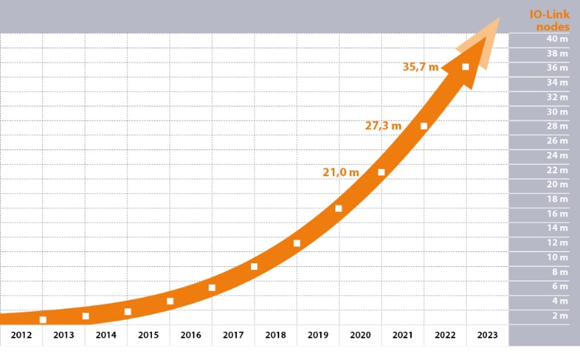

Press contact:
PI (PROFIBUS & PROFINET International)
PROFIBUS Nutzerorganisation e. V.
Barbara Weber

Haid-und-Neu-Str. 7

D-76131 Karlsruhe, Germany
Phone: +49 721 986 197 49
Barbara.Weber@profibus.com
http://www.profibus.com
The text of this press release is available for download at www.profibus.com.

