Contact person:
Barbara Weber
Barbara.Weber@profibus.com
+49 721 9658-549

P R E S S R E L E A S E

IO-Link Safety Specification Released

Hanover - Germany – April 25, 2017: With the release and publication of the IO-Link Safety specification by the IO-Link Community and the successful concept assessment by the TÜV SÜD, nothing else stands in the way of implementation in systems and devices.

Like IO-Link, IO-Link Safety is also fieldbus and system-independent. This is achieved through conversion of the many safety protocols available on the market to IO-Link Safety in the master. Thus the IO-Link Safety Devices remain available worldwide. As there are considerably more device types (already more than 4,000) than IO-Link masters, the advantages are obvious. To open a new market or a new system for IO-Link Safety, all that is necessary is to develop a corresponding IO-Link Safety master. All existing IO-Link Safety devices can then be used without modification.

The time and effort for configuring IO-Link Safety is minimal. The authentication is derived from the assignment to the master port, and the monitoring time is set automatically for each device. As with IO-Link, devices can be replaced without using an engineering tool. A replaced device is automatically assigned the stored parameters of its predecessor after startup. Furthermore, the authentication rules out both confusions and manipulations.

A significant challenge is open and secure parameterization of safety devices. IO-Link Safety devices always have an IODD device description, which contains the complete communication properties, identification, parameterization, and diagnosis. However, the applicable standards require a “dedicated safety tool” to rule out manipulations. Therefore, a software interface exists for integrating the dedicated tools associated with the devices into the IO-Link engineering tools. The Device Tool Interface (DTI) has been kept very simple and ensures that integration into the existing IO-Link engineering tools does not pose a problem and that safety-related device software can be easily adapted and used further on the device side.

In the process, it is important that the package consisting of the IO-Link Safety device, IODD, and the “dedicated tool” can be used globally in all system environments without modification. Thus users can access a broad range of devices – regardless of what automation system they use or in what industry and region they work.

On the basis of the existing specification, manufacturers can now begin to integrate IO-Link Safety into their systems. The test specification, the test system, and the certification are being developed in parallel. Therefore, although products are not yet expected in 2017, a rapid rollout is anticipated subsequently, especially in Asia and Europe.

***

Graphic: The IO-Link Safety Specification has been released. Manufacturers can now begin to integrate IO-Link Safety into their systems.

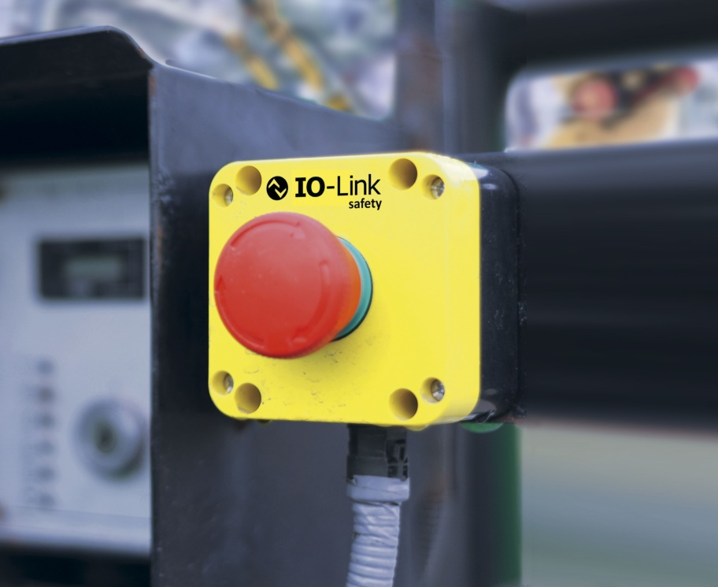

Press contact:
PI (PROFIBUS & PROFINET International)
PROFIBUS Nutzerorganisation e. V.
Barbara Weber

Haid-und-Neu-Strasse 7

D-76131 Karlsruhe, Germany
Tel.: +49 (721) 96 58 - 5 49

Fax: +49 (721) 96 58 - 5 89
Barbara.Weber@profibus.com
http://www.PROFIBUS.com
The text of this press release is available for download at www.profibus.com,

