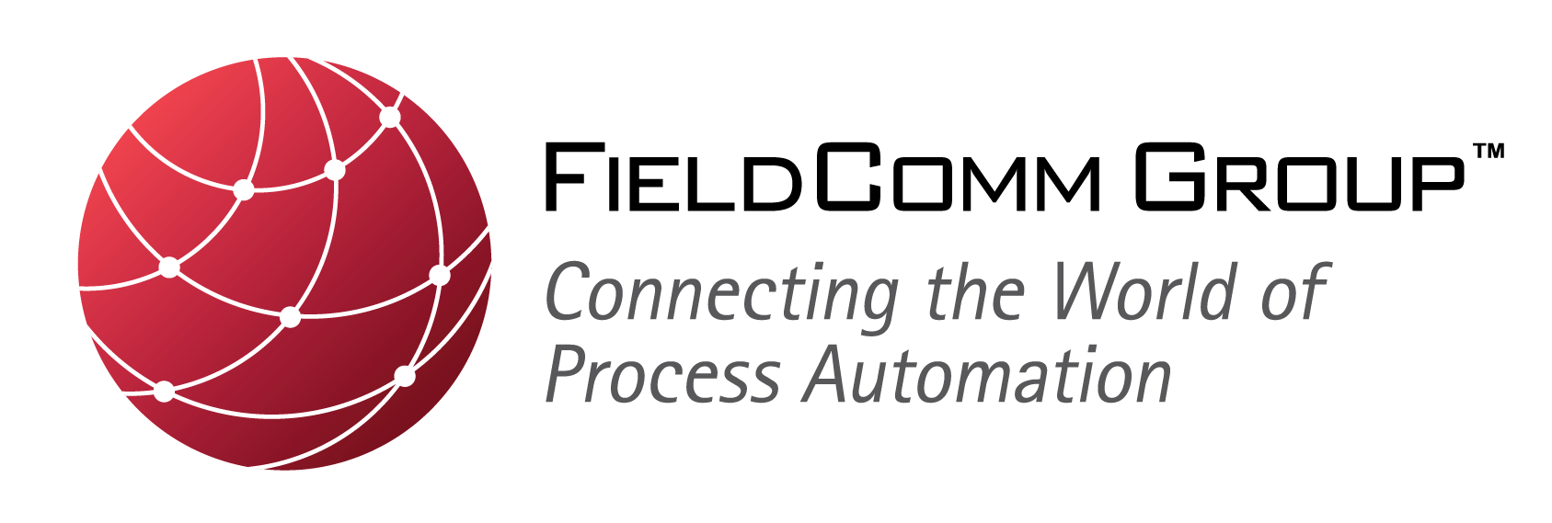

For Immediate Release

FieldComm Group, ODVA and PI Provide Joint Update on an Advanced Physical Layer for Industrial Ethernet

Organizations are cooperating to promote developments for Industrial Ethernet to expand use of EtherNet/IP™, HART-IP™ and PROFINET™ into hazardous locations in the process industry

Bad-Neuenahr, Germany — 8 November 2017 — The organizations FieldComm Group, ODVA and PI (Profibus & Profinet International) joined together to provide an update on the current status of future technology and standards for an advanced physical layer for Industrial Ethernet that will be suitable for use in demanding applications in process instrumentation, commonly referred to as “APL.” Their briefing explained industry activities and the projected timeline to realize an advanced physical layer for Industrial Ethernet - as intrinsically safe, single-pair and long-reach - for use with process automation field devices. The organizations were joined by representative from suppliers of process instrumentation and controls in order to provide a well-rounded perspective on the benefits of an advanced physical layer for end users in the process industries, as well as discuss the actions being taken to complete the work needed to realize APL in process field devices.

The organizations, in combination with process automation and instrumentation suppliers, are seeking to leverage the work currently underway in the IEEE 802.3cg Task Force, which is developing amendments to the IEEE 802.3 Ethernet standard for an Ethernet physical layer operating at 10 Mb/s over single-pair cable with power delivery, and additional developments being done by the suppliers to define the requirements and develop the necessary technology to achieve an Industrial Ethernet suitable for use in hazardous locations up to Zone 0, Division 1.

Together, the organizations and suppliers have formed a steering committee to coordinate the overall work effort to achieve and promote an advanced physical layer for EtherNet/IP, HART-IP and PROFINET. Dr. Jörg Hähniche, chairperson of the steering committee and employee of Endress+Hauser, Mr. Stefan Lüder, project manager for the advanced physical layer activity and employee of Siemens, Mr. Ted Masters, president of the organization FieldComm Group, Ms. Katherine Voss, president of the organization ODVA, and Mr. Karsten Schneider, chairman of the organization PI, shared in delivering the update.

“APL will be a significant advancement for our industry by extending existing Ethernet technology to address our traditional two-wire topology and intrinsic safety,” stated Ted Masters, president of FieldComm Group. “Like today, multiple protocols will be used in all facilities, but with the added capabilities of APL and Ethernet based technologies. With integration through FDI and its information model, our industry can now shift their focus from the protocol to capture value of the information provided by field devices.”

“EtherNet/IP has proven to users that it offers significant benefits in performance, ease-of-use, interoperability and its substantial ecosystem of suppliers,” said Katherine Voss, president of ODVA. “EtherNet/IP is future-ready to take advantage of the many exciting developments coming to Industrial Ethernet including single-pair Ethernet which will offer simplified and lower-cost connection schemes for users in a variety of applications. Users in the process industry will be one of the biggest beneficiaries of the future advanced physical layer technology.”

“Industrie 4.0 driven innovations, in particular, Ethernet-based communication systems are the main driving force for increasing the profitability of process industries, whose production systems have to work for years without interruption in rough environments,” added Karsten Schneider, chairman of PI. “Today, there is still a need for a solution with which PROFINET devices can also be provided for use in hazardous areas based on two-wires and supplying power over the line. This is why PI pushes the implementation of APL – the corresponding physical layer for Ethernet communication – being created in a joint project with well-known industrial companies and organizations.”

Based on timelines published by the IEEE 802.3cg Task Force, the organizations expect that enhancements to the IEEE 802.3 standard for long-reach, single pair Ethernet will be complete in 2019 and available for integration into their respective Ethernet specifications in 2020. Combined with the additional activities of the process automation and instrumentation suppliers to accelerate development of technology for an advanced physical layer, the organizations foresee that the first Ethernet-connected field devices for use in hazardous locations should appear in 2021 or 2022.

Because the future developments for an advanced physical layer for Industrial Ethernet will provide significant benefits to end-users in the process industry, this press conference was held in conjunction with activities leading up to the 2017 General Meeting of NAMUR, an international user association of automation technology in process industries. As part of their joint promotion of an advanced physical layer and its potential adaptation to their respective industrial Ethernet networks – EtherNet/IP, HART-IP and PROFINET – the organizations plan to provide future updates at venues relevant to end users in the process industry including, but not limited to, ACHEMA 2018, which will be held 11-15 June 2018 in Frankfurt, Germany.

About FieldComm Group
FieldComm Group is a global standards-based organization consisting of leading process end users, manufacturers, universities and research organizations that work together to direct the development, incorporation and implementation of new and overlapping technologies and serves as the source for FDI™ technology. FieldComm Group’s mission is to develop, manage and promote global standards for integrating digital devices into automation system architectures while protecting process-automation investments in HART® and FOUNDATION™ Fieldbus communication technologies. Membership is open to anyone interested in the use of the technologies. For more information, visit their web site at www.FieldCommgroup.org.

For more information, contact:
Talon Petty
Tpetty@FieldCommgroup.org

About ODVA
ODVA is an international standards development and trade organization with members from the world’s leading automation suppliers. ODVA’s mission is to advance open, interoperable information and communication technologies for industrial automation. Its standards include the Common Industrial Protocol or “CIP™,” ODVA’s media independent network protocol – and the network adaptations of CIP– EtherNet/IP, DeviceNet, CompoNet™ and ControlNet™. For interoperability of production systems and their integration with other systems, ODVA embraces the adoption of commercial-off-the-shelf, standard Internet and Ethernet technologies as a guiding principle. This principle is exemplified by EtherNet/IP – one of the world’s leading industrial Ethernet networks. Visit ODVA on-line at www.odva.org.

For more information, contact:
John Jackson
ODVA European Communications Office
jjackson@odva.org

Adrienne Meyer
ODVA Headquarters
ameyer@odva.org
+1(734)975-8840

About PI
PI is a wide spread automation community in the world represented by 25 different Regional PI Associations and is responsible PROFIBUS and PROFINET, the two leading industrial communications protocols covering all industries. The common interest of PI’s global network of vendors, developers, system integrators and end users lies in promoting, supporting and using PROFIBUS and PROFINET. Regionally and globally over 1,400 member companies are working closely together around the world to the best automation possible. The organization’s global influence and reach is unmatched in the world of automation. For more information, please visit the website at www.profibus.com .

For more information, contact:
Barbara Weber
PI (PROFIBUS & PROFINET International)
Barbara.Weber@profibus.com
+49 (721) 96 58 - 5 49

CIP, EtherNet/IP, DeviceNet, CompoNet and ControlNet are trademarks of ODVA, Inc.. FDI, FOUNDATION and HART-IP are trademarks of FieldComm Group. PROFIBUS and PROFINET are trademarks of Profibus & Profinet International. All other trademarks are property of their respective owners.

