Contact person:
Barbara Weber
Barbara.Weber@profibus.com
+49 (0) 721 9658-549

P R E S S R E L E A S E

Successful PROFINET Plugfest at SEW-EURODRIVE

Karlsruhe, June 7, 2019: The PROFINET developer community’s well-established Plugfest is the ideal opportunity to test new developments in a simple way and while sharing first-hand experiences with others in the community.

On 05./06 June 2019, this year’s venue was SEW-EURODRIVE’s DriveAcademy in Bruchsal, a site where PROFINET training events are also held. Small testing stations were set up for the various subject areas, alongside the construction of a huge network, allowing for the realistic testing of interesting configurations including many different manufacturers.

Cross-vendor testing at a plugfest has become an established part of the development process for new features – besides the basic steps of drafting the specifications and obtaining the necessary certification. Specialists representing controller/device and tool manufacturers come together to test their own developments against each other in a collegial atmosphere and to provide helpful input first-hand. In Bruchsal, the combination of long-established developers and newcomers led to interesting conversations resulting in the further refinement of PROFINET technology.

The focus areas of this year’s Plugfest included redundancy features such as MRP, S2 and DR, which are not only necessary in the field of process automation but are becoming increasingly essential for factory automation. However, the event also continued to highlight developments in the areas of diagnostics, asset management, PROFIsafe and, of course, drive integration.

The comprehensive specification of data and performance forms the basis for the specific mapping of higher-level layers, such as those currently defined in PROFINET-OPC UA mapping. Accordingly, the continuous development of PROFINET is setting up the focal areas for future Plugfests: OPC UA mapping and TSN integration in PROFINET.

***

Photo: This year’s PROFINET Plugfest was held at SEW-EURODRIVE in Bruchsal. Both long-established developers and technological newcomers gathered here to test their products against each other and to share their experience with each other first-hand.

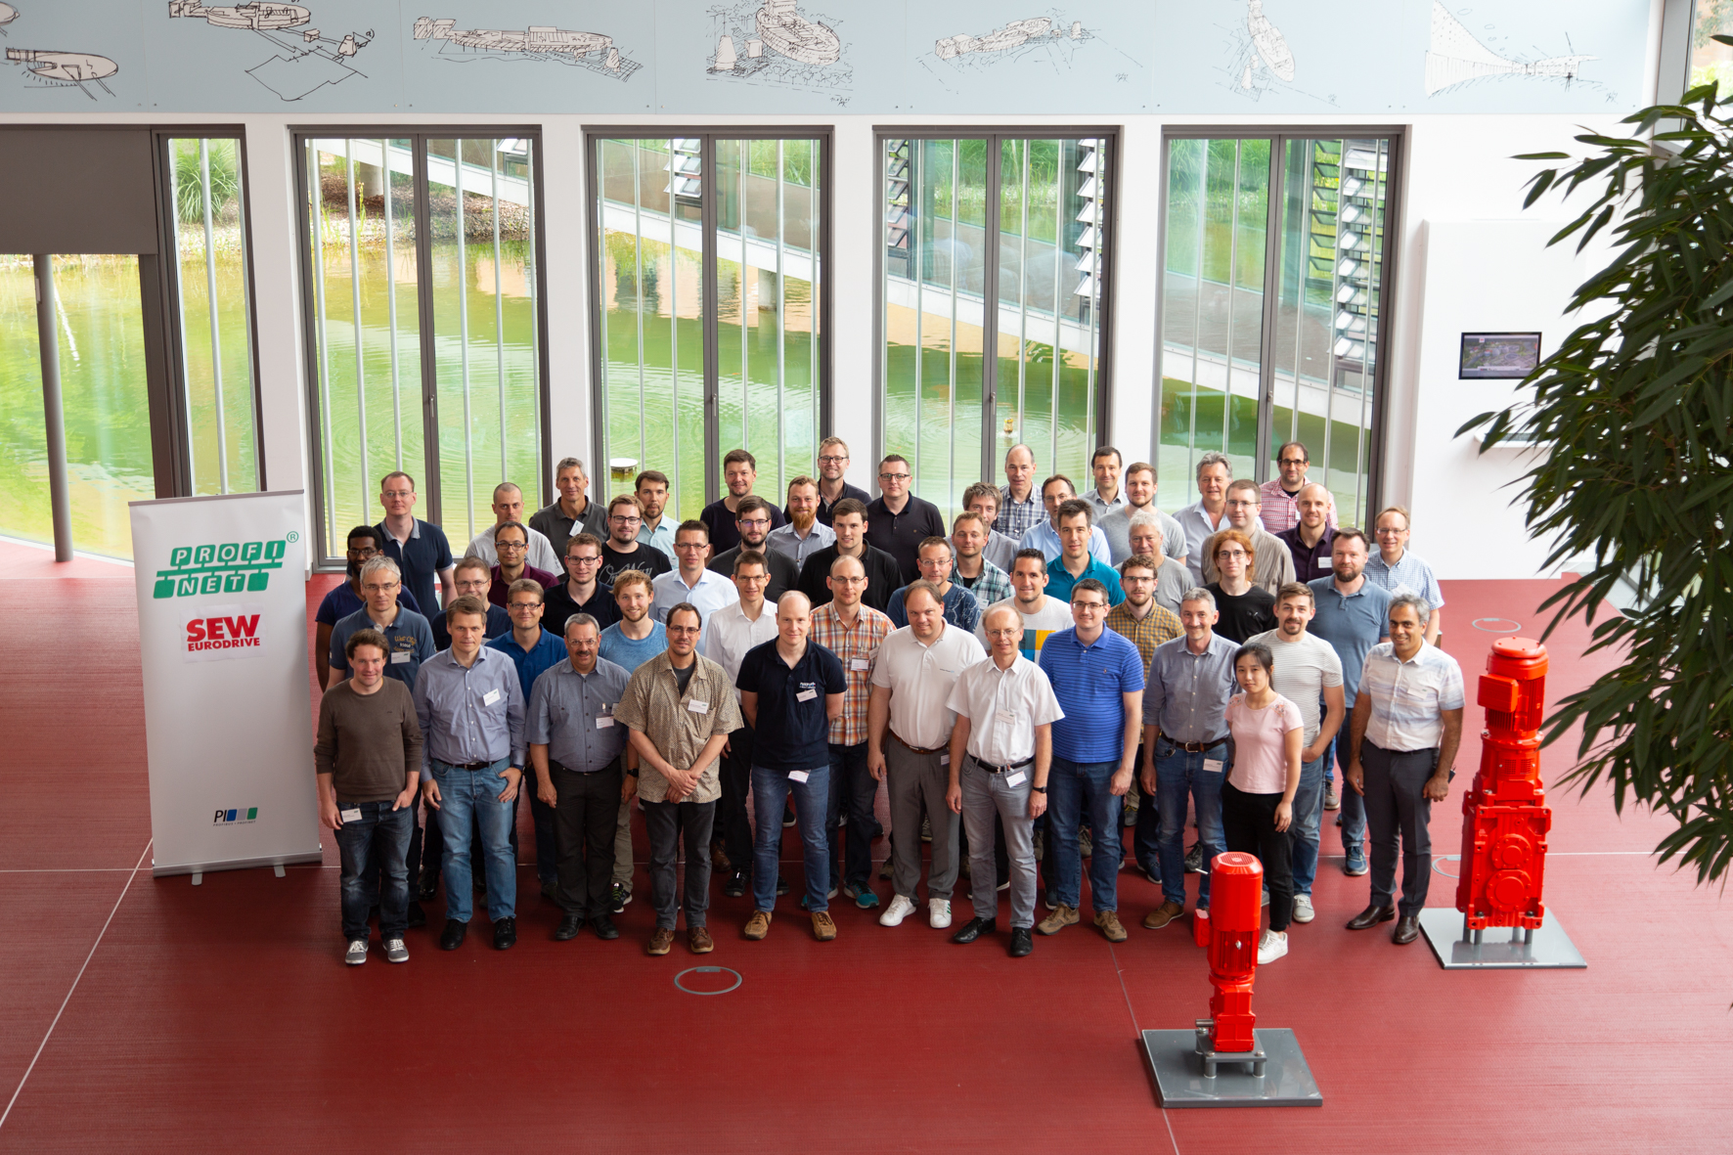

Press contact:
PI (PROFIBUS & PROFINET International)
PROFIBUS Nutzerorganisation e. V.
Barbara Weber

Haid-und-Neu-Strasse 7

76131 Karlsruhe, Germany
Phone: +49 (0) 721/96 58 - 5 49

Fax: +49 (0) 721/96 58 - 5 89
Barbara.Weber@profibus.com
http://www.PROFIBUS.com
The text of this press release is available for download at www.profibus.com.

