Contact person:
Barbara Weber
Barbara.Weber@profibus.com
+49 721 9658-549

P R E S S R E L E A S E

Technology Providers Implement PROFINET with TSN

Nuremberg, November 28, 2018: One indicator for the market relevance of new technologies is the early availability of various solutions from different manufacturers. Assigned working groups from PROFIBUS & PROFINET International (PI) are actively working on an open solution for integrating TSN (time-sensitive networking) in PROFINET. A live demo with solutions from three different manufacturers, which was introduced to the public for the first time at SPS IPC Drives 2018, shows how easily TSN can be integrated in PROFINET in view of different technologies. There are a number of benefits to the various technology companies’ specific implementation of this technology in hardware and firmware, which takes place at the same time as the development of corresponding specifications. For instance, it is possible to assess how the specifications can be realized in real products, and to verify whether the specification is consistent, complete and interoperable.

In the live demo, prototypical implementations from three different companies – Texas Instruments, Analog Devices and Hilscher – work together with their respective proprietary hardware and firmware platforms. Further providers are at the ready. The live demo served as proof that the TSN mechanisms selected by PI are suitable for real-world conditions, but also that the existing PROFINET stack can be easily adapted to the new Layer 2.

The interoperability between different technology providers gives device manufacturers the possibility to choose a platform that is best suited to their specific device, as they were accustomed to doing in the previous PI ecosystem of technology providers.

The demo shows the clear advantages for the user: a real-time capable IO application with less than 1µs jitter, plug-and-work during network changes, simple connection of existing PROFINET devices, and a robustness of PROFINET communication even with high network loads.

As a whole, this completes the next step of a proof of concept. A systematic completion of the specification work is currently underway, with the aim of being ready by the 2019 Hanover Fair. Other implementations are also in the works. And preparations are already underway for relevant certification tests.

***
Graphic: PROFINET@TSN has already become reality. The first chip vendors have implemented TSN in PROFINET.
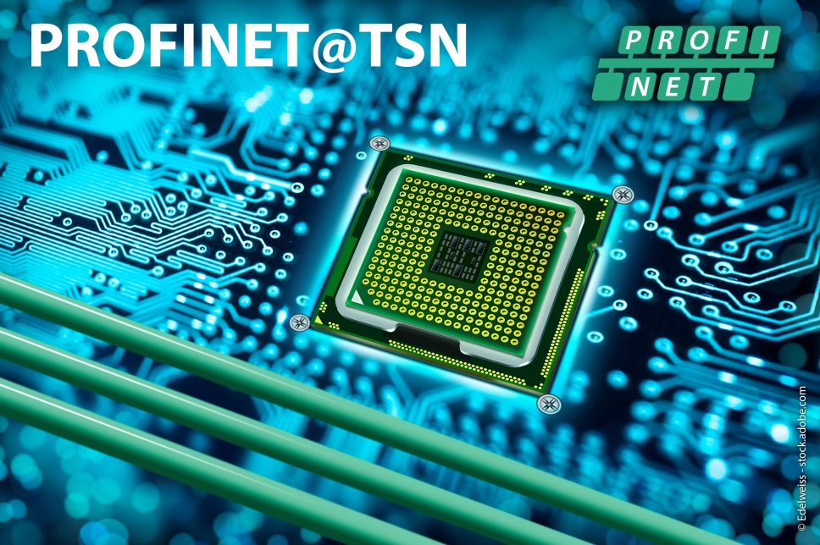
Please note the copyright as follows: © Edelweiss - stock.adobe.com

Press contact:
PI (PROFIBUS & PROFINET International)
PROFIBUS Nutzerorganisation e. V.
Barbara Weber

Haid-und-Neu-Strasse 7

76131 Karlsruhe, Germany
Phone: +49 721 96 58 549

Fax: +49 721 96 58 589
Barbara.Weber@profibus.com
http://www.PROFIBUS.com
The press release is available for download at www.profibus.com.

