Contact person:
Barbara Weber
Barbara.Weber@profibus.com
+49 (0) 721 9658-549

P R E S S R E L E A S E

Joint PI stand – Into the future with Industry 4.0!

Karlsruhe, Germany – September 23, 2019: The central theme of the joint stand of PI (PROFIBUS & PROFINET International) at the SPS 2019 trade show in Nuremberg, Germany (Hall 5, Stand 210) is the implementation of industrial communication for Industry 4.0. This will be demonstrated throughout the stand using concrete examples, e.g. using the new “digital twin” demo. The digital twin is based on a virtual round table picker system for component assembly which operates real motors using PROFIdrive communication (AC1 – AC5).

Thanks to further innovation in the IO-Link field, it will be possible to see concrete IO-Link Safety products for the first time. This includes development aids for IO-Link Safety Master with a master tool for safety IODDs and IO-Link Safety devices. Pre-certified safety stacks for integration into the IO-Link Safety Master and IO-Link Safety devices are also to be presented.

An overview of PROFINET products for process automation available on the market is provided by a redesigned live process automation demonstration, which also illustrates options for the further development of industrial communication solutions in existing systems. Visitors have the opportunity to interactively operate the system structure based on PROFINET and PROFIBSU PA here. The FDI and Ethernet APL (advanced physical layer) technologies developed in cooperation with other organizations will also be presented as a thematic compliment.

In addition to these innovations, tried-and-tested technology presentations will also be shown at the stand. The device diversity of PROFINET will be illustrated with over 200 different devices on the factory automation wall. The topic of functional safety will be presented through live demos on PROFIsafe and OPC UA safety.

Current Industry 4.0-relevant live demos and presentations on the topics of TSN, security, PROFINET and OPC UA will also once again be part of the joint PI stand. Here, you’ll be able to learn from stand staff about the concrete progress being made in specification work.

PI and more than 120 other exhibitors are looking forward to your visit and having interesting discussions on PI technologies. For more information on the joint PI stand and exhibitors, visit: www.profibus.com/sps.

***
Graphic:
Implementation of industrial communication for Industry 4.0 will be demonstrated at the joint PI stand using concrete examples.

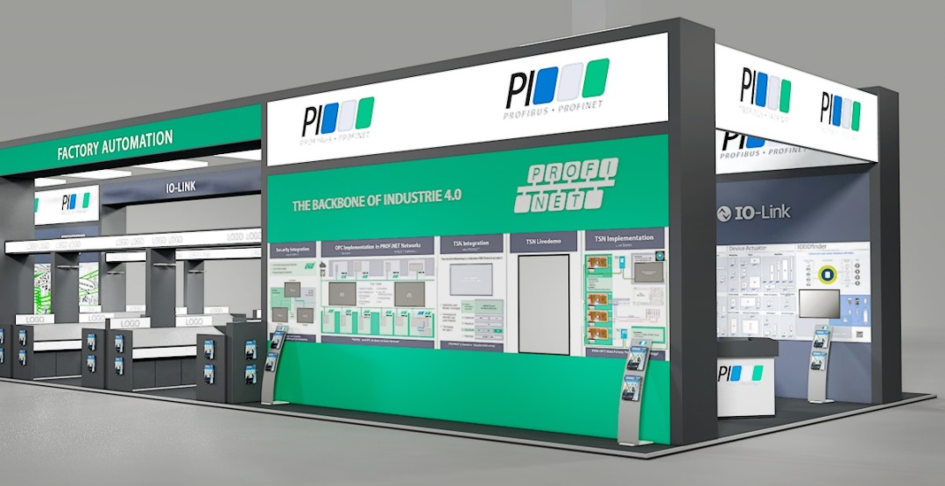

Press contact:
PI (PROFIBUS & PROFINET International)
PROFIBUS Nutzerorganisation e. V.
Barbara Weber

Haid-und-Neu-Str. 7

D-76131 Karlsruhe, Germany
Phone: +49 (0) 721/96 58 - 5 49

Fax: +49 (0) 7 21/96 58 - 5 89
Barbara.Weber@profibus.com
http://www.PROFIBUS.com
The text of this press release is available for download at www.profibus.com.

