Contact person:
Barbara Weber
Barbara.Weber@profibus.com
+49 (0) 721 9658-549

P R E S S R E L E A S E

PROFIsafe and IO-Link pass the 10 million mark

Hanover, Germany – April 01, 2019: PROFIBUS & PROFINET International (PI) has concluded its annual notarial count of the installed base of devices with interfaces using communication technologies from PI. As in previous years, the numbers from 2018 indicate a very positive trend.

In the case of PROFINET, the 5.1 million devices brought to market in 2018 represent an increase of 0.6 million over the previous year’s record. By the end of 2018, a total of 26 million PROFINET devices were working to automate production. This means that the annual number of PROFIBUS devices installed – 2.4 million – even rose slightly as compared to the previous year. Reaching nearly 61 million, the overall number passed yet another threshold. The total of the two annual values of 7.5 million also represents an all-time high number.

PROFIBUS’s trend in process automation also remains stable. Though the annual value reached in 2018 – 0.8 million – was slightly less than the previous year, a total of 12.3 million PROFIBUS devices (i. e. 20% of the overall total of 61 million) are now being used in process systems.

With 2.2 million PROFIsafe nodes brought to market in 2018, which corresponds to growth of nearly 25% as compared to the previous year, PROFIsafe also saw its highest annual gain ever. In total, PROFIsafe passed the 10-million hurdle by a considerable margin with its 11 million nodes.

As in the previous years, IO-Link likewise achieved a record in two regards in 2018. On the one hand, 3.3 million IO-Link nodes were brought to market, which amounts to growth of more than 40% compared to last year. An overall count of 11.4 million IO-Link nodes means that the 10-million hurdle was passed by a considerable margin here as well.

For Karsten Schneider, Chairman of PROFIBUS & PROFINET International (PI), these figures confirm the validity of decisions made over the past few years with regard to the development direction of PI technologies. “This motivates us to continue with resolve and to implement step by step the strategy presented at the PI Konferenz in Frankfurt (March 2019). Record-setting PI Konferenz attendance also confirms the broad acceptance of our technologies today and the trust in our organization to make the right decisions in the future as well, which in turn will be a crucial element for the economic success of our member companies. ”

***

Graphics:

By the end of 2018, a total of 26 million PROFINET devices were working to automate production.
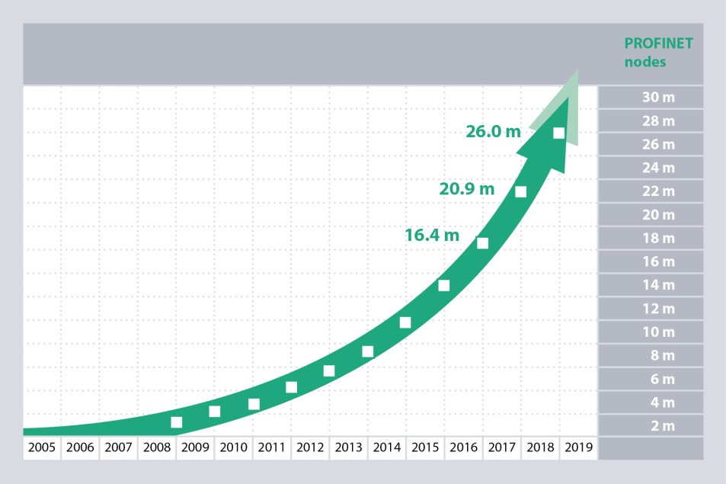

Approximately 20% of the overall total of 61 million PROFIBUS nodes (i. e. 12.3 million) are now being used in process systems.
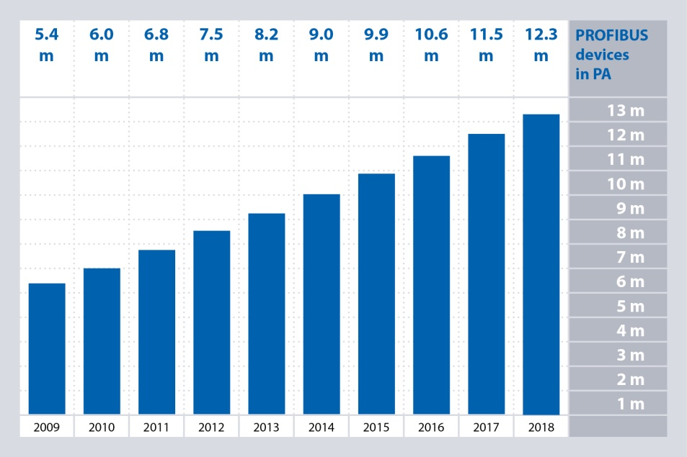

With its 11.2 million PROFIsafe passed the 10-million hurdle.
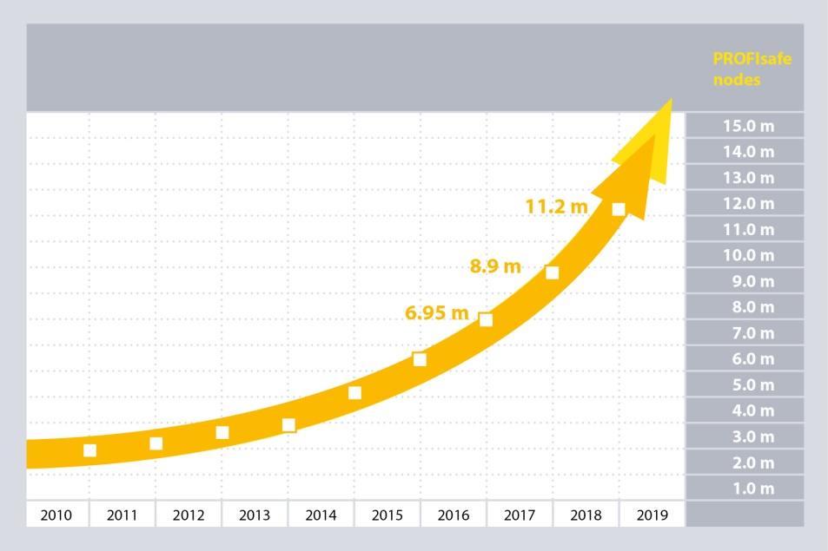
3.3 million IO-Link nodes were brought to market in 2018. The overall count amounts to 11.4 million IO-Link nodes.
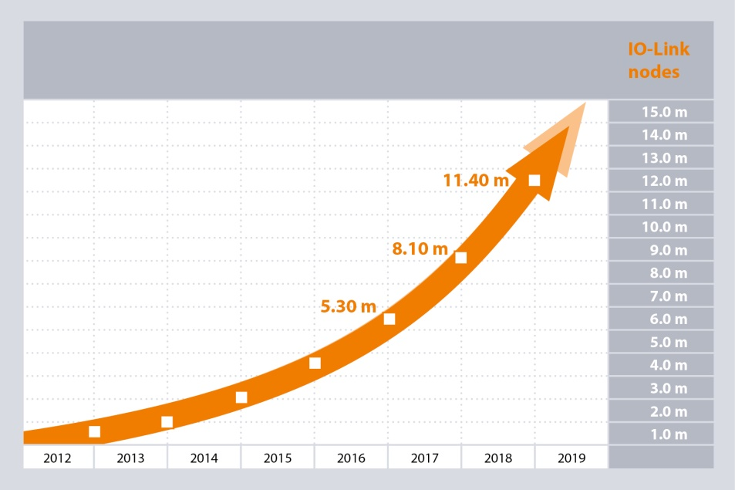
Press contact:
PI (PROFIBUS & PROFINET International)
PROFIBUS Nutzerorganisation e. V.
Barbara Weber

Haid-und-Neu-Strasse 7

D-76131 Karlsruhe, Germany
Phone: +49 (0) 721/96 58 - 5 49

Fax: +49 (0) 721/96 58 - 5 89
Barbara.Weber@profibus.com
http://www.PROFIBUS.com
The text of this press release is available for download at www.profibus.com.

