Contact person:
Barbara Weber
Barbara.Weber@profibus.com
+49 (0) 721 9658-549

P R E S S R E L E A S E

PROFINET and IO-Link on the rise

Still top technology, 30 years later

Karlsruhe, Germany – May 6, 2020: Even after more than 30 years since the founding of PROFIBUS & PROFINET International (PI), its technology is still very well received in the market. “To us, this is the ultimate proof that we’ve made a series of right decisions regarding the development of our technologies in the past,” said Karsten Schneider – chairman of both the PROFIBUS Nutzerorganisation and PI – of the latest node counts.

In the case of both PROFINET and IO-Link, the working group experts have not only continued developing the communication aspects of the technology, but have also provided crucial additional support to make them suitable for use in Industry 4.0-compliant production. One example of this is the two companion specifications, in which OPC UA-compatible information models for PROFINET and IO-Link are described.

IO-Link saw its largest annual increase (40 %) in 2019, achieving the same growth rate as the year before. This shows that IO-Link is establishing itself in the market for the long term. The total number of installed IO-Link devices is now more than 16 million.

With 6.4 million new devices installed in the market in 2019, PROFINET saw its largest annual increase so far. This corresponds to a growth rate of 25 % and contributes to the total node count of 32.4 million. “PROFINET represents reliable and sustainable communication technology which already meets requirements from an Industry 4.0 perspective very well today. To ensure that this remains the case for the long term, our experts – increasingly in cooperation with experts at other organizations as well – are continuously working on firmly anchoring PROFINET as an enabler for digitization in production,” continued Karsten Schneider. This is also being impressively demonstrated by the results of other market studies, like the one by IHS Markit where PROFINET was determined to be the most widely used Ethernet-based system in the world with a share of 29 %.

With its increase of 2.5 million nodes in 2019, the number of new PROFIsafe nodes installed has now exceeded the 2 million mark two years in a row. The total number of PROFIsafe nodes installed now lies close to 14 million.

Despite its long market presence, PROFIBUS has also managed to once again report an impressive number of new nodes – 1.9 million – in 2019. By the end of 2019, more than 62 million PROFIBUS devices were installed in industrial plants worldwide, with over 13 million of them being incorporated into process-engineering plants.

“Motivated by this market success, our members around the globe are strongly committed to continued development and many different marketing projects,” according to Schneider. In this context, we can hope that the constraints caused by the virus don’t last long and that people will quickly be able to get back to normal in both the business and private spheres.

***

Graphics:
IO-Link now has a base of 16 million installed IO-Link devices and is thus firmly established in the market.
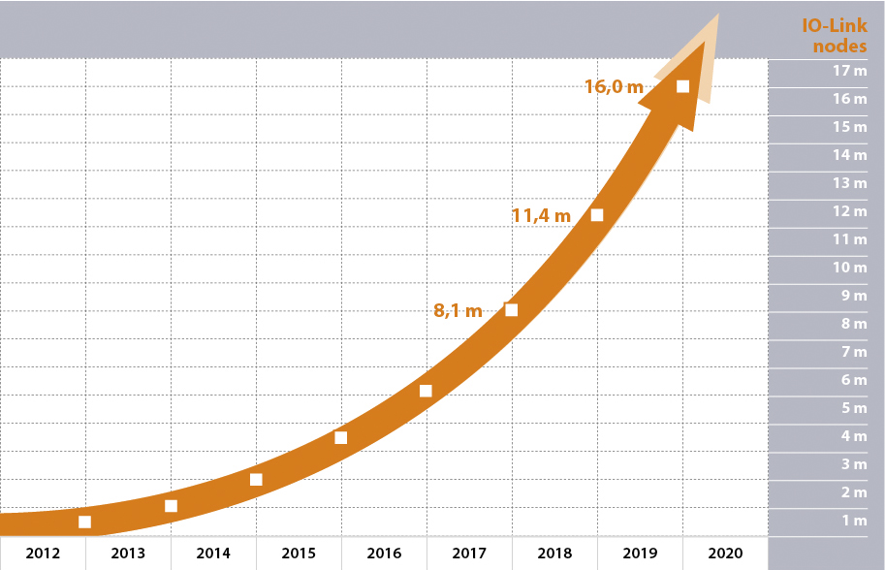
With a market growth of 25 %, the total number of PROFINET nodes increases to an impressive 32.4 million.
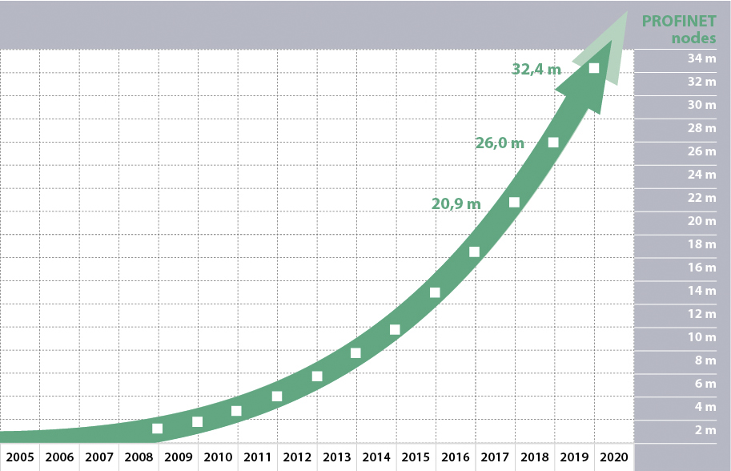

Press contact:
PI (PROFIBUS & PROFINET International)
PROFIBUS Nutzerorganisation e. V.
Barbara Weber

Haid-und-Neu-Str. 7

D-76131 Karlsruhe, Germany
Phone: +49 (0) 7 21/96 58-5 49

Fax: +49 (0) 7 21/96 58-5 89
Barbara.Weber@profibus.com
http://www.PROFIBUS.com
The text of this press release is available for download at www.profibus.com.

