P R E S S R E L E A S E

First live demo of MTP at Hanover Fair

Karlsruhe, Germany – March 28, 2023: At the Hanover Fair, PROFIBUS & PROFINET International (PI) will install a new demo wall in Hall 9, Booth D68, to demonstrate how process equipment assemblies (PEA) can be integrated into a higher-level control or SCADA system from the process orchestration layer (POL) within minutes using module type packages (MTP). This significantly increases efficiency in engineering. Using module type packages (MTP), automation systems can be modularized across vendors. This allows for increasing the flexibility of production plants.

At a PlugFest in Karlsruhe, Germany, in mid-March, the cross-vendor interoperability of the devices involved in the demo was tested in depth in various scenarios. At the PlugFest, the integration of seven different PEA automation solutions from ABB, Beckhoff, CopaData, Festo, Phoenix Contact and Siemens into four different POL systems was tested. POL systems with MTP functionality were provided by ABB, CopaData, Siemens and Yokogawa. At the Hanover Fair, the live demo is further complemented by solutions from Emerson and Wago.

“The test results obtained right at the first PlugFest were impressive” summarizes Mathias Maurmaier, Committee Leader at the PROFIBUS Nutzerorganisation (PNO), regarding MTPs. “In most cases, the MTPs – sometimes comprising several hundred tags, operating screens, services and operator interactions – were imported and communication between the POL system and the PEA was established within a few minutes,” Maurmaier continues.

See for yourself at the joint PI booth at the Hanover Fair that, with MTP, cross-vendor interoperability is no longer an illusion, but has become reality.

***

Graphic: The first MTP live demo will be shown at the joint PI booth in Hanover. Using module type packages (MTP), automation systems can be modularized across vendors.

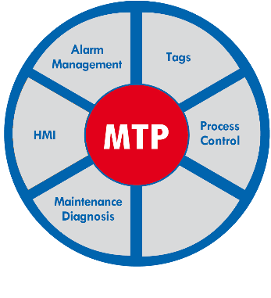
Press contact:
PI (PROFIBUS & PROFINET International)
PROFIBUS Nutzerorganisation e. V.
Barbara Weber

Haid-und-Neu-Str. 7

D-76131 Karlsruhe, Germany
Phone: +49 7 21 986197 49

Fax: +49 7 21 986197 11
Barbara.Weber@profibus.com
http://www.PROFIBUS.com

