P R E S S R E L E A S E

New date for the “IO-Link Safety Certified Designer” training course

Karlsruhe, Germany – March 07, 2023: The IO-Link Community is once again offering a training to become an IO-Link Safety Certified Designer in cooperation with TÜV-SÜD from May 09 to 11, 2023. IO-Link Safety expands machines and systems automated with IO-Link to include functionally safe components and communication. The training is held in English in Karlsruhe (Germany) and provides in-depth knowledge of the new technology as well as basic knowledge of safety engineering. After passing the exam, participants receive a personal TÜV certificate.

On the first day of the course, content will include the basics of IO-Link Safety, such as safety principles, functional objectives, requirements for IO-Link (“black channel”) and risks & remedial measures. Furthermore, the communication protocol, fault detection, device replacement without tools, configuration options & backup, possible architectures, testing & certification, environmental regulations and example applications are covered.

On the second day, TÜV-SÜD will cover the basics of safety development – of FS masters and FS devices in particular – in accordance with IEC 61508/62061 and ISO 13849, enabling participants to evaluate the implications for the engineering departments of their company. This includes an overview of the relevant standards and their content, project management, management for functional safety, required documentation, life cycle, safety functions, preferred architectures, methods for avoiding dangerous faults, FMEA, verification & validation and certification.

The third day will begin with a general overview of procedures for design & implementation and testing as well as the creation of IODDs and dedicated tools. A host of technology and service providers will then present test systems, development kits and development support.

Written tests are administered after the completion of each day’s training. All the tests must be passed in order to receive a certificate. A participation fee of 650 Euros is charged for the course. For more information and online registration, visit www.io-link.com.

***

Graphic: IO-Link Safety expands machines and systems automated with IO-Link to include functionally safe components and communication. The IO-Link Safety Certified Designer training provides in-depth knowledge of the new technology.
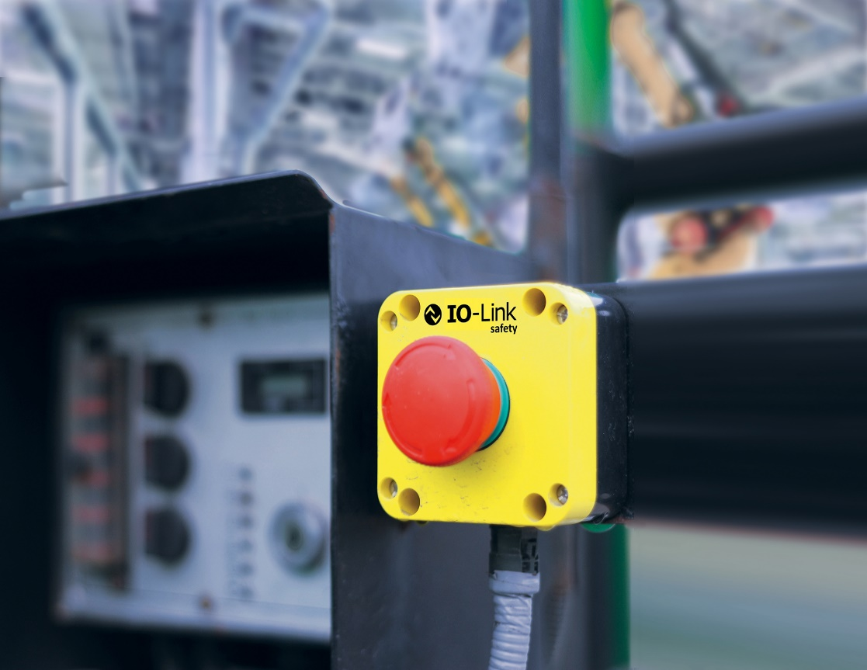
Press contact:
PI (PROFIBUS & PROFINET International)
PROFIBUS Nutzerorganisation e. V.
Barbara Weber

Haid-und-Neu-Str. 7

D-76131 Karlsruhe, Germany
Phone: +49 721 986 197-49
Fax: +49 721 986 197-11
Barbara.Weber@profibus.com
http://www.profibus.com
The text of this press release is available for download at www.profibus.com.

