Contact person:
Barbara Weber
Barbara.Weber@profibus.com
+49 721 9658-549

P R E S S R E L E A S E

IODDfinder contains almost all IO-Link devices

Karlsruhe, July 24th, 2017: A good six months after its introduction, far more than 80% of all IO-Link devices are already included in the IODDfinder, the central database for IO-device descriptions. The service launched by the IO-Link community at the start of this year was received very well by manufacturing companies and users alike and will contribute decisively towards the further spread of IO-Link.

The IODDfinder portal meets the desire of users of IO-Link technology for a central access point for IODDs of all IO-Link devices common in the market. This consistent data pool is available 24/7 and allows not only interested parties access to this database but also facilitates the direct connection of engineering and parameterization tools. Relevant software tools are given access via the Internet to this manufacturer-neutral data pool, which guarantees the user automatic access to all operationally-important description files of its IO-Link devices.

So far, more than 30 manufacturers of IO-Link devices are participating in the data platform and have already stored about 1900 IODDs. With this amount of IODDs, more than 3900 different IO-Link devices can be parameterized. On the consumer side, the platform was able to deal with roughly 2500 call-ups per day in the first half of the year.

These figures demonstrate in an impressive way how valuable the new Internet service is for the IO-Link world. The IODDfinder can be reached either from the IO-Link homepage (http://www.io-link.com) or directly via the following link: https://ioddfinder.io-link.com.

***

Graphic: Function of manufacturer-neutral, central database for IO-Device descriptions.
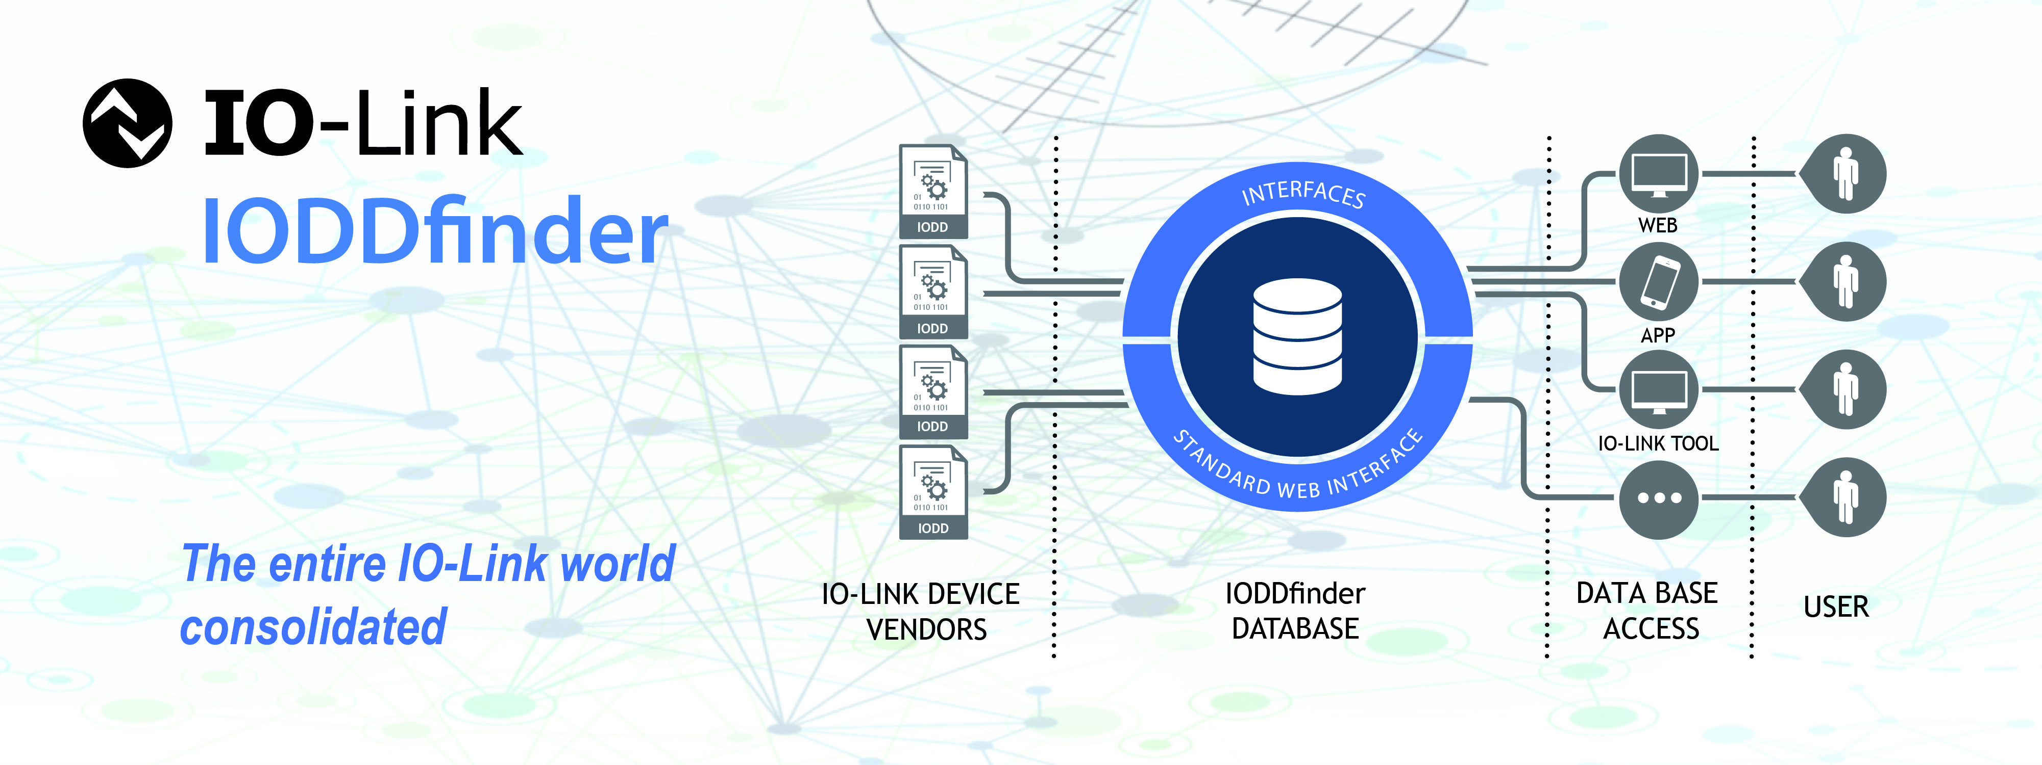
Press contact:
PI (PROFIBUS & PROFINET International)
PROFIBUS Nutzerorganisation e. V.
Barbara Weber

Haid-und-Neu-Strasse 7

D-76131 Karlsruhe, Germany
Phone: +49 (721) 96 58 - 5 49

Fax: +49 (721) 96 58 - 5 89
Barbara.Weber@profibus.com
http://www.PROFIBUS.com
The text of this press release is available for download at www.profibus.com,

