Contact person:
Barbara Weber
Barbara.Weber@profibus.com
+49 (0) 721 9658-549

P R E S S R E L E A S E

IODDfinder – The smart solution

Karlsruhe, Germany – January 13, 2020: It does not get easier than this. With the IODDfinder, files arrive from the Internet automatically – no fuss, no muss. That’s just the right way to describe the advantage of this centralized, cross-manufacturer database. And it’s been very well received by users, to boot. With more than 400,000 downloads in November of 2019 alone and over 12,000 devices, IODDfinder – the Internet platform for IO-Link description files – has become an established name in the market in just three years.

The database is maintained by members of the IO-Link Community and now hosts more than 7,500 description files from around 80 manufactures, making it the world’s largest collection of IODDs. By joining the community, each member gets the opportunity to create a manufacturer account in IODDfinder so they can upload the description files for their devices there. The platform features a web front end which people can use to search for and find IODDs for individual devices. The actual added value, however, comes from the application program interfaces (APIs) which device manufactures can also use to automatically upload, update and manage a large number of IODDs. These interfaces ensure that the central database is always complete and that their content is always up to date. Description files can also be downloaded automatically using APIs. This allows software tools to access the database over the Internet for device configuration or integration into automation systems, for example. A majority of downloads are now carried out using such tools. Each IO-Link device features its own device ID and a specific manufacturer ID. The software tools can read out these two identification numbers immediately after connecting to IO-Link devices and – if they are online – download the appropriate description file from the Internet fully automatically. This enables the software tool to communicate with the connected IO-Link device immediately after the download. This is exactly the desired convenience which modern I4.0 technologies are able to offer.

IODDfinder is available free of charge to users of the web front end. The best way to reach the database is using the IO-Link website: www.io-link.com (menu item “IODDfinder”).

***

Graphic: How the Internet database for IO device descriptions works.
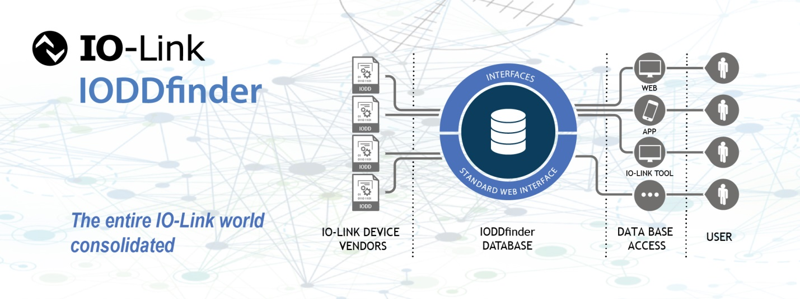
Press contact:
PI (PROFIBUS & PROFINET International)
PROFIBUS Nutzerorganisation e. V.
Barbara Weber

Haid-und-Neu-Str. 7

D-76131 Karlsruhe, Germany
Phone: +49 (0) 7 21/96 58-5 49

Fax: +49 (0) 07 21/96 58-5 89
Barbara.Weber@profibus.com
http://www.PROFIBUS.com
The text of this press release is available for download at www.profibus.com.

