Contact person:
Barbara Weber
Barbara.Weber@profibus.com
+49 721 986197-49

P R E S S R E L E A S E

International PROFINET Technology Webinar

Karlsruhe, Germany – February 02, 2023: PROFINET is the open, manufacturer-independent industrial Ethernet standard for production and process automation. Thanks to its scalable communication, it offers optimal performance and flexibility and meets all the requirements for the use of Ethernet in industrial automation. The PROFINET standard (IEC 61158/IEC 61784) also enables comprehensive implementation of the communication protocol in field devices.

To support manufacturers in developing PROFINET devices and their product range and design implementation to be easy and efficient for all companies, PI (PROFIBUS & PROFINET International) will once again be offering education opportunities for PROFINET in the form of workshops and webinars this year.

An English-language international PROFINET technology webinar on February 28, 2023 will kick off the series. To enable anyone who’s interested to take part, regardless of their respective time zone, two sessions with the same content will be held at different times that day.

The webinar tells which functions are offered by PROFINET and how they can be implemented by the device manufacturer. Presentation of the respective views of users and device developers is covered there.

Some leading technology companies will also be presenting their development support and providing practical tips on implementation and certification testing.

The presentations of the webinar aren’t just geared toward all the developers of PROFINET devices, but to anyone who’s interested – especially device manufacturers, suppliers and product managers who can benefit from deeper insight into PROFINET technology and the wealth of experience of individual companies and developers.

Participation in the webinar is free of charge. Additional information on the GoTo webinar on February 28th, 2023, registration for the event and the schedule can be found at:
https://www.profibus.com/pi-international-profinet-technology-webinar-february-2023

***

Graphic: PROFINET is the leading standardized Ethernet protocol. A free webinar provides detailed information.

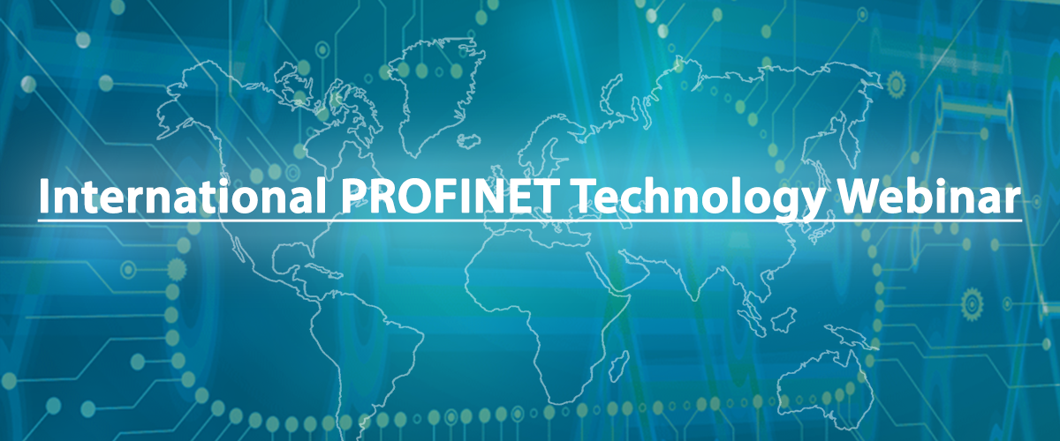

Press contact:
PI (PROFIBUS & PROFINET International)
PROFIBUS Nutzerorganisation e. V.
Barbara Weber

Haid-und-Neu-Str. 7

D-76131 Karlsruhe, Germany
Phone: +49 7 21 986197 49

Fax: +49 7 21 986197 11
Barbara.Weber@profibus.com
http://www.PROFIBUS.com

