P R E S S R E L E A S E

PI hosts two international PROFINET
webinars at the summer solstice!

Karlsruhe, Germany – May 15, 2023 PROFINET is the open, manufacturer-independent industrial Ethernet standard for production and process automation. Thanks to its scalable communication, it offers optimal performance and flexibility and meets all the requirements for the use of Ethernet in industrial automation.

To support manufacturers in developing PROFINET devices and their product range and to design implementation to be easy and efficient for all companies, PI (PROFIBUS & PROFINET International) will be offering two English-language PROFINET webinars at the summer solstice:

- The International PROFINET Certification Webinar on June 20, 2023
- The International PROFINET Technology Webinar on June 21, 2023

To enable anyone who’s interested to take part, regardless of their respective time zone, two sessions with the same content will be offered at different times for each webinar.

The International PROFINET Certification Webinar is especially geared toward the PROFINET community, developers and system testers at the companies and other interested people from the existing PI test laboratories and test centers.

The webinar offers an overview of the certification process and explains PROFINET’s ART testing system in detail. Participants can also look forward to a live demo.

The PROFINET Technology Webinar tells you which functions are offered by PROFINET and how they can be implemented by the device manufacturer. Presentation of the respective views of users and device developers, as well as the basics of PROFINET technology, will be covered there. The presentations of the webinar are geared toward all developers of PROFINET devices, as well as anyone else who’s interested, especially device manufacturers, suppliers and product managers.

Participation in the webinars is free of charge.
Additional information on the International PROFINET Certification Webinar on June 20, 2023, registration for the event and the schedule can be found at:
https://www.profibus.com/trainingevents/pn-certification-webinar-2023-june

Additional information on the International PROFINET Technology Webinar on June 21, 2023, registration for the event and the schedule can be found at:
https://www.profibus.com/trainingevents/international-pn-webinar-june-2023

***
Graphic: PROFINET is the leading standardized Ethernet protocol. A free webinar provides detailed information.
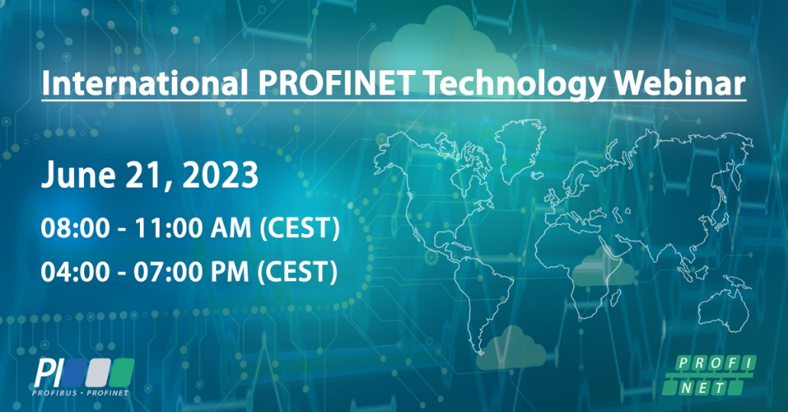

Graphic: Look forward to exchanging experience with certification experts from various companies and our exciting content.
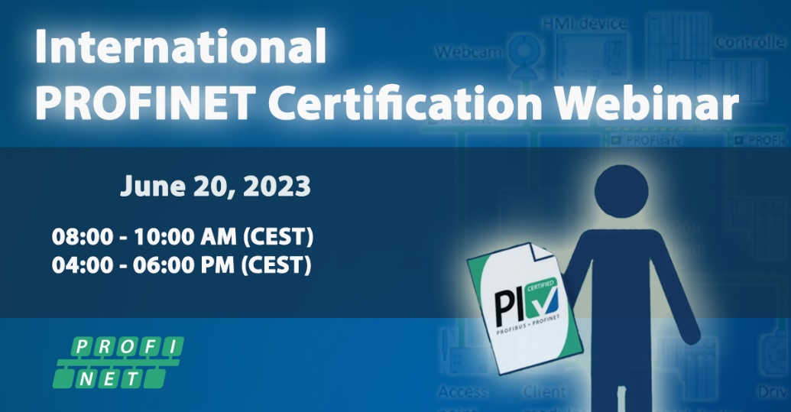
Press contact:
PI (PROFIBUS & PROFINET International)
PROFIBUS Nutzerorganisation e. V.
Barbara Weber

Haid-und-Neu-Str. 7

D-76131 Karlsruhe, Germany
Phone: +49 7 21 986197 49

Fax: +49 7 21 986197 11
Barbara.Weber@profibus.com
http://www.PROFIBUS.com
The text of this press release is available for download at www.profibus.com.

