Contact person:
Barbara Weber
Barbara.Weber@profibus.com
+49 721 9658-549

P R E S S R E L E A S E

Specification of PROFINET with TSN complete

Karlsruhe – July 01, 2019: The goal set by PI (PROFIBUS & PROFINET International) to integrate TSN as additional Layer 2 technology in the PROFINET architecture has been reached with the current PROFINET specification V2.4. The specification work has been completed and the three parts of the document are available for download on the PI website. Manufacturers and users alike can interoperably implement the advantages offered by TSN, such as future-proof IEEE Ethernet technology with higher bandwidth, deterministics, flexible network configuration and large range of chips.

The user interface remains unchanged, i.e., the use of IO data, diagnostics and parameterization, since the new TSN mechanisms act largely on the underlying communication layers. This makes it easier for users to get started with the new technology.

Through the dedicated work of the experts from many companies, the specification was prepared in just over a year in an intensive development and review process. The open discussion and many years of experience of the expert contributors in the respective working groups ensure an accurate and complete technical description.

In addition, both the initial implementations as well as concepts for the certification were created early on in parallel. The stability of the specification could thereby be tested and also demonstrated at trade fairs. For easy understanding of the functionality, a guideline is also available that clearly explains the fundamentals of TSN.

PROFINET specification 2.4 and IEEE specifications are necessary fundamentals above all for the developers of the basic technology of hardware and firmware. The device manufacturers then simply use the corresponding stacks or modules and no longer need to understand the details or even implement them themselves. As a result, device manufacturers can simply expand their existing PROFINET portfolio with TSN.

Of course, the specification will continue to be maintained in the familiar annual maintenance process so that new customer requirements, experiences from the field or technological developments can be integrated in an open and easy-to-understand way. This process supports the “living” PROFINET standard, which has proven itself a million times over and is still developed continuously, according to user needs and compatibly.

***

Graphic: PROFINET@TSN is already reality, the specification is available.
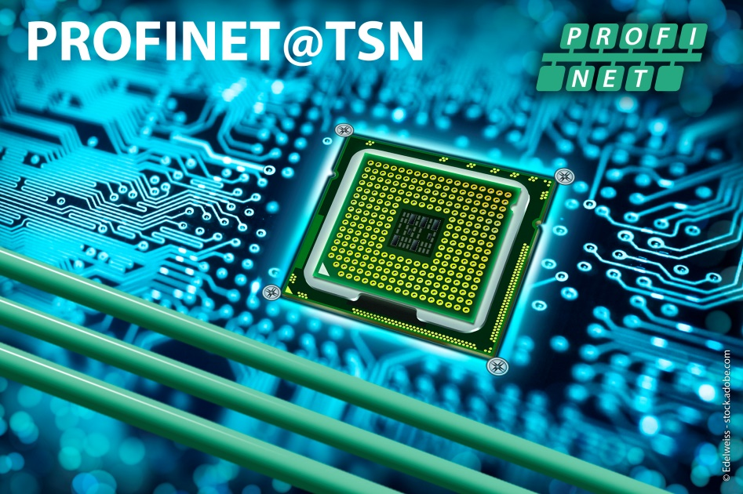
Please observe copyright notice: © Edelweiss - stock.adobe.com

Press contact:
PI (PROFIBUS & PROFINET International)
PROFIBUS Nutzerorganisation e. V.
Barbara Weber

Haid-und-Neu-Strasse 7

76131 Karlsruhe, Germany
Phone: +49 721 / 96 58 - 5 49

Fax: +49 721 / 96 58 - 5 89
Barbara.Weber@profibus.com
http://www.PROFIBUS.com
This press release is available for download at www.profibus.com.

