Contact person:
Barbara Weber
Barbara.Weber@profibus.com
+49 (0) 721 9658-549

P R E S S R E L E A S E

Omlox off to flying start at PI

First open standard for industrial positioning technologies

Karlsruhe – July 9, 2020: The 30 years of experience in the user-oriented development and successful global marketing of technologies at PROFIBUS & PROFINET International (PI) was decisive for the initiative of the omlox partner companies to entrust PI in the further development and propagation of the omlox technology. “We consider omlox to be a very good addition to the existing development activities of the PI technologies – which are oriented towards Industry 4.0 – and were therefore happy to accept the offer to add the omlox positioning technology to our portfolio”, says Karsten Schneider, Chairman of Profibus Germany (PNO) and Chairman of PROFIBUS & PROFINET International (PI), who is pleased with the recent technological growth.

Already in April, a vote was held among the members in accordance with the internal rules to include the omlox positioning technology in the technology portfolio of the PNO as well as to establish Committee D omlox. The organizational foundation was thereby laid. In June, the managing board and advisory board then elected Dr. Matthias Jöst (Heidelberg mobil international GmbH) as committee head and established the five omlox working groups (Use Cases, Hub, Core Zone, Marketing, Quality-Test) to perform the work associated with the implementation and also appointed the heads of the working groups. A “call for experts” to participate in the activities was sent to all member companies worldwide in the relevant newsletters. Serving as the basis for the start of the work within the scope of the established working groups is the first version of the omlox technology, which was formally handed over to PI – represented by Karsten Schneider – during the virtual go-live event on June 29, 2020.

The omlox technology – like IO-Link – is technologically independent of PROFIBUS and PROFINET. The working groups will therefore operate independently, but can draw upon the experience of the existing working groups if necessary. The advantage of the affiliation with PI arises, for example, from the use of established globally networked structures as well as from a proven set of rules for the work of the committees, the handling of IP such as patents and copyright, as well as the use of the existing contacts of the regional PI associations, competence centers and training centers to the industrial companies of the regions.

“Against the backdrop of the strategic decision to develop PI as an organization to become the carrier of technologies for the production of the Industry 4.0 generation, omlox has come at just the right time,” adds Karsten Schneider. “We will do everything we can to continue to develop omlox as an open technology in the best interest of the users and to spread it through our globally distributed organization form.”

***
Photo: Dr. Matthias Jöst (Heidelberg mobil international GmbH) is the new committee head at PI for the omlox positioning technology.

Foto: The new omlox team when formally handing over the omlox technology to PI. ((back row from left to right: Karsten Schneider (PI Chairman), Dr. Matthias Jöst (Head of Committee omlox), Celine Daibenzeiher (WG Marketing), Ingo Rechenberger (WG Quality), Jean-Marie André (WG Core Zone). Front row: Eberhard Wahl (WG Use Cases), Marc Braun)

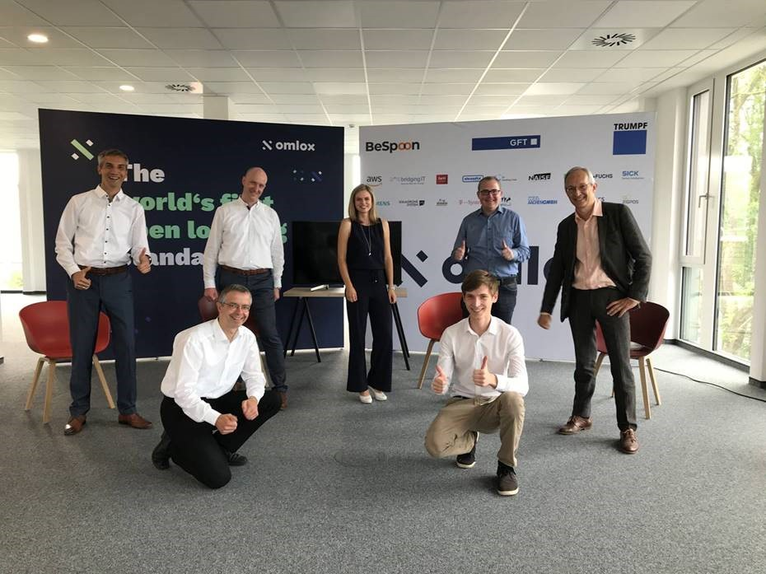

Press contact:
PI (PROFIBUS & PROFINET International)
PROFIBUS Nutzerorganisation e. V.
Barbara Weber

Haid-und-Neu-Str. 7

D-76131 Karlsruhe, Germany
Tel.: +49 (0)7 21 /96 58 - 5 49

Fax: +49 (0)7 21 / 96 58 - 5 89
Barbara.Weber@profibus.com
http://www.PROFIBUS.com
The text of this press release is available for download at www.profibus.com.

