P R E S S R E L E A S E

PI standards for interoperability
Innovations explained at the Hanover Fair

Karlsruhe, Germany – February 28, 2024: How can I securely and reliably get data out of a system, machine or field device to the place where it will be processed? Answers to this question will be provided by 60 member companies of PROFIBUS & PROFINET International (PI) at this year’s Hanover Fair.

Developments and innovations revolving around PROFIBUS and PROFINET, IO-Link, omlox, MTP, NOA and the SRCI robot interface will be presented in an area of 300 square meters at the joint PI booth in Hall 9 (stand D68). “Our fresh new trade fair concept will not only allow us to discuss the latest developments and their corresponding uses with interested users, but will also get new engineers excited about our technologies,” promised Xaver Schmidt, Chairman of PI.

No standards? No reliability.
Whether it’s high-motion applications or the integration of additional information from cameras, the reliable provision of data is the alpha and the omega of innovative and exciting applications and is becoming increasingly important in the world of OT all the time. Large amounts of supplementary knowledge are being retained in clouds and Edge, and the data is being delivered in different ways, e.g. from an in-house network, using the network of another participant or wirelessly. “This requires a broad spectrum of expertise, not only in terms of communication technology, but knowledge of safety applications, security, data analytics and energy management as well,” said Schmidt in pointing out current challenges.

New technology demos
New technology demos will show how this is implemented in practice at the Hanover Fair. The IO-Link Wireless demo, for example, demonstrates that a connection can be resolved very easily over the last few meters. An MTP demo impressively illustrates how modular system construction is inspiring the process industry. “The demos show how data can easily be generated from a system, machine or sensor and used even more easily for efficient and sustainable production,” remarked Schmidt. “Without data, there’s no innovation, but the data has to be made available to an application so it can be processed!”

PI has been setting standards for cross-company interoperability for decades in this regard. This is all thanks to precise specifications, high-quality testing tools, global certification, test labs, competence & training centers and more than 50 working groups. As a result, users are able to rely on robust and practical technologies for secure and reliable data transfer.

***

Graphic: At the joint PI stand, visitors can learn about developments and innovations revolving around PROFIBUS and PROFINET, IO-Link, omlox, MTP, NOA and the SRCI robot interface.

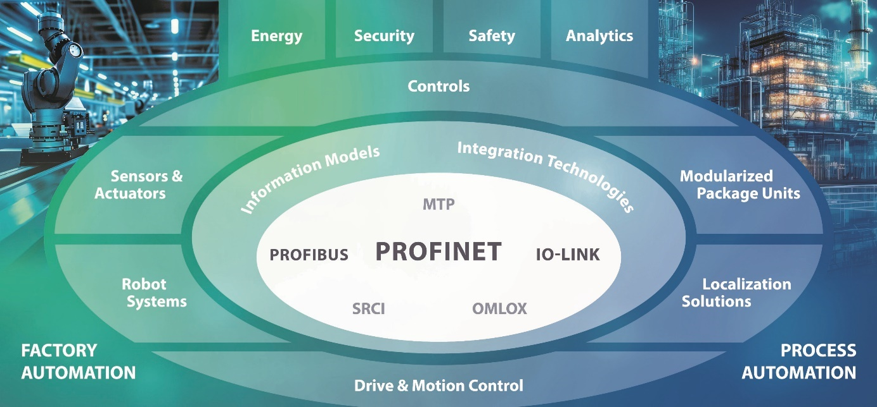

Press contact:
PI (PROFIBUS & PROFINET International)
PROFIBUS Nutzerorganisation e. V.
Barbara Weber

Ohiostr. 8

D-76149 Karlsruhe, Germany
Phone: +49 7 21 986197 49

Fax: +49 7 21 986197 11
Barbara.Weber@profibus.com
www.PROFIBUS.com
www.PROFINET.com

