Contact person:
Barbara Weber
Barbara.Weber@profibus.com
+49 721 9658-549

P R E S S R E L E A S E

Practical Cooperation between PROFINET and OPC UA

Nuremberg, November 28, 2018: In close cooperation, and within the framework of a joint working group, experts from PROFIBUS & PROFINET International (PI) and the OPC Foundation have specified a solution for presenting PROFINET data in the OPC UA object model. PROFINET’s OPC UA companion specification is set to be reviewed soon. The solution’s user-friendliness has already been tested in terms of its practical implementation, using the example of a multi-vendor demonstrator; at the PI booth at SPS IPC Drives 2018, multiple applications were shown in interaction with PROFINET and OPC UA.

According to extensive coordination talks with users, the most significant content of PROFINET’s OPC UA companion specification includes the collection and display of asset management and diagnostic data. This information can be displayed flexibly in specific ways on various devices, based on the requirements and possibilities.

Asset and diagnostic data from the devices employed today can be collected in a system controller through existing mandatory PROFINET services and delivered to higher-level entities by means of OPC UA. This service can also be offered by an edge gateway, which can additionally be added to the system. The advantage here is that no changes have to be carried out on the controller. These use cases are predestined for innovating characteristic brownfield systems. It is also possible to directly integrate the OPC mapping in a PROFINET field device. In this OPC UA use case, which is in demand by customers, the basic characteristics of PROFINET are once again proving to pay off – specifically, PROFINET’s openness for parallel TCP/IP communication and its comprehensive structuring of data.
These possibilities lay the foundation for further applications, such as the implementation of an own OPC UA modeling (e.g. for collecting energy data) or of standardized models (e.g. Namur Open Architecture [NOA]).

During the drafting of the companion specification, the experts’ discussions concerning the existing and planned applications raised a fundamental architectural question in relation to different OPC UA implementations in a device or system: How can different aspects of a device – such as the hardware view, technology view and communication view – be coherently displayed in a way that is useful and comprehensible for the user? This issue will lead to extensions of the OPC UA basic specification; it demonstrates that PI is bringing significant improvements in the OPC UA basic specification to the Foundation, while PI’s expertise is also contributing to OPC UA’s suitability for industrial applications.

With their combined forces, PROFINET and OPC UA are already in a position to offer added value to customers and will integrate new possibilities – such as TSN – in the future. “In the coming years, we want to further intensify our longstanding cooperation with the OPC Foundation – a partnership that has yielded technologies such as FDI,” emphasizes Karsten Schneider, Chairman of PI. “We can mutually benefit from each other’s expertise, thereby facilitating Industry 4.0 in the field of communication.”

***

Graphic: OPC UA and PROFINET are the ideal combination for Industry 4.0.
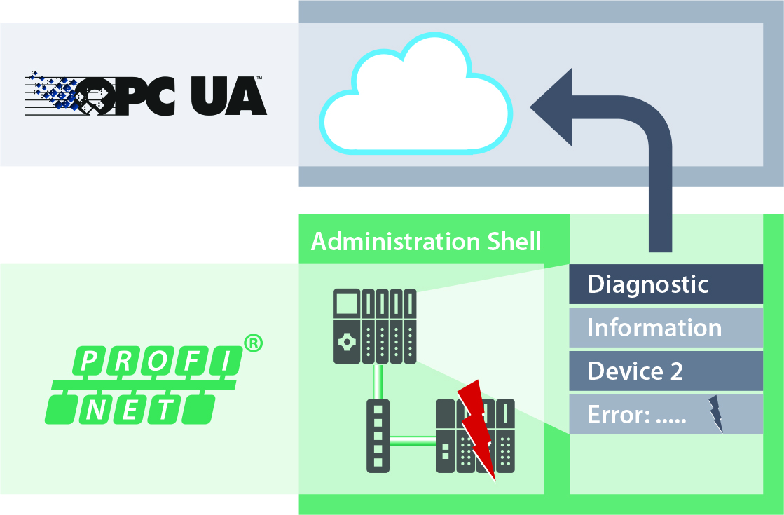
Press contact:
PI (PROFIBUS & PROFINET International)
PROFIBUS Nutzerorganisation e. V.
Barbara Weber

Haid-und-Neu-Strasse 7

76131 Karlsruhe, Germany
Phone: +49 721 96 58 549

Fax: +49 721 96 58 589
Barbara.Weber@profibus.com
http://www.PROFIBUS.com
The text of this press release is available for download at www.profibus.com.

