Contact person:
Barbara Weber
Barbara.Weber@profibus.com
+49 721 9658-549

P R E S S R E L E A S E

New PICCs for PROFINET established in China

Karlsruhe - Germany, July 03, 2017: Accredited PI (PROFIBUS & PROFINET International) Competence Centers (PICCs) stand for high-quality support for PROFIBUS and PROFINET technologies worldwide. PI is very pleased with the continued strong interest on all the continents in being added to the list of accredited PICCs. In the past three months, three PICCs were established in South America, one in Turkey, one in Canada as well as yet another in Germany.
In recent weeks in China, the companies Siemens (Chengdu) and Phoenix Contact (Nanjing) applied for accreditation as PROFINET PICC, and the already existing PICC for PROFIBUS, PROCENTEC China, applied to expand its scope to include PROFINET. The accreditations were successful. This brings the total number of PICCs worldwide to 60.

The certificates were ceremonially presented during the PI-China Forum in Beijing on June 19, 2017, by PI Chairman Karsten Schneider, PI Deputy Chairman Michael Bowne and the Head of the PICCs, Prof. Frithjof Klasen.

The accredited Competence Centers play an important role for PI in helping to spread its technologies. The Centers offer a wide range of technical support to interested companies and provide assistance to the 25 regional PI associations, which represent the interests of their members in the respective region in all technical issues.

PI is pleased with the ongoing trend, which is proof of the success of the PI technologies and welcomes further candidates from around the world.

***
Photo: Ceremonial presentation of the certificates to the new PROFINET Competence Centers in China.
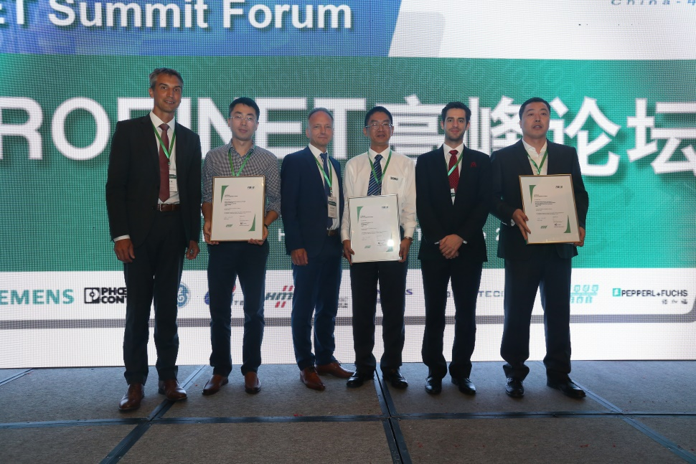
Press Contact:
PI (PROFIBUS & PROFINET International)
Barbara Weber

Haid-und-Neu-Str. 7

D-76131 Karlsruhe
Tel.: +49 (721) /96 58 - 5 49

Fax: +49 (721) / 96 58 - 5 89
Barbara.Weber@profibus.com
http://www.PROFIBUS.com
This text of this press release is available for download at www.profibus.com.

