Contact person:
Barbara Weber
Barbara.Weber@profibus.com
+49 721 9658-549

P R E S S R E L E A S E

IO-Link General Meeting sets course for the future

IO-Link community welcomes its 200th member

Karlsruhe, June 28, 2018: At this year’s IO-Link General Meeting on June 21, 2018, around 70 members came together in Frankfurt to discuss the direction IO-Link will be taking in the coming years and to set the agenda for the future. IO-Link’s success is a reason for many companies to join the community. At the General Meeting, Nanotec Electronic GmbH & Co. KG of Feldkirchen, near Munich, was welcomed as the community’s 200th member. Nanotech develops and distributes motors and controllers for premium drive solutions that are primarily utilized in the fields of automation technology, laboratory automation, medical technology, the packaging industry and semiconductor manufacture.

IO-Link’s success is evident through its extremely strong increase of products brought to the market. The number of IO-Link nodes had already reached over 8 million by the end of 2017. “Besides the absolute figures, it’s especially interesting to see the rate of acceleration. The total number of nodes had increased by 47% at the beginning of 2016, and we then recorded a further increase of 52% in 2017,” says Reinhard Schlagenhaufer of Siemens AG, who also chairs the newly elected Steering Committee. The Steering Committee is reelected every three years and currently consists of the companies Balluff, Banner, Beckhoff, Festo, ifm, Leuze electronic, Pepperl+Fuchs, Omron, Phoenix Contact, Rockwell Automation, Sick, Siemens, TE Concept, TMG and Turck.

IO-Link was originally developed for the easy wiring of intelligent, complex sensors and actuators using a simple, standardized, three-core sensor cable. Meanwhile, IO-Link has proven to be the key in implementing powerful Industry 4.0 concepts. In order to effectively guide IO-Link into the future, complementary topics have very recently been broached and developed successfully. This includes the release of the “IO-Link Safety System Extensions” specification in April 2017. Also, the “IO-Link Wireless System Extensions” specification underwent all internal reviews in the IO-Link community and was released in March 2018. It is now available globally to all device manufacturers.
Additional topics that were discussed in depth during the General Meeting related to Automation ML, mapping with OPC UA or JSON, and the vertical integration of IO-Link (e.g. in SAP systems). “Thanks to the great interest of our member companies and tremendous commitment of their representatives, I am confident that we are well equipped for the various tasks and challenges that remain in distributing IO-Link even further on the market,” comments Schlagenhaufer. “Users are already benefitting from a very simple and inexpensive solution for obtaining data from sensors and for further processing the data. Users can continue to rely on this in the future.”

***

Image:
Delighted about the 200th IO-Link member: Elmar Büchler, Balluff; Rainer Schönwald, head of the development department at Nanotec; and Reinhard Schlagenhaufer, Siemens (left to right).
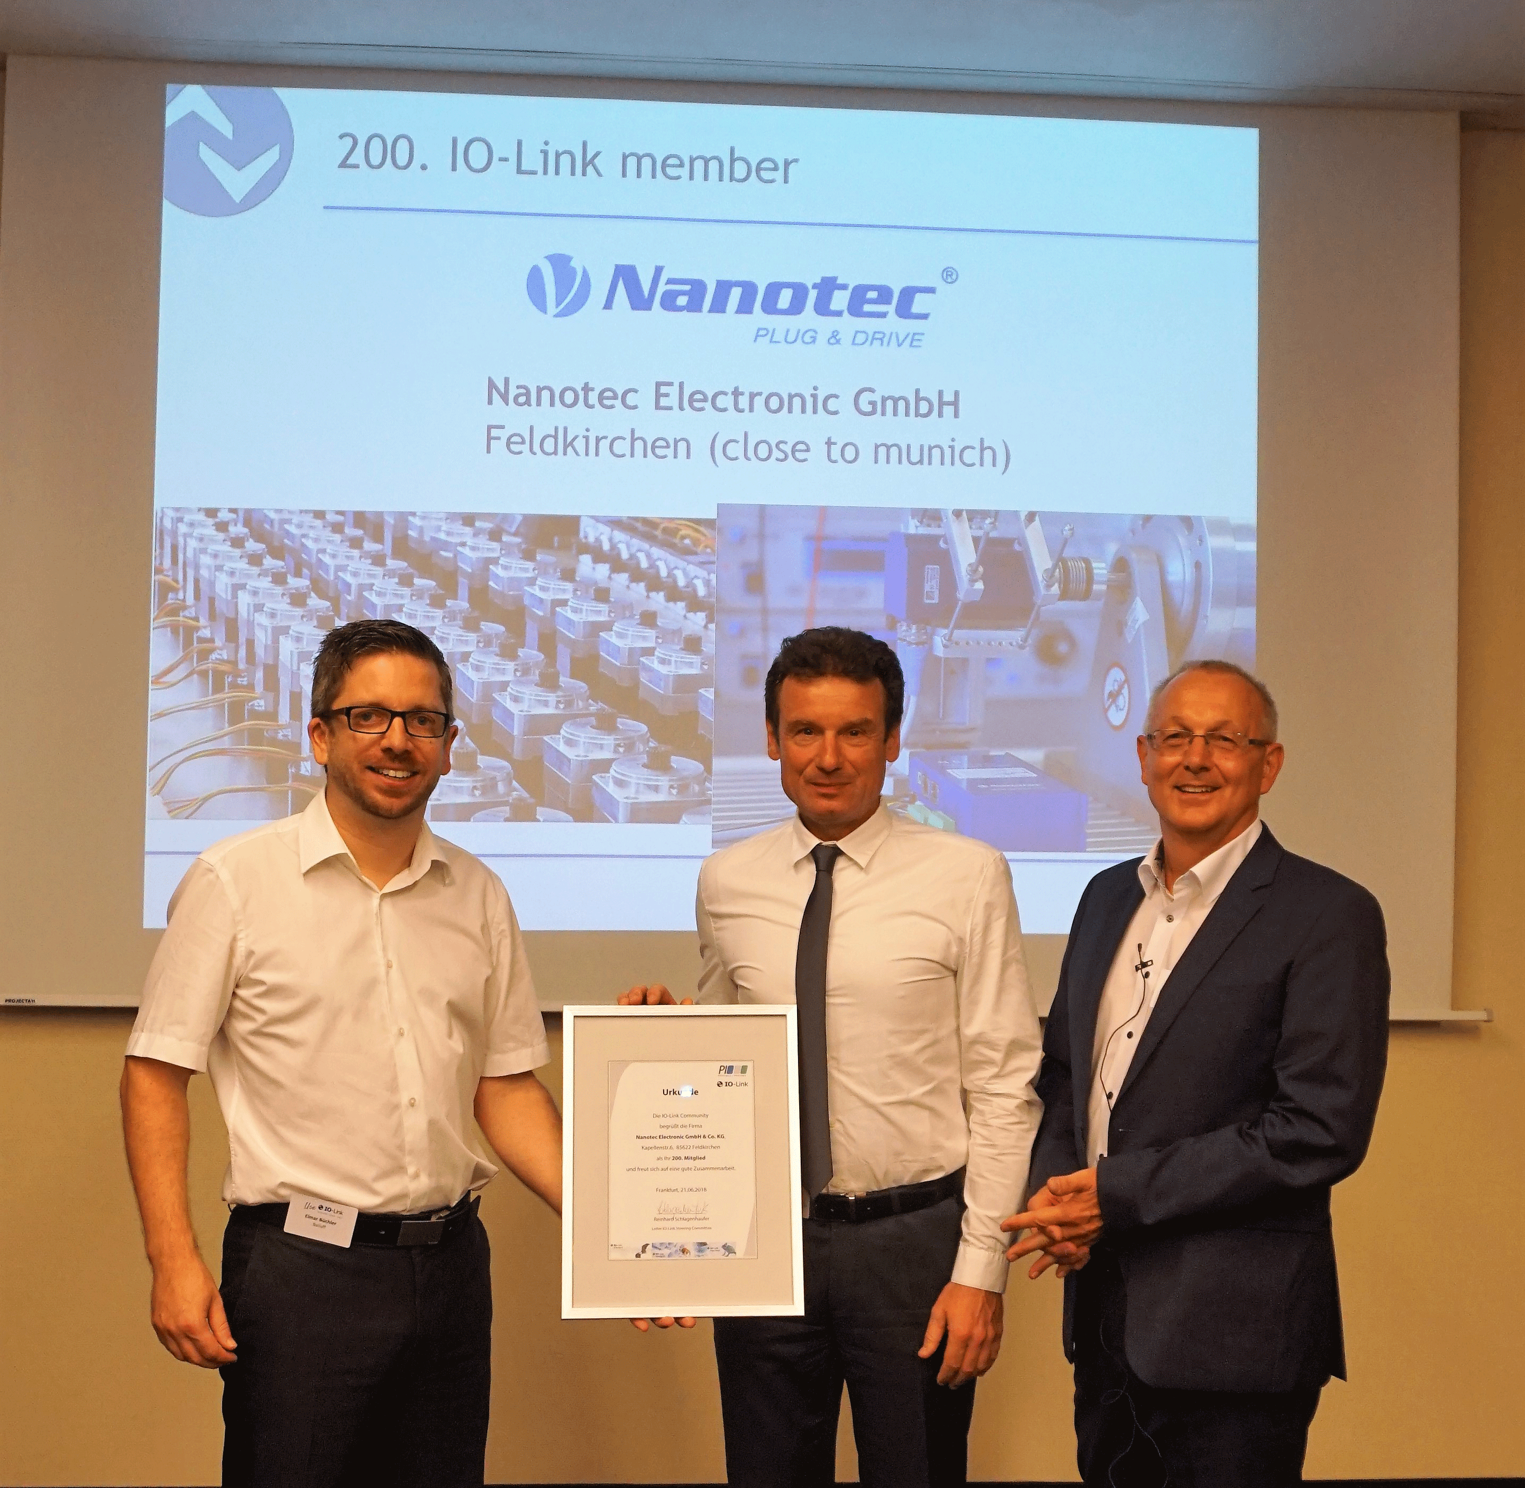
Press contact:
PI (PROFIBUS & PROFINET International)
PROFIBUS Nutzerorganisation e. V.
Barbara Weber

Haid-und-Neu-Strasse 7

D-76131 Karlsruhe, Germany
Phone: +49 (721) 96 58 549

Fax: +49 (721) 96 58 589
Barbara.Weber@profibus.com
http://www.PROFIBUS.com
The text of this press release is available for download at www.profibus.com.

