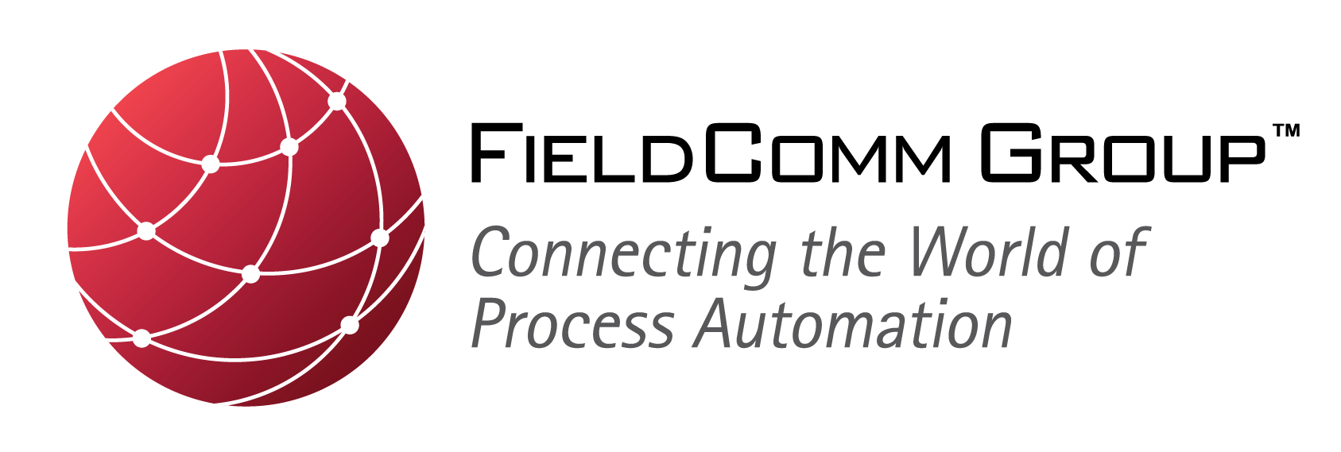

For Immediate Release

FieldComm Group, ODVA and PI Provide Joint Update on an Advanced Physical Layer for Industrial Ethernet

Organizations are cooperating to promote developments for Industrial Ethernet to expand use of EtherNet/IP™, HART-IP™ and PROFINET™ into hazardous locations in the process industry

Frankfurt, Germany — 12 June 2018 — The organizations FieldComm Group, ODVA and PI (Profibus & Profinet International) joined together to provide an update on developments that are underway to realize an advanced physical layer for Ethernet that can be used in process automation and instrumentation to connect field devices in remote and hazardous locations, commonly referred to as “APL.” The organizations were joined by representatives from suppliers of process instrumentation and controls in order to provide a well-rounded perspective on the benefits of an advanced physical layer for end users in the process industries, as well as discuss the actions being taken to complete the work needed to realize APL in process field devices.

The organizations announced the publication of a joint white paper, “Ethernet to the Field,” which lays out the vision and timeline for realization of an Ethernet technology suitable for use in remote and hazardous locations founding in the process industries. The organizations foresee that the first Ethernet-connected field devices for use in hazardous locations should appear in 2022. To achieve this result, the organizations are seeking to leverage the work currently underway in the IEEE 802.3cg Task Force, which is developing amendments to the IEEE 802.3 Ethernet standard for an Ethernet physical layer operating at 10 Mb/s over single-pair cable. Because of good progress for the specification of the long-reach solution (10BASE-T1L), it is planned that the IEEE 802.3 standard will include 10BASE-T1L by the end of 2019.

Experts of the APL project have already started the necessary additional developments to define the requirements and develop the necessary technology to achieve an Industrial Ethernet suitable for use in hazardous locations up to Zone 0, Division 1. To get the necessary approval, the experts work closely with a certification body for intrinsic safety to validate the developed Ex protection concepts and to prepare for standardization in the IEC.

Because the future developments for an advanced physical layer for Industrial Ethernet will provide significant benefits to end-users in the process industry, this press conference was held in conjunction with ACHEMA 2018, one of the world’s leading trade fairs for the process industries. As part of their joint promotion of an advanced physical layer and its potential adaptation to their respective industrial Ethernet networks – EtherNet/IP, HART-IP and PROFINET – the organizations plan to provide future updates at venues relevant to end users in the process industry including, but not limited to, the 2018 NAMUR General Meeting 2018, which will be held 8-9 November 2018 in Bad-Neuenahr, Germany.

About FieldComm Group
FieldComm Group is a global standards-based organization consisting of leading process end users, manufacturers, universities and research organizations that work together to direct the development, incorporation and implementation of new and overlapping technologies and serves as the source for FDI™ technology. FieldComm Group’s mission is to develop, manage and promote global standards for integrating digital devices into automation system architectures while protecting process-automation investments in HART® and FOUNDATION™ Fieldbus communication technologies. Membership is open to anyone interested in the use of the technologies. For more information, visit their web site at www.FieldCommgroup.org.

For more information, contact:
Talon Petty
Tpetty@FieldCommgroup.org

About ODVA
ODVA is an international standards development and trade organization with members from the world’s leading automation suppliers. ODVA’s mission is to advance open, interoperable information and communication technologies for industrial automation. Its standards include the Common Industrial Protocol or “CIP™,” ODVA’s media independent network protocol – and the network adaptations of CIP– EtherNet/IP, DeviceNet, CompoNet™ and ControlNet™. For interoperability of production systems and their integration with other systems, ODVA embraces the adoption of commercial-off-the-shelf, standard Internet and Ethernet technologies as a guiding principle. This principle is exemplified by EtherNet/IP – one of the world’s leading industrial Ethernet networks. Visit ODVA on-line at www.odva.org.

For more information, contact:
John Jackson
ODVA European Communications Office
jjackson@odva.org

Adrienne Meyer
ODVA Headquarters
ameyer@odva.org
+1(734)975-8840

About PI
PI is a wide spread automation community in the world represented by 25 different Regional PI Associations and is responsible PROFIBUS and PROFINET, the two leading industrial communications protocols covering all industries. The common interest of PI’s global network of vendors, developers, system integrators and end users lies in promoting, supporting and using PROFIBUS and PROFINET. Regionally and globally over 1,400 member companies are working closely together around the world to the best automation possible. The organization’s global influence and reach is unmatched in the world of automation. For more information, please visit the website at www.profibus.com .

For more information, contact:
Barbara Weber
PI (PROFIBUS & PROFINET International)
Barbara.Weber@profibus.com
+49 (721) 96 58 - 5 49

CIP, EtherNet/IP, DeviceNet, CompoNet and ControlNet are trademarks of ODVA, Inc.. FDI, FOUNDATION and HART-IP are trademarks of FieldComm Group. PROFIBUS and PROFINET are trademarks of Profibus & Profinet International. All other trademarks are property of their respective owners.

