P R E S S R E L E A S E

World’s first omlox test lab commences operations
On the path to open, future-proof tracking systems

Karlsruhe, Germany – February 13, 2024: The world’s first omlox test lab began its work in November 2023. PROFIBUS & PROFINET International (PI) has accepted the Fraunhofer Institute in Lemgo, Germany as a PI test lab for omlox. This enables manufacturers of tracking technologies to have their products tested according to the omlox standard at an independent test lab. The PI Certification Office creates certificates on the basis of positive test reports. The use of certified products in systems achieves a high degree of interoperability.

The function and interfaces of the manufacturer-independent omlox technology are described by standards. In order for components (hardware and software) from different manufacturers to work with one another in a system, the components must be implemented precisely following the standards. This is referred to as conformity. Conformity must be checked to ensure a high level of system quality and usability for users. At the world’s first test lab for this purpose, conformity is now being tested and confirmed so components can receive an omlox certification.

For the first time, omlox enables the technology- and manufacturer-independent provision of localization information in production environments. Various different localization technologies, such as ultra-wideband wireless (or UWB, which is widely used in localization systems thanks to its robustness), 5G, RFID, QR codes and GPS, can be used together and with standardized interfaces in an omlox system. The standard also ensures that so-called omlox satellites (components of the localization infrastructure in a building) can be integrated with omlox tags (devices localized via signals) regardless of the manufacturer.

Users are therefore able to implement future-proof, manufacturer-independent tracking systems based on omlox-certified products. Thus, omlox achieves a new level of transparency and is therefore regarded by experts as a pioneering localization standard with key functions for the advancing digitization taking place in industry and logistics. The availability of the first test lab marks a milestone for the omlox localization standard and its global distribution.

***
Graphic: The Fraunhofer Institute in Lemgo, Germany has been accepted as the world’s first test lab for omlox.
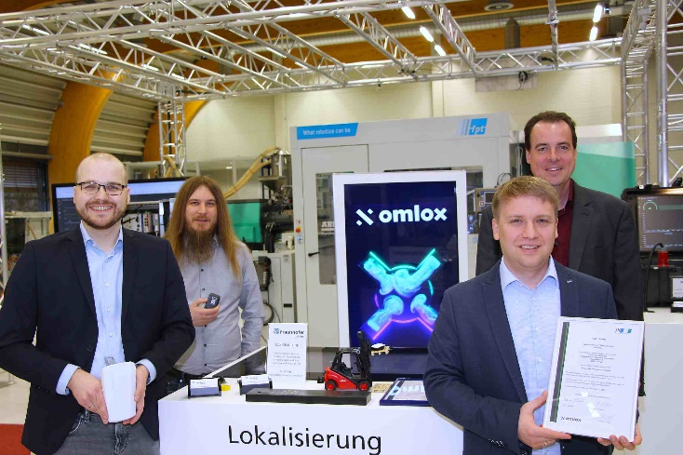
(from left to right): Florian Hufen, Florian Jungbluth, Harry Fast and Dr. Holger Flatt.
Source: (C) Fraunhofer IOSB-INA

Press contact:
PI (PROFIBUS & PROFINET International)
PROFIBUS Nutzerorganisation e. V.
Barbara Weber

Ohiostr. 8

D-76149 Karlsruhe, Germany
Phone: +49 07 21 986 197-49
Barbara.Weber@profibus.com
http://www.profibus.com
This press release is available for download at www.profibus.com.

