P R E S S R E L E A S E

PI-Konferenz back again in person in 2023

Nuremberg, Germany – November 9, 2022: The PROFIBUS Nutzerorganisation e.V. (PNO) is planning the next PI-Konferenz, once again as an in-person event at the House of Logistics and Mobility (HOLM) in Frankfurt am Main (Germany). On March 22 and 23, 2023, the eighth PI-Konferenz will be held with the aim of presenting PI technologies for the digital transformation.

The field of industrial communication is continuing to develop at an astonishing pace, resulting in constant changes in the field of automation technology. Industrial communication was, and is, a driving force for this process. It has enabled migration from centralized to decentralized automation systems, makes possible the use of distributed intelligence and links the worlds of OT and IT together. As the globally leading open industrial networking standards, PROFIBUS, PROFINET and IO-Link offer complete consistency with a high degree of application orientation for consistent communication – from the field level to the company management level.

Focal points of the conference will be driven by topics on digitization in the industrial environment. Key aspects will include semantics & information models, horizontal & vertical communication and flexible & energy-efficient production systems. Essential topics of the numerous presentations include the integration of TSN and OPC UA into PROFINET, security measures, the definition of semantic aspects in cooperation with other organizations – such as the OPC Foundation, IDTA and ECLASS – as well as innovations in sensor communication like IO-Link and Ethernet APL. Other topics recently added to the PI technology portfolio, such as omlox, the real-time tracking standard in buildings, and MTP, the standard for modular production systems, top off the program.

The joint framework for presentations will be the guiding theme “PI Technologies for the Digital Transformation.” The event isn’t just targeted at the community of the PI technologies, but its users as well – from decision makers to specialists.

Preliminary information on the program, as well as the option to register, can be found at:
www.pi-konferenz.de. The PI-Konferenz will be held in German language only.

***

Graphic: At the 2023 PI-Konferenz everything will revolve around digitization in the industrial environment.
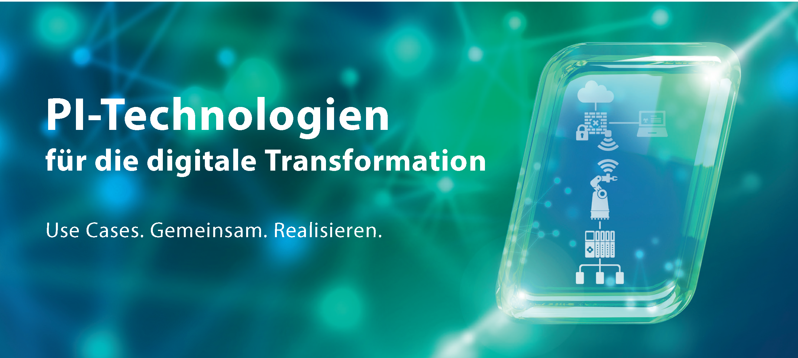
Press contact:
PI (PROFIBUS & PROFINET International)
PROFIBUS Nutzerorganisation e. V.
Barbara Weber

Haid-und-Neu-Str. 7

D-76131 Karlsruhe, Germany
Phone: +49 721 986 197 49
Barbara.Weber@profibus.com
http://www.PROFIBUS.com
The text of this press release is available for download at www.profibus.com.

