P R E S S R E L E A S E

New Virtual Meeting Place for Technology Enthusiasts

Karlsruhe, Germany – October 04, 2023: With the PROFINET Ecosystem Platform, PI (PROFIBUS & PROFINET International) has set up a virtual collaboration space for anyone who would like to actively play a part in the future of PROFINET technology. A center of knowledge for developers and product managers is being established with a new PROFINET website (www.profinet.com) and the associated PROFINET Community Forum. The forum is the heart of the platform—a place for technical discussion and cooperation. Technology experts from all around the world meet here to discuss the technical aspects of PROFINET. This interdisciplinary cooperation promotes the transfer of knowledge and the creation of collaborative solutions in production and process automation.

In the age of digitization, the networking of machines and systems is becoming more important all the time. To professionals taking part in this process, quick access to the right information and tools is indispensable. This is where the new PROFINET Ecosystem Platform comes in: It creates a virtual space where developers, product managers and technology enthusiasts can exchange knowledge, ideas and solutions revolving around PROFINET.

The platform combines the new PROFINET website and the PROFINET forum to create a comprehensive information center. It offers an abundance of technical knowledge relating to each and every PROFINET topic. Information on the latest technologies, implementations and certification, as well as all the relevant aspects of PROFINET, is available here.

A comprehensive FAQ section and extensive technical information make it easier for both beginners and experts alike to work with PROFINET. They serve as signposts for seamless integration of the technology into existing systems and the successful implementation of new projects.

PROFINET is continually being developed to meet the needs of industry. To this end, the new platform makes it easier to get started with a variety of different PROFINET topics - such as PROFINET application profiles, real-time & connectivity technologies and direct exchange with the network - to ensure smooth integration and interoperability of the solutions.

One focal point here lies on the implementation of PROFINET in devices and systems. Those who are interested receive instructions on preparing their devices for communication with PROFINET, including PROFINET stack integration, testing, certification and tried-and-tested procedures.

The openness of the Ecosystem Platform enables anyone to connect with the growing community, access information and contribute knowledge. The broad spectrum of topics requires cooperation by a variety of different specialist disciplines so the future of PROFINET can be shaped together.

The PROFINET Ecosystem Platform (www.profinet.com) is a pioneering project which will advance the digitization of industry with valuable information. It creates space for the exchange of knowledge, cooperation and innovation which developers, product managers and technically savvy specialists can use to push and extend the boundaries of industrial networking.

***

Graphics: The new PROFINET Ecosystem Platform is a virtual meeting place and knowledge center for developers and product managers alike.
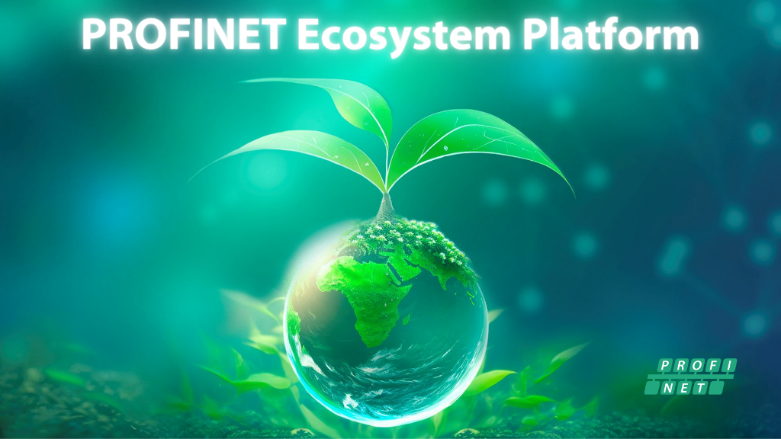
Press contact:
PI (PROFIBUS & PROFINET International)
PROFIBUS Nutzerorganisation e. V.
Barbara Weber

Ohiostraße 8

D-76149 Karlsruhe, Germany
Phone: +49 7 21 986 197-49
Barbara.Weber@profibus.com
http://www.profibus.com
This press release is available for download at www.profibus.com.

