P R E S S R E L E A S E

Impressive variety of PI technologies

Karlsruhe, Germany – February 28, 2023: At this year’s Hanover Fair from April 17 - 21, PI (PROFIBUS & PROFINET International) will be exhibiting its innovations at an impressive joint booth in Hall 9; Stand D68. Once again, a large number of technology demos on the current topics of PROFINET over TSN, PROFIsafe, OPC UA Safety, IO-Link Safety and omlox will be presented. In addition, the new topics of PROFINET over APL and PROFIsafe goes APL, which are of interest for applications in process automation, will also be exhibited as part of the live demo for PROFINET PA. The demos are continually being expanded and supplemented for this.

New at the joint booth will be the demo of a digital twin of drives and a machine, the physical versions of which will also be on display. Smooth interaction in a time-synchronized application with PROFINET IRT with eleven different manufacturers will be presented. To illustrate the advantages of digital transformation standardization, the digital twin for virtual commissioning and simulation of the drives and machine will also be shown.

For the first time, the new multi-vendor live demo will vividly illustrate the mechanisms of MTP (Module Type Package). Other feature walls will also be exhibiting the product variety of PROFINET and IO-Link.

A host of member companies will be showing their latest products and solutions in the technology demos and in individual presentation areas at the joint booth.

To find out more, go to:
https://www.profibus.com/hmi/
***
Graphic: New technology demos will be shown for the first time at the joint PI booth at the Hanover Fair.
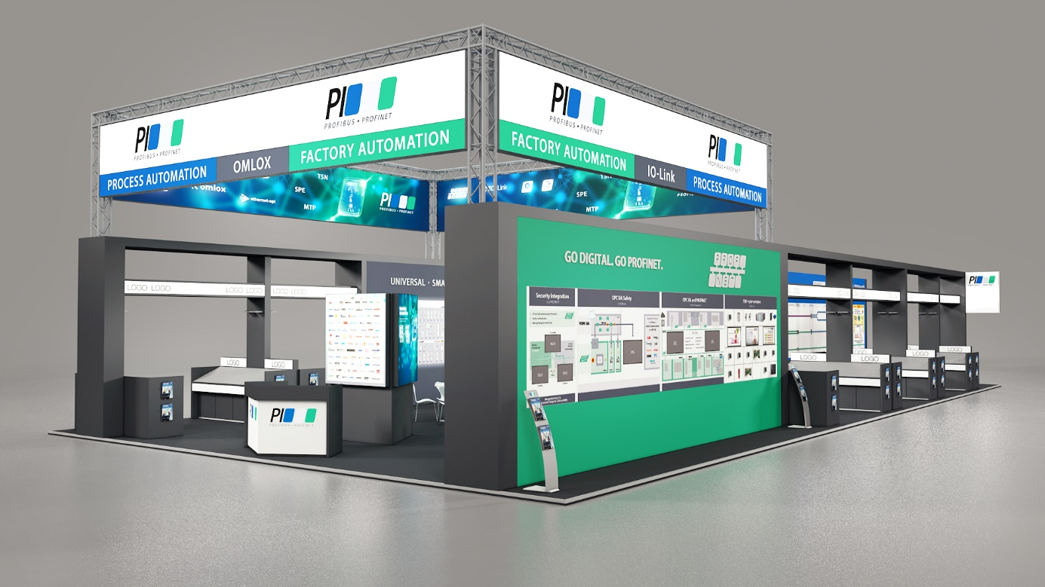
Press contact:
PI (PROFIBUS & PROFINET International)
PROFIBUS Nutzerorganisation e. V.
Barbara Weber

Haid-und-Neu-Str. 7

D-76131 Karlsruhe, Germany
Phone: +49 721 986 197 49
Barbara.Weber@profibus.com
http://www.PROFIBUS.com
The text of this press release is available for download at www.profibus.com.

