P R E S S R E L E A S E

TÜV Süd is the 400th member of the IO-Link Community

Hanover, Germany – May 30, 2022: IO-Link is a prerequisite for Industry 4.0 and the fastest growing technology in the industrial automation field internationally. There are now more than 22,000 different products with more than 27 million nodes installed around the world. IO-Link Safety is an extension of IO-Link, stipulating an additional layer of safety communication on both the master and device sides, making them the "FS Master" and "FS Device". Numerous manufacturers are now working on the development of IO-Link Safety products and systems.

That's why PI (PROFIBUS & PROFINET International) is especially pleased that TÜV SÜD has become the 400th member of the IO-Link Community. The company has been engaging with IO-Link technology for many years and is a leading driver of IO-Link Safety. “We at TÜV SÜD are impressed with IO-Link technology and want to support this technology, both through our membership and as a Test Lab for IO-Link Safety in the future,” said Günter Greil, head of the automation division at TÜV SÜD.

As an independent testing body, the company certifies the functional safety of the IO-Link Safety concept. TÜV SÜD accompanies device manufacturers should they have safety-related questions when implementing IO-Link Safety solutions. A separate Test Lab for IO-Link Safety is planned for the future, and operation is slated to begin at the end of the year.

***

Photo: As one of his first official acts, new Head of the IO-Link Steering Committee Joachim Uffelmann is pleased to welcome TÜV SÜD, represented here by Günter Greil, as the 400th IO-Link member.

Joachim Uffelmann (left) / Günter Greil (right)
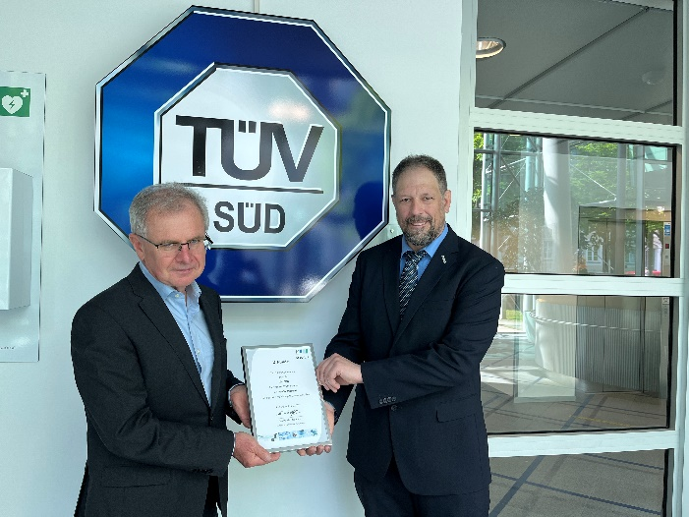
Günter Greil left / Joachim Uffelmann right

Press contact:
PI (PROFIBUS & PROFINET International)
PROFIBUS Nutzerorganisation e. V.
Barbara Weber

Haid-und-Neu-Str. 7

D-76131 Karlsruhe, Germany
Phone: +49 7 21/96 58-5 49

Fax: +49 7 21/96 58-5 89
Barbara.Weber@profibus.com
http://www.PROFIBUS.com
The text of this press release is available for download at www.profibus.com.

