P R E S S R E L E A S E

An Anniversary Year for the PNO
35 years of reliability and innovation in communication technology

Karlsruhe, Germany – March 19, 2024: 35 years ago, on December 11, 1989, the PROFIBUS Nutzerorganisation e. V. (PNO) was founded in Frankfurt am Main, Germany to promote the standardization and technology of fieldbus systems. Back then, the foundation of an assertive fieldbus standard was laid by 10 companies, four technical & scientific institutions and ZVEI e. V. Today, PROFIBUS & PROFINET International (PI) is the world’s leading user organization for industrial communication technology with 24 regional user organizations found on all the continents of the globe. PROFINET is the world’s number one core technology in both the production & process industries and in motion control applications as well.

The number of member companies isn’t the only thing that has grown, though, as the portfolio managed by the PNO has also diversified. Long gone are the days when PI’s range included only PROFIBUS and PROFINET. Today, these technologies are joined by IO-Link, omlox, MTP and the SRCI robot interface.

Extensive Qualification Process

Success isn’t a matter of chance. “When users decide to use a certain technology, they trust the reliability, stability and interoperability of the components. That’s why PI relies on global standardization with no compromises,” emphasized Xaver Schmidt, Chairman of PI. “We consilidate data and make sure that it can easily be collected and processed by the corresponding application.”
Incidentally, this requirement was already a core element of the PNO philosophy back when it was founded 35 years ago. To ensure the interoperability of products from different suppliers from the very beginning, the PNO established an extensive, global certification system. Today, this includes 10 globally collaborating test laboratories supplemented by 56 competence centers, as well as training courses, webinars and workshops, where both developers and users are able to exchange information on a regular basis.

The PNO isn’t just a host of experts in industrial network technology, as they excel in interpersonal communication as well. Over 600 experts in 50 working groups are currently committed to implementing new trends from the market into reliable technology. This includes topics like wireless applications, safety, security, data transfer for data analytics and energy management. PI is working closely together with ZVEI, VDMA, ECLASS, NAMUR, the FieldComm Group, ODVA, the Industrial Digital Twin Association (IDTA) and the OPC Foundation here. Practical, cross-technology solutions are correspondingly being developed on a collaborative basis.

No PI Technology? No Digitization!

The numbers speak for PI’s success. According to the 2022 count, more than 67 million PROFIBUS nodes, over 58 million PROFINET nodes and 35 million IO-Link nodes have been installed. A new count has been initiated. Ethernet APL and MTP will get underway this year, and omlox is represented in more than 300 applications so far. “Over the years, we’ve set standards in communication technology and automation. In many cases, this was the basis for enabling innovations to get a foothold in practice,” remarked Schmidt, continuing, “The future belongs to PI technology, not only for simply making digitization possible, but also for designing energy- and resource-efficient processes in practice.”

***

Graphic: The PNO is celebrating its 35th anniversary this year.

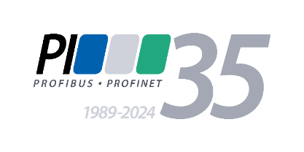

Graphic: For 35 years now, the PNO has been one of the most important drivers and trend setters in the field of communication technology. No PI technology? No digitization!
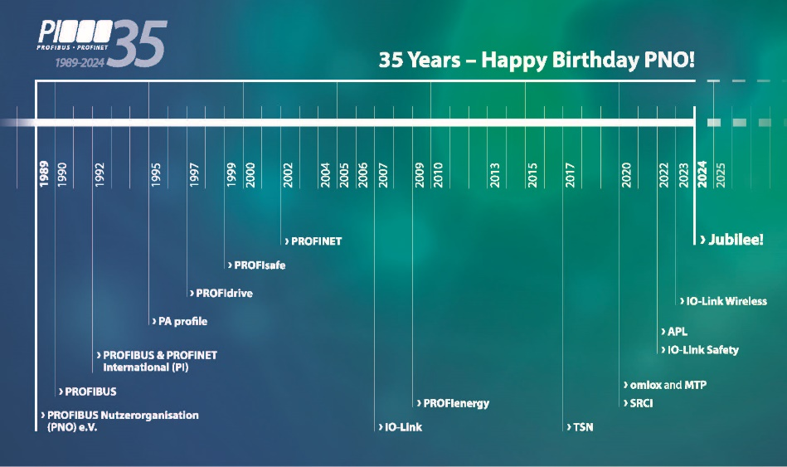

Press contact:
PI (PROFIBUS & PROFINET International)
PROFIBUS Nutzerorganisation e. V.
Barbara Weber

Ohiostr. 8

D-76149 Karlsruhe, Germany
Phone: +49 7 21 986197 49

Fax: +49 7 21 986197 11
Barbara.Weber@profibus.com
www.PROFIBUS.com
www.PROFINET.com

