Contact person:
Barbara Weber
Barbara.Weber@profibus.com
+49 721 9658-549

P R E S S R E L E A S E

Over 100 million PROFIBUS and PROFINET devices in use

Karlsruhe, Germany – May 03, 2021: Despite challenges brought about by the pandemic, products featuring technology from PROFIBUS & PROFINET International (PI) have been very well accepted by users. With the total number of PROFIBUS and PROFINET products so far installed at plants has exceeded 104 million, an impressive threshold has been crossed. On a yearly basis, PROFINET has beaten all previous records with a total of 7.3 million products placed on the market. The number of installed PROFINET devices rose by more than 22% in comparison to the previous year, reaching a combined total of 40 million. In 2020, a total of 1.7 million PROFIBUS devices were placed on the market, of which 0.8 million were used in process industry applications. Over the past few years, the percentage of PROFIBUS products installed in processing plants has continually increased. It’s expected that the majority of PROFIBUS products supplied next year will be utilized in process automation plants. In production technology, meanwhile, around four times as many devices have been equipped with a PROFINET interface than a PROFIBUS interface.

As for IO-Link, 5 million devices were supplied in 2020 – the largest number of any year so far. Even in tough times, IO-Link managed to achieve a growth rate of 31%, which proves that the technology is firmly anchored in the applications. The total number of installed IO-Link devices is now more than 21 million.

In 2020, 2.6 million PROFIsafe nodes were installed, narrowly beating out the previous year’s figure. The total number of PROFIsafe nodes installed now stands at over 16 million.

“The user sees our technologies as proven in practice, reliable and viable for the future. For some time now, users have been implementing Industry 4.0 requirements at their plants on a large scale, and our technologies provide a solid basis for this. In the past year, we added another important component for flexible and efficient production to our portfolio: omlox. This demonstrates our clear orientation toward the future,” commented Karsten Schneider, Chairman of PROFIBUS & PROFINET International (PI).

Despite the constraints caused by the pandemic, PI continued to forge ahead with technology development and distribution at full speed to provide device manufacturers and users a good basis for the time when society and the economy return to business as usual or a new normal – hopefully in the foreseeable future.

***
Graphic: Even during a year faced with coronavirus-related challenges, PROFINET was able to achieve solid growth, with the installed base having passed the 40 million mark.
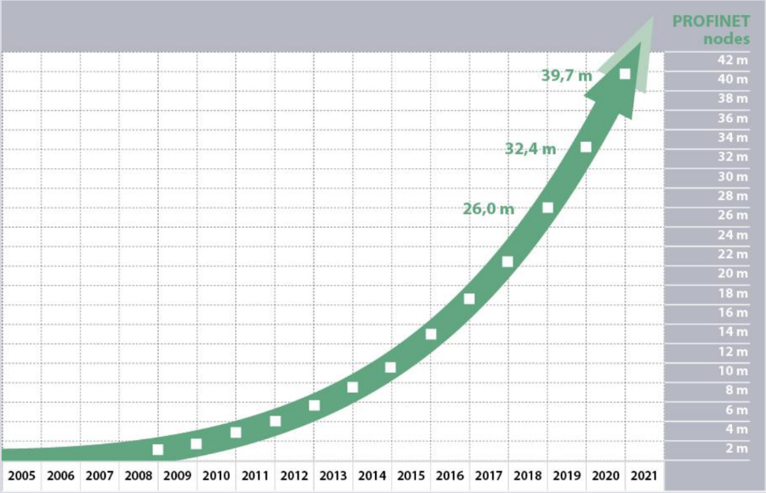
IO-Link also continued along its path of growth in 2020, having supplied a record-breaking 5 million new IO-Link devices in one year.
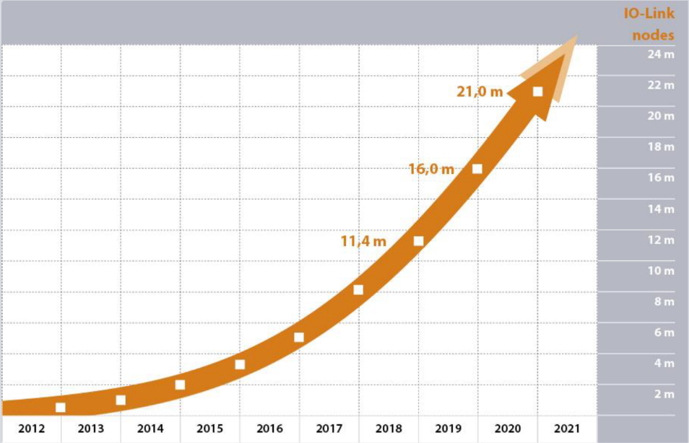

Press contact:
PI (PROFIBUS & PROFINET International)
PROFIBUS Nutzerorganisation e. V.
Barbara Weber

Haid-und-Neu-Str. 7

D-76131 Karlsruhe, Germany
Phone: +49 7 21/96 58-5 49

Fax: +49 7 21/96 58-5 89
Barbara.Weber@profibus.com
http://www.PROFIBUS.com
The text of this press release is available for download at www.profibus.com.

