Contact person:
Barbara Weber
Barbara.Weber@profibus.com
+49 (721) 9658-549

P R E S S R E L E A S E

New IO-Link Design Guideline

Karlsruhe, February 16, 2017: A new Design Guideline from the IO-Link Community offers all interested users support during the planning of automation systems with IO-Link devices. In an action-oriented approach, the tasks required during planning are described step by step. Used as the basis for this desing guideline is the IO-Link specification version 1.1.2.

Beginning with a short description of the IO-Link technology and its place in the automation pyramid, the guideline details the advantages of IO-Link. An example system is then used to illustrate and find solutions for the subtasks of the electotechnical planning. Chosen as the example for the planning was a conveyor system consisting of multiple conveyor belts. These conveyor belts are based on a uniform basic module. Different types of IO-Link devices are planned on the conveyor belts.

In a first step of the electrotechnical planning, the technical properties of the IO-Link devices are explained. This includes properties such as IO-Link version, port class, power demand and size of the process data. In a subsequent step, the IO-Link master is selected on the basis of various aspects, such as higher-level bus system, protection class, port class and a number of other criteria.

After the system structure has been established and the IO-Link devices and the IO-Link master defined, the wiring is planned in the next step. Of primary concern with the wiring is the connection between the IO-Link master and its IO-Link devices. Taken into account here are both the number of cable cores and the number of pins on the connectors, the currents and the voltage drop on the cable. Once all relevant points of the planning applicable to hardware have been completed, the results are documented in tabular form.

The guideline is available for download free of charge at www.io-link.com.

***
Graphic: New Design Guideline Available for IO-Link
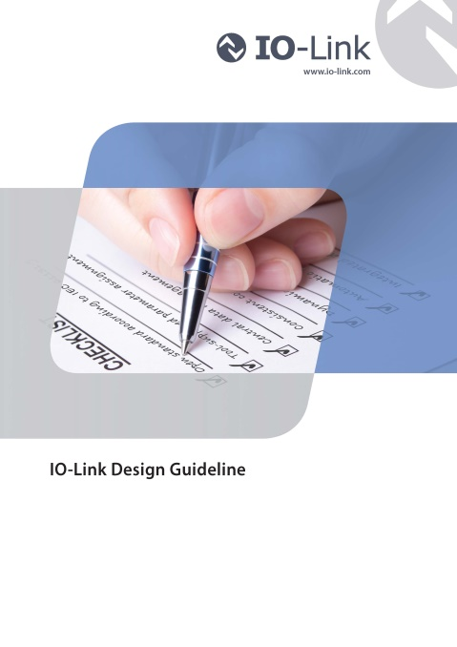
Press contact:
PI (PROFIBUS & PROFINET International)
PROFIBUS Nutzerorganisation e. V.
Barbara Weber

Haid-und-Neu-Strasse 7

D-76131 Karlsruhe, Germany
Tel.: +49 (721) 96 58 - 5 49

Fax: +49 (721) 96 58 - 5 89
Barbara.Weber@profibus.com
http://www.PROFIBUS.com
The text of this press release is available for download at www.profibus.com,

