P R E S S R E L E A S E

“IO-Link Safety Certified Designer” training course

Karlsruhe, Germany – May 10, 2022: IO-Link Safety expands machines and systems automated with IO-Link to include functionally safe components and communication. The latest version of the IO-Link Safety specification (1.1.3) and version 1.1 of the associated test specification with protocol and functional tests build upon the successful base technology specifications in the IO-Link 2020 package.

An English-language “IO-Link Safety Certified Designer” training course will be held for interested participants from October 4 through 6, 2022 in Karlsruhe. This course is being organized together with the TÜV-SÜD assessment body and will award a personal TÜV certificate to each participant who passes the test.

On the first day of the course, content will include the basics of IO-Link Safety, such as safety principles, functional objectives, requirements for IO-Link (“black channel”), risks & remedial measures, the communication protocol, fault detection, device replacement without tools, configuration options & backup, possible architectures, testing & certification, environmental regulations, and example applications.

On the second day, TÜV-SÜD will cover the basics of safety development – of FS masters and FS devices in particular – in accordance with IEC 61508/62061 and ISO 13849, enabling participants to evaluate the implications for the engineering departments of their company. This includes an overview of the relevant standards & their content, project management, management for functional safety, required documentation, life cycle, safety functions, preferred architectures, methods for avoiding dangerous faults, FMEA, verification & validation and certification.
The third day will begin with a general overview of procedures for design & implementation and the creation of IODDs, including CRC calculations, and dedicated tools. A host of suppliers will then present development kits and development support.

Written tests are administered after the completion of each day’s training. All the tests must be passed in order to receive a certificate. A participation fee of 500 Euros is charged for the course. For more information and online registration, visit www.io-link.com.

***

Graphic: IO-Link Safety expands machines and systems automated with IO-Link to include functionally safe components and communication. IO-Link is offering an IO-Link Safety Certified Designer training course together with TÜV-SÜD.

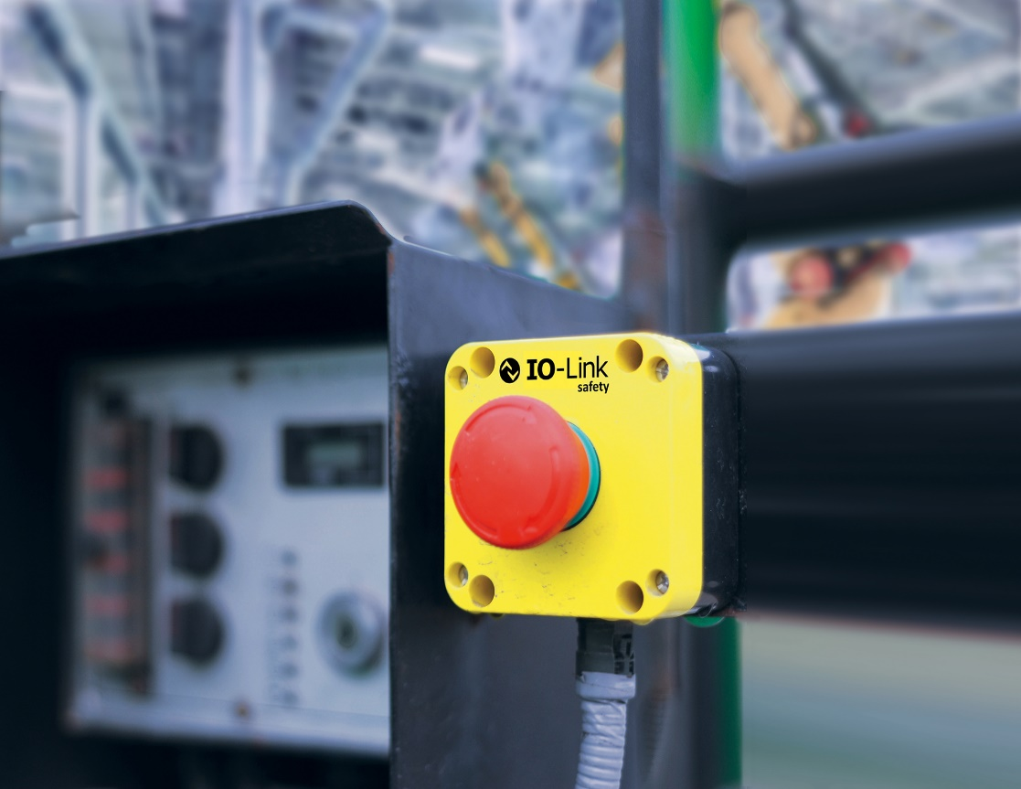
Press contact:
PI (PROFIBUS & PROFINET International)
PROFIBUS Nutzerorganisation e. V.
Barbara Weber

Haid-und-Neu-Str. 7

D-76131 Karlsruhe, Germany
Phone: +49 721 986 197-49
Fax: +49 721 986 197-11
Barbara.Weber@profibus.com
http://www.profibus.com
The text of this press release is available for download at www.profibus.com.

