P R E S S R E L E A S E

IO-Link Digital Days 2024: An Interactive Platform of Experts
Karlsruhe, Germany – March 25, 2024: The IO-Link Digital Days 2024 will be held for the first time from May 6 through June 3, 2024. This interactive platform provides information on the future-oriented IO-Link technology, as well as innovative solutions and services. Its special event format, which includes live presentations, a digital trade show hall and a chat function will network users, integrators and IO-Link experts alike and will support the exchange of current developments in digital industrial communication. Organized by the IO-Link Community, the IO-Link Digital Days are a supplement to the familiar user forums which take place in different locations multiple times a year.

IO-Link technology is revolutionizing industry by digitizing values and data of machines. One important feature of this is bidirectional communication, where both the master and the connected devices can send & receive process and service data. The IO-Link Digital Days are intended to network companies, users and integrators from the IO-Link community with one another—globally and in real time. This creates solid connections which further advance IO-Link in practice.

In the context of Industry 4.0, the service data of IO-Link masters can easily be transferred to higher-level IT ecosystems and customer clouds over standardized IoT interfaces such as OPC-UA, REST API and MQTT. Practical examples relating to new systems, upgrading and remote service will be presented here.

The centerpiece of the event will be an exclusive program of presentations by leading IO-Link experts, who will provide live information on the IO-Link basics, specific benefits of IO-Link, innovative technical solutions and future trends. Both exhibitors and visitors will move throughout the digital rooms and presentation rooms with a personalized avatar, which will enable them to interact with one another and converse live via video chat. This new platform of the IO-Link community offers interested parties around the globe the ability to exchange information in person without the need for time or money to travel.

More information on the digital O-Link Days 2024 event can be found on the IO-Link website (www.io-link.com).
***

Graphics: This interactive platform provides information on the IO-Link technology. The centerpiece of the event will be an exclusive program of presentations by leading IO-Link experts.
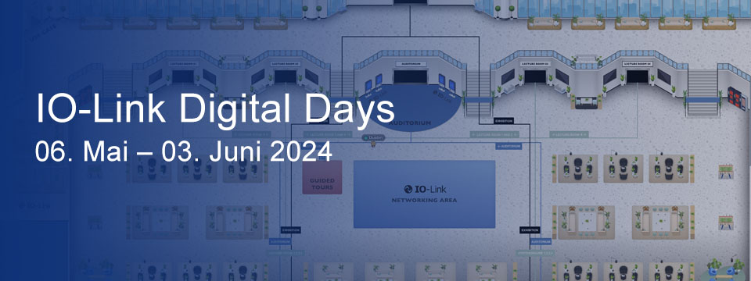
Press contact:
PI (PROFIBUS & PROFINET International)
PROFIBUS Nutzerorganisation e. V.
Barbara Weber

Ohiostr. 8

D-76149 Karlsruhe, Germany
Phone: +49 07 21 986 197-49
Barbara.Weber@profibus.com
http://www.profibus.com
This press release is available for download at www.profibus.com.

