Contact person:
Barbara Weber
Barbara.Weber@profibus.com
+49 721 986 197-49

P R E S S R E L E A S E

New white paper released: “Information models – PI strategy for Industry 4.0”

Karlsruhe, Germany – April 12, 2022: The classic communication landscape consists of cyclic data exchange between controllers and field devices, as well as data exchange for parameter setting, monitoring and diagnostics of the field devices. In the meantime, though, new vertical information channels with a large amount of data are being added more and more frequently. Standardized, open information models help to structure large data volumes and add additional descriptions to a variable here. For information modeling, PI (PROFIBUS&PROFINET International) is committed to using OPC UA technology, which is widespread today. A new white paper entitled “Information models” describes their role within PI technologies and points out the path to implementation of Industry 4.0 applications.

Machine-interpretable semantic descriptions can be generated for all data provided by devices and components using PI technologies. This being the case, the more than 48 million devices with a PROFINET interface in use in the field open up access to this data. Information models now give us very easy access to information from devices, machines & systems and save lots of time when integrating new components in doing so. They also considerably simplify the coupling of IT applications to systems.

Industrial communication, especially PROFINET and IO-Link, meets all the requirements for vertical communication. It therefore makes sense to integrate the information models into PI technologies in such a way that seamless further development of the existing device technology is enabled. This has to happen in such a way that vertical communication doesn’t affect control tasks and that it’s equipped with the necessary IT security measures.

The first standardized, open information models for PROFINET and IO-Link are already available. A successful example of this is PROFIenergy. This profile provides the means to collect energy measurement values in the systems of different manufacturers and therefore make them available to other applications, such as an energy management app, without much effort.

A newly released white paper describes how implementation of information models works in practice, the role played by PI technology there and future areas of focus.

The white paper is available for download for free in both German and English at www.profibus.com.

***
Graphic: The new white paper entitled “Information models” describes their role within PI technologies and points out the path to implementation of Industry 4.0 applications.

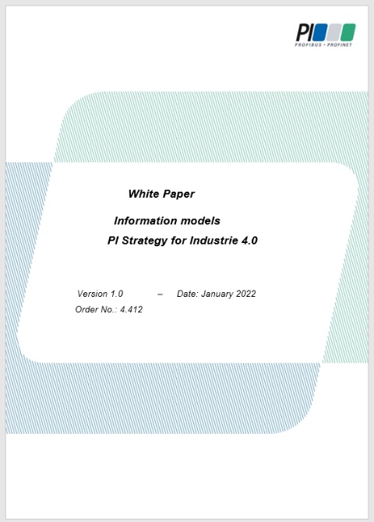

Press contact:
PI (PROFIBUS & PROFINET International)
PROFIBUS Nutzerorganisation e. V.
Barbara Weber

Haid-und-Neu-Str. 7

D-76131 Karlsruhe, Germany
Phone: +49 721 986 197-49
Fax: +49 721 986 197-11
Barbara.Weber@profibus.com
http://www.profibus.com
The text of this press release is available for download at www.profibus.com.

