Contact person:
Barbara Weber
Barbara.Weber@profibus.com
+49 (0) 721 9658-549

P R E S S R E L E A S E

IO-Link and JSON

Karlsruhe, Germany – April 24, 2020: The IO-Link Community has published a new specification for easy data exchange (www.io-link.com). This specification describes how data can be exchanged by IO-Link over JSON REST and MQTT – fully in line with the transparent communication of Industry 4.0.

The Industrial Internet of Things (IIoT) and Industry 4.0 are among the most important concepts and developments for the future of industrial communication. This future will require transparent communication from the lowest sensor/actuator level to a new generation of mobile and cloud-based applications. One of the deciding factors for this future will be simple, standardized and cross-manufacturer protocols. These protocols have to be able to work across all physical layers in order to enable global access to data for identification, diagnostic and configuration information. In the field of automation technology, Ethernet-based communication has been very widely implemented on the transport layer for some time now. PROFINET is a global market leader ahead of all the others here.

For seamless data transport into the world of IT, JSON (Java Script Object Notation) has established itself as a highly streamlined exchange format which can be used across all system boundaries. Through additional specification of the semantics, easy interpretation of the data is also made possible. This enables the seamless connection of the IO-Link level to MES/ERP systems, cloud-based services and applications outside classical PLC automation in general.

The demand for uniform standardized data consistency from the lowest field level to cloud-based services was accepted by the IO-Link Community, which first defined a JSON-based exchange format in a dedicated working group and thus the uniform semantic integration of the IO-Link field level into the world of IT. The specification encompasses both the definition of an API as the REST interface and data transport over MQTT.

This standardized exchange format now provides fundamentally new opportunities, such as cross-manufacturer engineering and global access to measurement values and other monitoring data. For example, classical configuration tools can be tied in across all manufacturers by JSON via REST. Streamlined “sensor to cloud” (IIoT) applications are also easy to implement with the very widely used MQTT protocol with the publisher/subscribe mechanism. This even makes it possible to implement a cloud-based automation task with manufacturer-independent components, for example.

***
Graphic: Fully in line with Industry 4.0, the new specification enables the easy exchange of data with IO-Link and JSON.
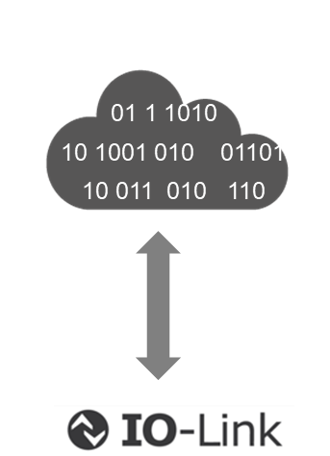

Press contact:
PI (PROFIBUS & PROFINET International)
PROFIBUS Nutzerorganisation e. V.
Barbara Weber

Haid-und-Neu-Str. 7

D-76131 Karlsruhe, Germany
Phone: +49 (0) 7 21/96 58-5 49

Fax: +49 (0) 07 21/96 58-5 89
Barbara.Weber@profibus.com
http://www.PROFIBUS.com
The text of this press release is available for download at www.profibus.com.

