Contact person:
Barbara Weber
Barbara.Weber@io-link.com
+49 (721) 9658-549

P R E S S R E L E A S E

IO-Link Wireless Developer Workshop in Hamburg

Hanover, April 23, 2018: The IO-Link Community is holding an IO-Link Wireless Developer Workshop in June 2018. This workshop will be held on June 27 and 28, 2018, at the Helmut Schmidt University (HSU) in Hamburg.

IO-Link is the world's first standardized, cross-manufacturer IO technology (IEC 61131-9) that communicates from the control all the way down to the lowest automation level. The universal interface is a fieldbus-independent, point-to-point connection that functions with an unshielded standard cable. IO-Link transfers all sensor/actuator signals to the control level and, vice versa, passes control data on to the sensor/actuator level. Due to high demand, this technology has now been expanded to include wireless communication. With respect to parameter data, process data, configuration or diagnostics, IO-Link Wireless is fully compatible with the familiar IO-Link technology and also offers additional advantages in terms of the number of devices that can be used per master and, of course the reduction in wiring.

Do you want to learn how you can develop an IO-Link Wireless device? What tools are available? Who offers development support? The IO-Link Wireless Developer Workshop provides answers to these questions. In application-oriented presentations, you will receive a compact overview of this amazing technology.

Extensive live demonstrations and hands-on sessions demonstrate the easy-to-use IO-Link Wireless system with corresponding hardware and software solutions. During the presentation of innovative
and interoperable technologies, participants will receive valuable information concerning their specific application in a personal dialog with specialists.

The IO-Link Wireless Developer Workshop is intended for both developers and technology specialists as well as for product managers of device manufacturers. On the one hand, participants will learn about the possibilities for simple and fast integration of IO-Link Wireless in devices, and, on the other hand, will receive instruction about the basics of IO-Link Wireless. Participants will become acquainted with mechanisms and details of wireless communication. The goal of the workshop is to provide a comprehensive overview of the IO-Link Wireless technology to device manufacturers. The interplay between the various components (master, base station, device, engineering, PLC) as well as the handling and configuration of these components will be shown using live demonstrations.

The participation fee for this two-day workshop is €190. You can find further information and registration details at: www.io-link.com/wireless_workshop

***
Graphic:
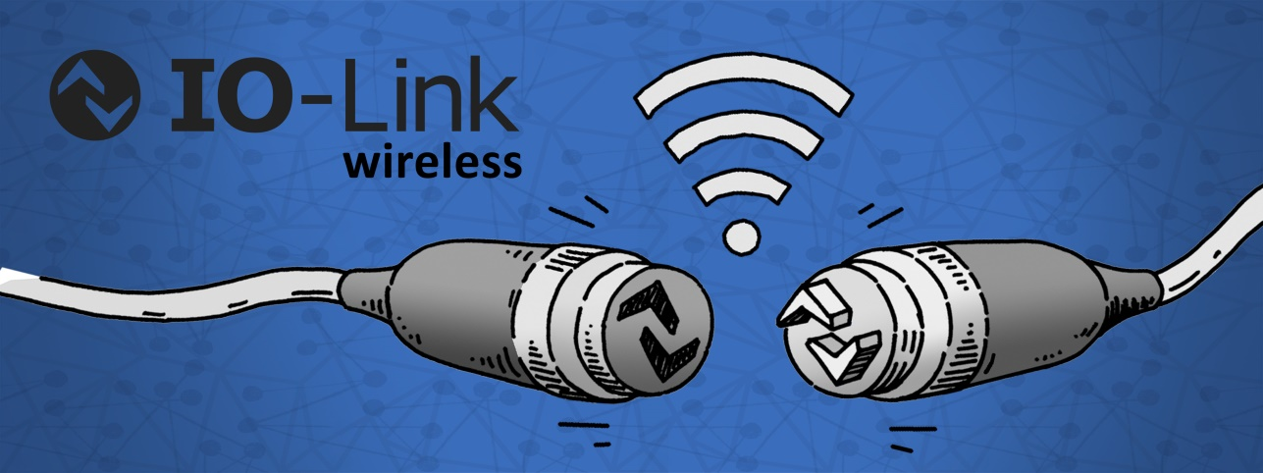

Press contact:
PI (PROFIBUS & PROFINET International)
PROFIBUS Nutzerorganisation e. V.
Barbara Weber

Haid-und-Neu-Strasse 7

D-76131 Karlsruhe, Germany
Phone: +49 (721) 96 58 - 5 49

Fax: +49 (721) 96 58 - 5 89
Barbara.Weber@profibus.com
http://www.PROFIBUS.com
This press release is available for download at www.profibus.com,

