Contact person:
Barbara Weber
Barbara.Weber@profibus.com
+49 721 9658-549

P R E S S R E L E A S E

Joint PI stand at the SPS IPC Drives trade fair – At the center of Industry 4.0

Karlsruhe, Germany – September 18, 2018: The joint PI (PROFIBUS & PROFINET International) stand at the SPS IPC Drives trade fair in Nuremberg, Germany November 27 – 29, 2018 will now be located in Hall 5, Stand 210, and will form an impressive fundamental bridge between automation and IT.
SPS IPC Drives is the ideal platform for PI to present its new “Industry 4.0 Demonstrator,” which shows PROFINET in the Industry 4.0 environment and the link between automation and IT in many application scenarios. Use cases include, increasing flexibility based on a modular and convertible factory, increasing productivity by analyzing data in the cloud and reducing time-to-market through virtual commissioning, among others. The Demonstrator will present the flow of data/information between the various levels, all the way to the IoT, in a clear way.
The interaction between automated production and order management will be rounded off with a live demonstration by a number of drive manufacturers who will show the application and advantages of the PROFIdrive profile in the respective application classes.
The implementation of industrial communication for Industry 4.0 will be one of PI’s core topics. In another new live demo, the goal and function of OPC UA in a PROFINET context will be shown with a variety of use cases. TSN and security will also be presented using demonstration models, where visitors will be able to see the collaboration between different manufacturers for themselves for the first time.
PROFIsafe will be refocusing its priorities at SPS 2018 with an updated live demo showing interoperability and manufacturer-independence through failsafe peripherals, controllers, drives, sensors and actuators. The topic of PROFIsafe via OPC UA will also be presented by the experts from PI.
Regarding IO-Link, the focus will still be on device diversity with different masters, devices and service providers, IODDfinder and the topics of IO-Link Safety and IO-Link Wireless.
PI and its 100+ international co-exhibitors are looking forward to your visit in Hall 5, Stand 210, and providing you with lots of information on PI at the center of Industry 4.0. For more information on the joint PI stand and our exhibitors, visit: www.profibus.com/sps.

***
Foto: The joint PI (PROFIBUS & PROFINET International) stand at the SPS IPC Drives trade fair in Nuremberg, Germany November 27 – 29, 2018 will now be located in Hall 5, Stand 210, and will form a bridge between automation and IT.

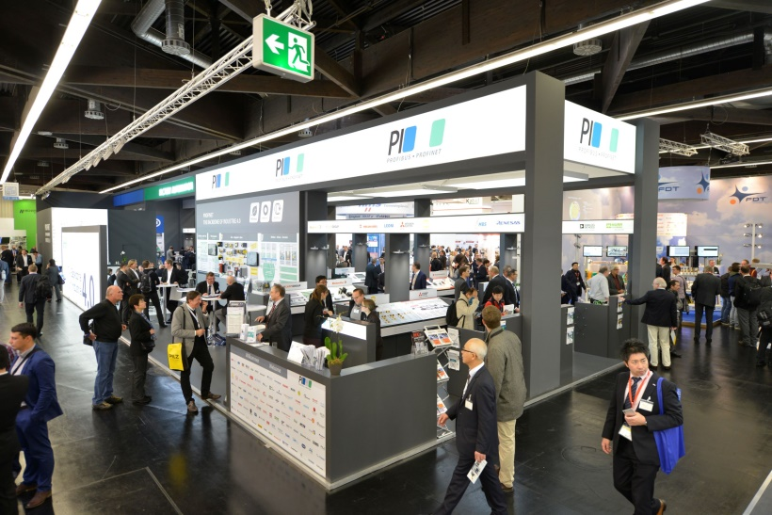
Press contact:
PI (PROFIBUS & PROFINET International)
PROFIBUS Nutzerorganisation e. V.
Barbara Weber

Haid-und-Neu-Strasse 7

D-76131 Karlsruhe, Germany
Phone: +49 7 21 /96 58 - 5 49

Fax: +49 7 21 / 96 58 - 5 89
Barbara.Weber@profibus.com
http://www.PROFIBUS.com
The text of this press release is available for download at www.profibus.com.

