P R E S S R E L E A S E

The omlox standard provides transparent workflows in the process industry

Karlsruhe, Germany – August 22, 2022: Supply bottlenecks, energy prices, staff shortages – the process industry is currently facing very significant challenges. In this volatile business environment, process flow transparency is the key component for reacting quickly to changes and achieving the necessary savings. Many companies in the process industry, however, are struggling to use their mobile production equipment more efficiently, optimize their logistics and make the best use of scarce human resources. This is where the technology-open and vendor-neutral location standard omlox from PROFIBUS & PROFINET International (PI) can make a significant contribution, as this standard enables the seamless location determination of objects in extensive and complex production facilities.

Cross-technology standard

A little background information: In their private lives, people have long since become accustomed to the fact that every cell phone can determine their location in many everyday situations. In the industrial sector, on the other hand – and especially inside buildings – the location determination of production equipment is usually not possible or, if it is possible, this function usually is limited to individual, manufacturer-specific and closed stand-alone solutions.

Using the open standard omlox, location data can now be accessed uniformly and seamlessly across technologies, approaches and providers. This standard was launched four years ago by more than 60 companies and has been hosted by PI since 2020. This situation constantly opens up further application possibilities, especially in the process industry, offering interesting applications – from tracking IBC containers, plant logistics or plant maintenance to lone worker protection.

How does it work?

The omlox standard describes two core components. A software called the "omlox hub," which unifies tracking data from all tracking technologies and manufacturers and makes it available through standardized interfaces. This software can provide seamless location determination of objects – outdoors and indoors – at large factory sites. Location data enables a new level of process transparency and allows resources to be used more efficiently.

To determine locations precisely and quickly in complex, metal-intensive environments, omlox also describes an open radio location system based on ultrawide-band technology (UWB). The so-called “core zone” lets the user determine the location of hardware devices from different manufacturers in a UWB infrastructure and therefore drastically reduces the overall costs for such a system.

Wide range of possible applications

In addition to tracking movable goods – such as IBCs (Intermediate Bulk Containers) or other operating equipment – omlox can also be used for third-party worker protection. In conjunction with VR glasses, for example, a service provider can be directed to the correct piece of equipment to be serviced or repaired. Using geofencing or dynamic distance calculation, omlox can also contribute to safety-critical application situations, for example, in the maintenance of systems in explosive environments. Safety management of this type can be implemented not only in a single area, but also across several floors.

The degree of networking of modern production processes in the chemical industry – and therefore the importance of real-time data – is constantly increasing. The omlox positioning standard can easily integrate existing positioning technologies, as well as being modular and future-proof due to its open interfaces, which permits of more efficient and reliable design of a wide variety of processes, thereby significantly increasing process safety in the chemical industry.

***

Graphic: omlox enables the seamless determination of the location of objects in large and complex production plants.

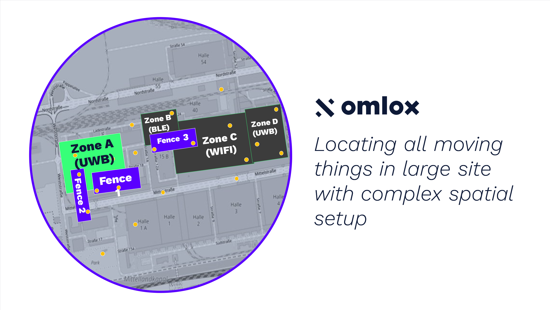
Press contact:
PI (PROFIBUS & PROFINET International)
PROFIBUS Nutzerorganisation e. V.
Barbara Weber

Haid-und-Neu-Str. 7

D-76131 Karlsruhe, Germany
Phone: +49 721 986 197 49

Fax: +49 721 986 197 11
Barbara.Weber@profibus.com
http://www.PROFIBUS.com
The text of this press release is available for download at www.profibus.com.

