Your contact:
Barbara Weber
Barbara.Weber@profibus.com
+49 721 9658-549

P R E S S R E L E A S E

Moving into the Future of Industry 4.0 with PI Technologies
Joint PI Stand at Hanover Fair 2019

Karlsruhe, 22. February 2019: The implementation of industrial communication for Industry 4.0 is the central theme of the joint PI stand at the Hanover Fair (Hall 9, Stand D68).

Here, trade visitors can see for themselves how PROFINET, TSN and OPC UA work together with devices from different manufacturers, on the basis of a variety of use cases. The “Industry 4.0 Demonstrator” will help to make this synergy especially vivid. Increasing flexibility based on a modular and convertible factory, increasing productivity by analyzing datasets in the cloud, and reducing time-to-market through virtual commissioning are just some of the use cases that will be demonstrated. A live demo with products from different drive manufacturers will also be presented. And a demo model on security mechanisms in PROFINET networks will complete the Industry 4.0 theme. In regard to functional safety, not only will PROFIsafe be presented by means of a live demo, but the operation of the new standard “Safety over OPC UA based on PROFIsafe” for controller-to-controller communication will also be demonstrated.

Visitors will get a first-hand impression of the variety of devices covered by PI’s proven technologies while attending the Factory Automation and IO-Link presentations and the process automation live demo. Thanks to a new design, the Factory Automation wall will be attractively integrated into the innovative and modern design of the joint PI stand. The IO-Link Community will also be exhibiting IO-Link Safety and IO-Link Wireless. Additionally, two technologies that have been developed in cooperation with other organizations will be showcased at the stand: FDI and Ethernet to the Field (APL, advanced physical layer).

For more information on the joint PI stand, co-exhibitors and complimentary visitor tickets, visit www.profibus.com/hmi.

***
Graphic: The joint PI stand at the Hanover Fair (Hall 9, Stand D68) will be exhibiting current topics in the field of Industry 4.0, such as the cooperation between PROFINET, TSN and OPC UA, and a demo model on security mechanisms.
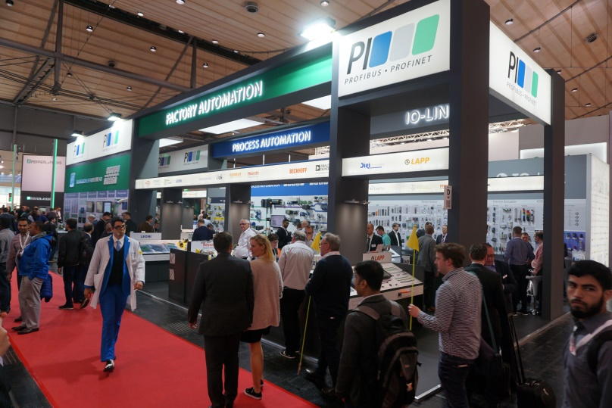
Press Contact:
PI (PROFIBUS & PROFINET International)
Support Center
Barbara Weber

Haid-und-Neu-Str. 7

D-76131 Karlsruhe
Tel.: 07 21 /96 58 - 5 49

Fax: 07 21 / 96 58 - 5 89
Barbara.Weber@profibus.com
http://www.PROFIBUS.com
The text of this press release is available for download at www.profibus.com.

