P R E S S R E L E A S E

IO-Link Community meets for testing

Karlsruhe, Germany – October 25, 2022: On October 11 and 12, 2022, more than 100 representatives (experts and manufacturers) from 37 international businesses gathered together for an interoperability workshop in Bad Soden, Germany. The goal of this workshop organized by the IO-Link Community was to test the interaction between devices, masters and tools under real-world practical conditions. Also on the agenda was the testing of data transfer and data visibility across all layers up to cloud connections.

During the two-day event, the latest IO-Link device developments were tested with regard to the interface itself, as well as cross-system integration into a variety of different engineering tools.

The various devices show that the IO-Link interface is now also making its way into actuator and hand-held control unit operation and has matured into a universal interface. An automated testing system for the IO-Link JSON REST interface was shown in Bad Soden for the first time ever. IO-Link physics can be checked in an automated way with a tester now as well.

Community experts were always happy to lend their support by fielding participants' questions on implementation and operation. As always, there was plenty of opportunity for making suggestions and a lively exchange of experience among users. This makes it easier to identify flaws and weaknesses during product development and, ideally, to already find a possible solution on site.

***

Graphic: Successful testing at the IO-Link Interop Workshop 2022.
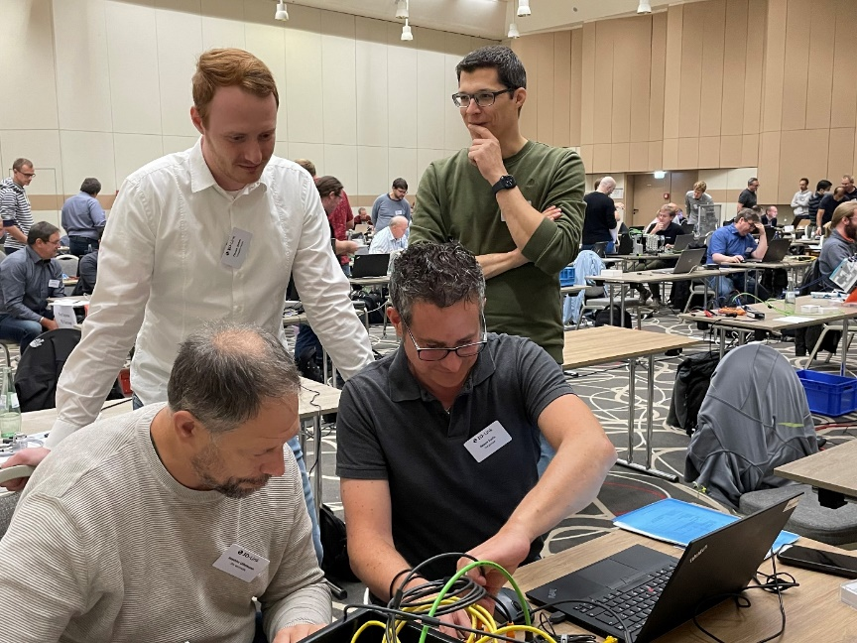
Press contact:
PI (PROFIBUS & PROFINET International)
PROFIBUS Nutzerorganisation e. V.
Barbara Weber

Haid-und-Neu-Str. 7

D-76131 Karlsruhe, Germany
Phone: +49 721 986 197 49
Barbara.Weber@profibus.com
http://www.PROFIBUS.com
The text of this press release is available for download at www.profibus.com .

