Contact person:
Barbara Weber
Barbara.Weber@profibus.com
+49 (0) 721 9658-549

P R E S S R E L E A S E

Go digital. Go PROFINET – PI presents Industry 4.0 progress

Karlsruhe, Germany – April 27, 2020: In an ordinary year, PI (PROFIBUS & PROFINET International) would already – and once again – have presented its progress on Industry 4.0 work at the Hanover Fair – but this is no ordinary year. Nevertheless, the working group experts are working tirelessly on implementing concepts like the use of PROFINET over TSN, fail-safe machine-to-machine communication and information models for vertical communication – virtually and at a safe distance, of course.

Obviously, this is not an easy time for an organization which has committed itself to the networking of automation systems, and especially also those of technical experts. PI has been part of the digital transformation from the very beginning, though, which makes it ideally equipped for this situation. This being the case, it is no wonder that the working groups chose to continue developing their concepts. Online meetings and processes have been part of everyday work at PI for many years, enabling effective and easy cooperation. To share this progress with PROFINET users as well, PI is now implementing a number of different virtual methods of communication.

The focal point of this communication is the PI website, http://www.profibus.com/I40, where “Industry 4.0” is being rolled out again in its entirety. PI is focusing on the highlights of its Industry 4.0 work here, beginning with PROFINET over TSN, OPC UA Safety and vertical communication. Additional concepts will be addressed and added successively over time. PI won’t just be providing an overview of the technology and leaving it at that – technical details on solutions and use cases for applications will be added as well. This gives device manufacturers and users solid information for their own implementation of Industry 4.0-compliant integration.

In addition to this digital content, PI will also be visualizing the Industry 4.0 workshop (March 27/ 28, 2020) to enable discussion with users and enter into dialog in these trying times – times which everyone at PI hopes will be over soon. Regardless, the working groups will continue to work hard on implementing Industry 4.0, in keeping with the motto: Go digital. Go PROFINET.

For more information on the status of Industry 4.0 implementation at PI, visit: http://www.profibus.com/I40.

***

Graphic: Lots of new information on Industry 4.0 work can be found on the PI website.
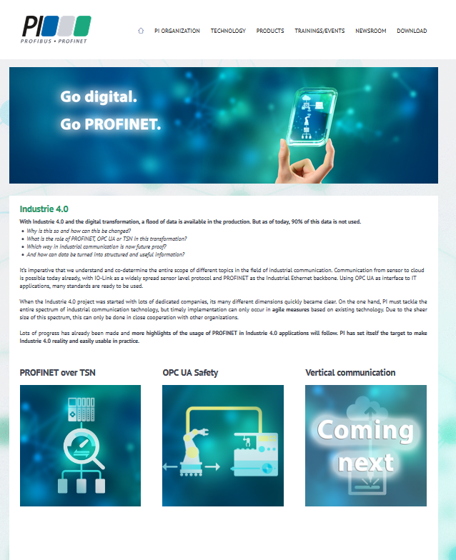

Press contact:
PI (PROFIBUS & PROFINET International)
PROFIBUS Nutzerorganisation e. V.
Barbara Weber

Haid-und-Neu-Str. 7

D-76131 Karlsruhe, Germany
Phone: +49 (0) 7 21/96 58-5 49

Fax: +49 (0) 7 21/96 58-5 89
Barbara.Weber@profibus.com
http://www.PROFIBUS.com
The text of this press release is available for download at www.profibus.com,

